**(Slide No: 1)**

**Today in this video let us discuss about the Pharmaceutical calculations:**

**Subtopic:**

**Applying Alligation to HLB Calculations Selecting the Right Surfactant for Emulsions**

**(Slide No: 2)**

**Content:**

* Objectives
* Introduction to HLB Scale
* Problems solving

**(Slide No: 3)**

**Objectives:**

Student will be able,

1. To differentiate between alligation medial and alligation alternate, understanding when to apply each method.
2. To apply alligation techniques to real-world pharmaceutical problems, such as adjusting the strength of a medication or preparing stock solutions.
3. To develop critical thinking and analytical skills through problem-solving exercises involving alligation.

**(Slide No: 4)**

**Introduction to HLB Scale:**

The HLB values range from 1 to 20, with lower values indicating lipophilic properties (suitable for water-in-oil emulsions) and higher values indicating hydrophilic properties (suitable for oil-in-water emulsions.) The HLB value is fundamental in formulating stable emulsions by guiding the selection of appropriate surfactants based on their hydrophilic and lipophilic characteristics.

Any emulsion is highly stable at a particular HLB value, which can be established by using suitable single surfactant or better to use combination of the two or more surfactants of which one possesses high HLB than required and other possesses low HLB than required. HLB values can be mathematically added and thus two or more surfactants can be mixed to form a blend providing desired HLB value for the formulation of a stable emulsion.

Some Common Emulsifiers and their HLB Values for examples :

|  |  |
| --- | --- |
| **Surfactants** | **HLB** |
| Sorbitan Trioleat (Span 85) | 1.8 |
| Propylene Glycol lsostearate | 2.5 |
| Glyceryl Stearate | 3.8 |
| Polysorbate 85 | 11 |
| PEG-8 Laurate | 13 |
| Polysorbate 60 NF | 14.9 |

When two or more emulsifiers are combined, the HLB of the combination is determined mathematically by adding the contribution that each makes to the total HLB of the mixture.

If two emulsifiers of different HLBs are used to establish a particular HLB of an emulsion, the proportions of these two emulsifiers to provide required HLB could be calculated by Alligation method.

**(Slide No: 5)**

**Problem 1.**

**What is the HLB of a mixture of 30% of span 60 (HLB= 4.7) and 70% of tween 60 (HLB =14.9)?**

**Solution: here apply Alligation medial principle**

HLB of span 60 = 4.7

HLB of tween 60 = 14.9

Surfactant HLB × % =

Span 60 4.7 × 30% = 1.4

Tween 60 14.9 × 70% = 10.4

----------------------------------------------------------

11.8

**HLB of mixture of different HLBs is 11.8**

**(Slide No: 6)**

**Problem 2.**

What will be the proportions of the two emulsifiers having HLB values (A) 15 and (B) 4 be mixed to provide 10 HLB of the mixture?

Solution: here **apply Alligation alternate principle**

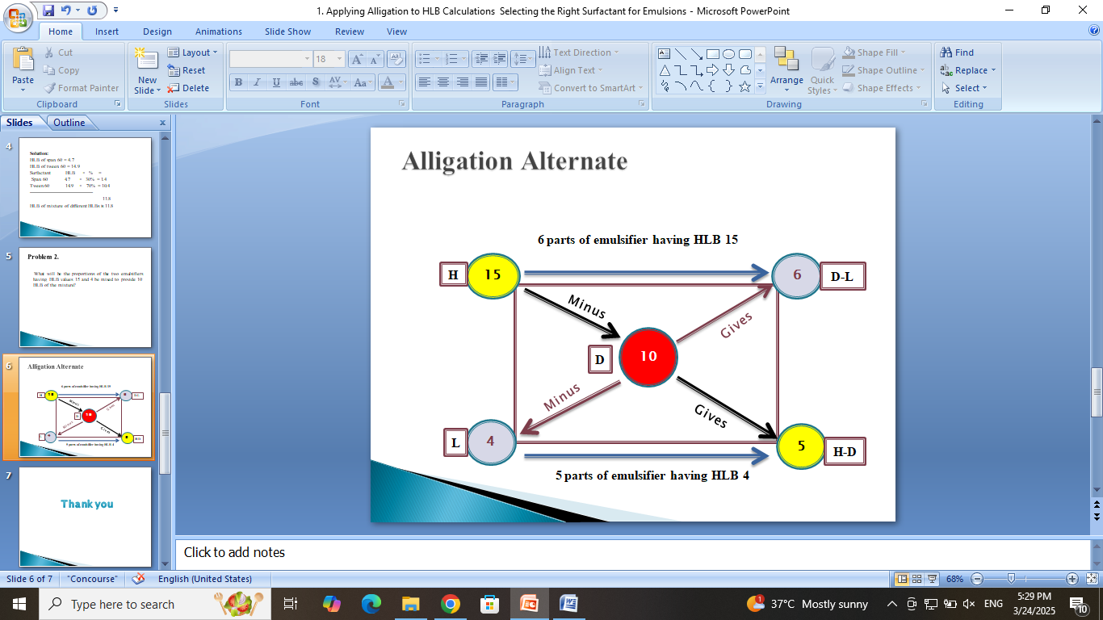

Using the following formula, this problem can be solved:

% H = 100(x-HLBL)/ (HLBH-HLBL)

Where, x= derived HLB

% L= 100- %H

In the above example HLB of emulsifier H and L are given 15 and 4 respectively.

The derived HLB is 10

% H = 100(x-HLBL)/ (HLBH-HLBL)

% H = 100(10-4)/ (15-4)

= 100(6)/ (11)

= 600/11

% H =54.5%

% L= 100- 54.5

= 45.5%

Therefore, when 54.5% of emulsifier A and 45.5% of emulsifier B is added to formulate and emulsion, that emulsion would possess a HLB value of 10.

**(Slide No: 7)**

Thank you