**KRISHNA INSTITUTE OF NURSING SCIENCES KARAD.**

**SUB. CHILD HEALTH NURSIN**

**TOPIC. KANGAROO MOTHER CARE**

**MRS. SUSHAMA S.SHETE**

**OBJECTIVES**

* At the end of the lecture students should be able to
* Define the Kangaroo Mother Care.
* Discuss about Kangaroo Mother Care.
* Identify the problems of Low Birth Weight Babies.
* Explain the components of Kangaroo Mother Care.
* Explain the criteria for eligibility of Kangaroo Mother Care.
* Understand about requirements’ For KMC Implementation
* Enumerate the advantages of KMC to Baby and Mother



* In India Rate Of Low Birth Weight Baby Is More , Lbw Are Suffering From Health Problem, So Prevention Of This Problem There Is Need Skin To Skin Contact.
* Expert Are Giving Kangaroo Mother Care To Low Birth Weight Babies.

**KANGAROO MOTHER CARE**

* Caring of low Birth Weight Baby Is A Great Challenge For The Neonatel Care

Unit And The Family . This Method Of Care Was Introduced And Popularized By Dr.

Edger Ray, Dr.Marthinez And Dr.Charpak In Late 1970. Kmc Facilities Love And Emotional Bonding Between Mother And Child.

**DEFINITION –**

* Kangaroo Mother Care Is A Special Way of Caring Low Birth Weight Infants By Skin To Skin Contact . It Prometes Their Health And Welling By Effective Thermal Control Breast Feeding And Bonding.Kmc Is Intiated In Hospital And Continued At Home.

**KANGAROO MOTHER CARE.**

* Kmc Is A Method Of Caring For Lbw Babies
* The Baby Is Placed Between Mothers Breastin Direct Skin To Skin Contact,Given Exclusive Breast Feeding.
* Get Proper Warmth, Adequte Nutrition.

**PROBLEMS OF LOW BIRTH WEIGHT BABIES**

* High Mortality Rate
* Hypothermia
* Hypoglycemia
* Apnea
* Hypoxia
* Infection
* Poor Weight Gain

**COMPONENTS OF KMC**

**THE FOUR COMPONENTS**

* Kangaroo Position.
* Kangaroo Nutrition.
* Physical Emotional And Educational Support.
* Early Discharge And Regular Followup.

**KANGROO POSITION (SKIN TO SKIN CONTACT)**

* Kmc For 24 Hours In Vertical Position Between Mothers Breast And Her Clothes.
* Babies Head Turned On One Side In Slight Exetened Position .
* Hands Are Kept Above The Breast.

In Frog Position Slight Extened Head Position Keeps Air Way Open

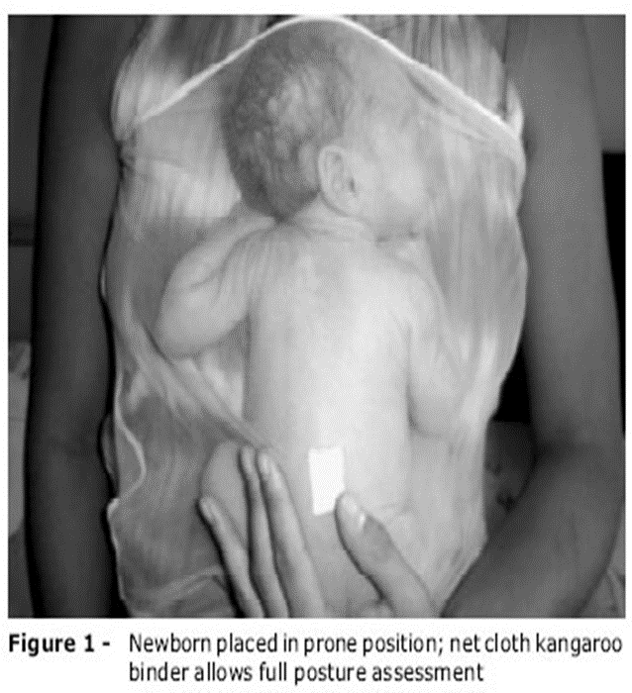

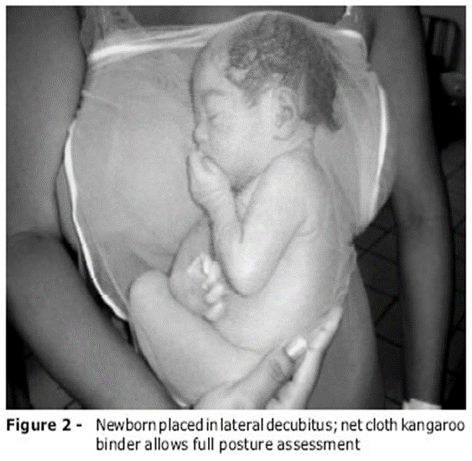

**KANGAROO NUTRITION**

* Skin To Skin Contact Promote Laction
* Exclusive Breast Feeding For Adequate Nutrition And To Improve Desired Weight Gain.
* Mother Milk Provides All Nutrients For Physical And Mental Growth.
* Colostrum –Initial – Thick Milk.
* Prevents Infection Malnutrition And Allergies.

**PHYSICAL EMOTIONAL AND EDUCATIONAL SUPPORT**

* This Should Be Provided By The Nursing And Medical Staff To The Mother And The Family.
* Mother Needs Motivation To Continue Kmc
* She Should Be Encouraged To Ask Question To Remove Anxity.

**EARLY DISCHARGE AND**

**REGULAR FOLLOWUP**

* Weight Gain Of 15-20gm/Kg/Day For 3 Consecutive Dayes.
* Baby In Kangroo Position For 24 Houres.
* Maintaining Temperature Without Assistance .
* No Evidence Of Illness.
* Educate Mother Regarding Danger Sign.

Ex Apnea, Difficult Breathing, Decreased Activity.

**CRITERIA FOR ELIGIBILITY OF KMC**

All Babies Are Eligiable For Kmc.

* Kmc Should Be Started After The Baby Has Stable.
* Weight >1800gm. Start Soon After Birth.
* Weight 1200gm-1799gm Soon After Birth.
* Weight < 1200gm Or Gestation < 30weeks
* It May Take Weeks Before Their Condition Allows Initation Of Kmc

**REQUIRMENTS FOR KMC IMPLEMENTATION**

* Requirment Of Traning Of Nurses Douctors, Other Staff.
* Educational Material Ex. Information Booklet Pamplet, Poster,Video Film Etc .
* Reclining Chairs Or Beds With Adjustable Backrest Or Pillow.

**THE KANGAROO BAG**

* The Kmc Kangaroo Bag Is Made Of Soft Flannel Cloth. It Has 2 Ties On Either Side So That The Mother Can Tie The Bag Herself One Side Without Help.
* The Loop Arround The Neck May Be Adjusted According To The Comfort Of The Mother And Baby.

**HOW LONG CONTINUE KMC**

Once Baby Startes Maintaining Her Temperature,She Shall Cry And Kick This The Time Kmc May Stopped.

**DONTS OF KMC**

* Do Not Keep Baby In Horizontal Position
* Do Not Bath Till Baby Weighs 2500gm.
* Do Not Handle Baby Too Frequently.
* Do Not Keep Baby With Sick People.

**ADVANTAGES OF KMC TO BABY**

* Warmth 24 Houres
* Reduced Infection
* Multimodal Stimulation
* Quiet Sleep
* Reduced Apnea And Oxygen Requriment
* Better Iq
* Physiological Stability.

**BENEFITES OF KMC TO MOTHER**

* Develops Self Confidence.
* Better Bonding with Baby.
* Reduced Hospital Stay.
* Mental Satisfaction.
* Economical.
* Successful Breast Feeding.
* Provide Rest.

**SUMMARY**

* This Chapter Illustrates The Kangaroo Mother Care. It Also Discuss About Defenation Of Kmc, Problems Of Low Birth Weight Baby ,Components Of Kmc Criteria For Eligiblity Of Kmc, Requriment For Kmc Implemention, Advantages Of Kmc To Baby And Mother.To Prevent Low Birth Weight Banies Problem And Long Term Complication, So There Is Need Of Kangaroo Mother Care.

**BIBLIOGRAPHY**

* Wongs.Nursing Care Of Infant And Children.8 Ed. Elsevier : Up India;2009.P 222
* Parul .D . Vicky .G . Pediatric Nursing 2nd Ed. Jaypee : New Delhi; 2009.P 109-112.
* Ghai O. P. Paul .V .Essential Pediatric .7th Ed . Satish Kumar : New Delhi ; 2009 . P 116-121.
* Udani Rekha. Nanavati Runchi. Tranning Mannual On Kangraoo Mother Care ,Kem Hospital And Seth Gs Medical College Mumbai . 2004.P.20-31.
* File .11 K1 Kmc Images And Biw = 13668 Bih=576.
* Prashanth S,2 Annual Conference Of Neonatal Nursing .2 Ed. Davageri 2006. P92-102.

**ASSIGNMENTS**

**LAQ**

1. Discuss in detail the concept of Kangaroo Mother Care (KMC). Include in your answer the historical background, components, mechanisms of action, benefits for both infants and mothers, and the challenges faced in implementing KMC in different healthcare settings.

2. Elaborate on the strategies for implementing Kangaroo Mother Care (KMC) in resource-limited settings. Discuss the role of healthcare professionals, community involvement, and potential barriers that need to be addressed to ensure successful implementation.

3. Compare and contrast Kangaroo Mother Care (KMC) with conventional neonatal care methods. Discuss the advantages and disadvantages of each approach, and provide evidence-based recommendations for integrating KMC into standard neonatal care practices.

4. Analyze the psychological and developmental impact of Kangaroo Mother Care (KMC) on preterm and low birth weight infants. Discuss relevant research findings and the implications for long-term outcomes.

5. Discuss the ethical and cultural considerations involved in the practice of Kangaroo Mother Care (KMC). How can healthcare providers address these considerations to ensure culturally sensitive and ethically sound care?

**SAQ**

1. What is Kangaroo Mother Care (KMC)? Define Kangaroo Mother Care (KMC) and list its three main components.
2. How does KMC benefit preterm and low birth weight infants? Describe at least three benefits of Kangaroo Mother Care for preterm and low birth weight infants.
3. What challenges are commonly faced in implementing KMC? Identify three common challenges in the implementation of Kangaroo Mother Care in healthcare settings.
4. How does KMC impact maternal health? Explain two ways in which Kangaroo Mother Care positively impacts maternal health.
5. What are the long-term outcomes associated with KMC? Discuss two long-term outcomes for infants who receive Kangaroo Mother Care

**BAQ**

1. What is the primary objective of Kangaroo Mother Care (KMC)? What is the primary objective of Kangaroo Mother Care (KMC)?
2. Which key component of KMC helps in maintaining an infant’s body temperature?
3. Why is exclusive breastfeeding important in KMC?
4. How does KMC contribute to reducing neonatal infections?
5. What is one significant psychological benefit of KMC for mothers?