Chloride practical protocol

**Aim**: Estimation of chloride in given water samples.

**Introduction**:

* Chlorides occur in all types of waters.
* In natural freshwaters the concentration of chlorides remains quite low and generally less than that of sulphates and bicarbonates.
* The concentration of chlorides in waters can be increased by pollution
* Domestic sewage contains high quantity of chlorides.
* Chloride are highly soluble and generally do not precipitate in water.
* Drinking water limits for chloride is 200 mg /L but it can be tolerated up to 1000mg/L
* A chloride level about 250mg/Lor above gives a salty test to water.
* **PRINCIPLE:**

Silver nitrate reacts with chlorides to form very slightly soluble white precipitate of AgCl and silver ions become free. At the end point when all the chlorides get precipitated, free silver ions reacts with chromate to form silver chromate of reddish brown colour.

* Ag+ +Cl- <=> AgCl
* 2Ag+ +CrO4
* 2- <=> Ag2CrO4
* **APPARATUS:**
* 1.Beaker
* 2.Measuring cylinder
* 3.Conical flask
* 4.Pipette
* 5.Titration assembly
* **CHEMICALS**:
* **1. Silver nitrate 0.02N solution**: Dissolve 3.400gm of dried AgNO3 in distilled water to make 1 liter of solution and keep in dark bottle.
* **2.** **Potassium Chromate 5%:** Dissolve 5 gm of K2CrO4 in 100 ml of distilled water.
* **PROCEDURE:**

**Step 1**

* Take 50 ml of sample in a conical flask. Dilute the sample if necessary.

**Step 2**

* Add 2 ml K2CrO4 potassium chromate indicator solution in the flask of sample

**Step3**

Shake well a yellow colour appears .

**Step 4**

* 4. Now titrate the entire sample with standard silver nitrate AgNO3 (0.02N) solution till a persistent brown tinge appears at the end point.

**Step5**

* 5. The end point turns yellow to brick red colour .

**Step 6**

. Repeat the same procedure and obtain three readings.

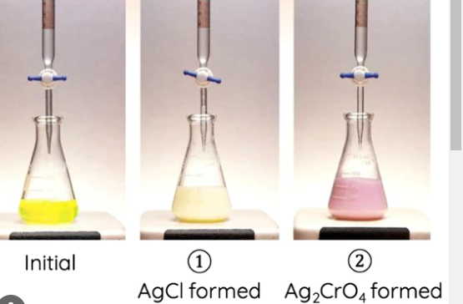

Initial 1**. Agcl formed** **2. Agco4**

**Observation :**

In flask – 50 ml sample

In burette- 0.020N

Indicator- 5%

End point – yellow colour to brick red colour

**Observation table :**

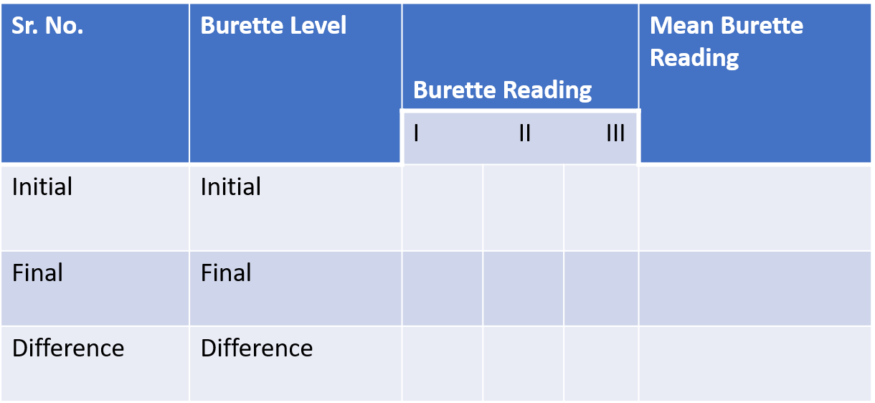

**Calculation :**

**Chloride (mg /L) = ( mL *Normality of AgNO3 ) *35.5*1000**

**volume of sample**

**Result :**

The concentration of chloride in the given water sample is ---------------------------mg /L

**References :**

1.Chemical and Biological Methods for Water Pollution Studies

EM International

http://www.envirobiotechjournals. water analysis practical book P.K Goel and Trivedi from www.envirobiotechjournals.com

2. Chemical and Biological Methods for Water Pollution Studies ... Author: R.K. Trivedy**,**

3. Analysis of Physico-Chemical Parameters of Drinking2] Trivedi.R.K and Goel P.K. (1984) book on chemical and biological methods for water pollution studies, Karad,. Environmental Publication pp.1-251 M. [3]

4.https://nitsri.ac.in/Department/Civil%20Engineering/WATER_QUALITY_AND_ENVIRONMENT_Chlorides