**UNDER FIVE CLINIC**

* Under -five clinic is a center were preventive, promotive, curative, referral and educational services are provided in a combined manner to under – five children under one roof.
* The overall goal of under-five clinic is to provide comprehensive health care to young children in a specialized facility.

**SYMBOL OF UNDER FIVE CLINIC**

* **CARE IN ILLNESS: -**
* Children are treated acute and chronic illness and ailments of growth and development at these clinics. Nurses play an important role in taking care of children.
* This is the need of the mother and child for which any child is brought to the clinic.
* Common ailments include fever, diarrhea, helminthiasis, etc.
* Facility should provide essential laboratory investigations and X-ray facilities. An effective referral mechanism should be present.
* **GROWTH MONITORING :-**
* Child is weighed periodically
* every month during the first year
* every 2 monthly during 1-3 years
* every 3 monthly during 14 and 5 years
* Along with weight, mid-arm circumference and height is also measured.
* Growth chart is prepared and growth curve obtained.

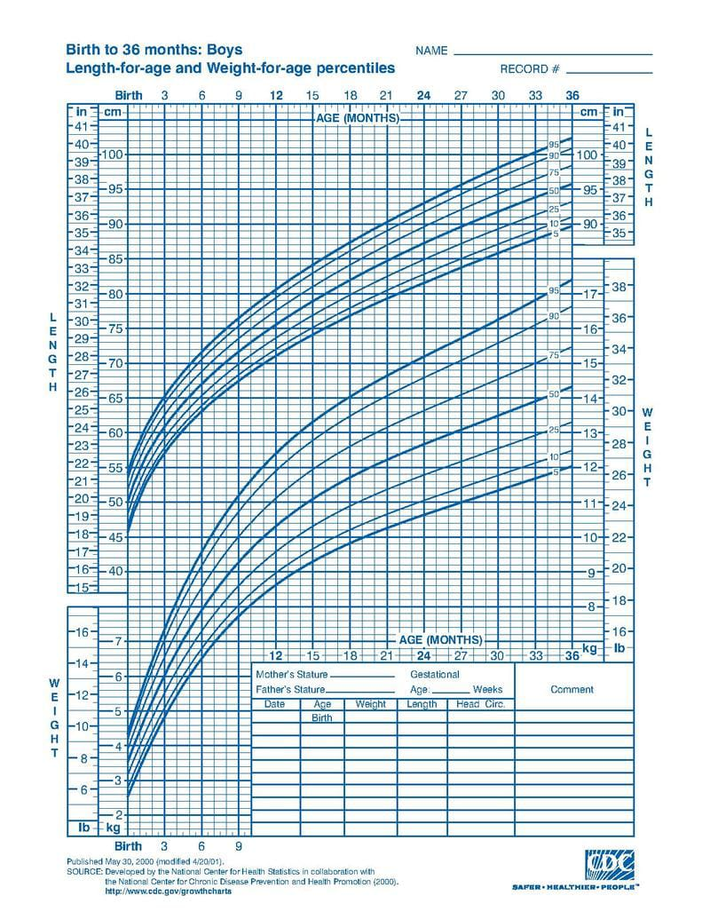

* **PREVENTIVE CARE :-**
* **This includes**
* Timely physical examination of children.
* Immunization along with vitamin A supplementation.
* Nutritional care.
* Oral rehydration therapy.
* Administration of iron supplementation and anti-helminthic medication to prevent anemia.
* **FAMILY PLANNING**
* Central to any programme involving mother and child.
* Mothers are more receptive to family planning during puerperium and lactation period.
* Mother is counselled on various options that are available, so that they get to choose which is best for them personally.
* **HEALTH EDUCATION**
* **The opportunity should be made use to educate the mother on issues of –**
* Child care
* Breast feeding
* Nutrition
* Growth monitoring
* Immunization
* Hygiene of safe water and food preparations.

**ASSIGMENT**

1.What is under five clinic also called?

2. what are the main services of under-five clinic?

3. what is meaning of the under-five clinic symbol?

4. what are the objective of the under-five clinic?

**Multiple Choice Questions.**

1. What does the apex of the under -five clinic triangle represents
2. Treatment and care of sick children
3. Care in illness
4. Health education
5. Vaccination

**Answer: - Care Of Illness**

1. Components of the under – five clinics
2. Vaccination
3. Nutrition survey
4. O.R.S. Therapy
5. All of these

**Answer: - All of These**