TANNINS Part 1

**Definition of Tannins:**

Tannins are high molecular weight (500–3000 Da), water-soluble polyphenolic compounds found in many plant species. They have the ability to precipitate proteins, alkaloids, gelatin, and other biological compounds. Tannins are responsible for the astringent taste of many plants and plant products.

**Classification of Tannins:**

Tannins are mainly classified into two major groups:

**1. Hydrolyzable Tannins:**

* These are esters of a sugar (mainly glucose) with phenolic acids like **gallic acid** or **ellagic acid**.

* They can be hydrolyzed by acids, enzymes, or alkalis to yield sugars and phenolic acids.
* Subtypes:
  + **Gallotannins** – give **gallic acid** on hydrolysis.
  + **Ellagitannins** – give **ellagic acid** on hydrolysis.
* **On dry distillation gallic acid and other components get converted to pyrogallol**

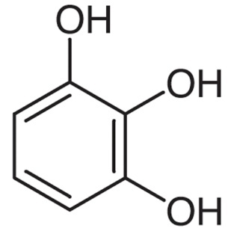

* **Examples**: Gallotannin (from *Nutgall*), Ellagitannin (from *Pomegranate, Oak, Myrobalan*).

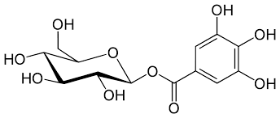

**2. Condensed Tannins (Proanthocyanidins):**

* **They are also known as non hydrolysable tannins, phlobatannins or proanthocyanidins**
* These are polymers of flavan-3-ols such as catechin. They are related to flavonoids because they are formed via derivatives of flavones like catechin or flavan- 3-ol or flavan3,4 diols.
* They are not easily hydrolyzed by mineral acids, they decompose to red colored substances called phlobaphenes.
* Phlobaphenes. are insoluble in water and indicate the typical brownish red colour of many plants and drugs
* On dry distillation, they yield **catechol**.
* 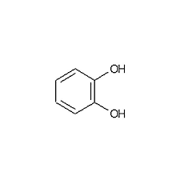
* They do not contain any sugar in their structure.
* They are distributed in different plant parts like leaves of green tea, bark of cinchona and cinnamon, rhizome of male Fern, seeds of Areca.
* Methanol, hot water, acetone and ethyl acetate are common solvents used for extraction of tannins
* **Examples**: Catechin (from *Acacia*), Leucoanthocyanidins.

**3. Complex Tannins (or Mixed Tannins):**

* These contain both hydrolyzable and condensed tannin units.
* Result from the combination of a galloyl group and a flavonoid unit.
* **Example**: Found in *Castalagin* and *Vescalagin* (from oak wood).

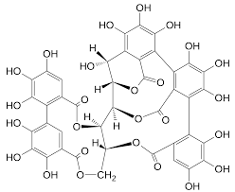

CASTALAGIN

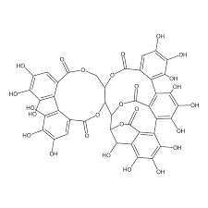

VESCALAGIN

**4. Pseudo-tannins:**

* These are simple phenolic compounds of lower molecular weight.
* They do not form true tannins and cannot precipitate proteins.
* They do not give Gold beater’s skin test.
* **Examples**: Chlorogenic acid, Caffeic acid, and Catechol.
* A structure of a chemical formula

  AI-generated content may be incorrect.

**5**. Phlorotannins:

* These are oligomers of phloroglucinol and are based on arrangement of phloroglucinol monomers.
* They are found in dark brown algae and in few red algae.
* They precipitate with proteins and are reported only in Araliaceae family.
* Their subclasses include (based on linkage):

1. Ether linkage: Phlorethols
2. Phenyl linkage: Fucols
3. Ether and Phenyl linkage: Fucophlorethols
4. Dibenzodioxin linkage: Eckols and carmalols