VINCA

Synonyms

Vinca rosea, Catharanthus, Madagascar , Periwinkle.

Barmasi.

Biological Source

Vinca is the dried entire plant of Catharanthus roseus Linn., belonging to family Apocynaceae.

Geographical Source

The plant is a native of Madagascar and is found in many tropical and subtropical countries especially in India, Austra-lia, South Africa and North and South America. The plant is cultivated as garden plant in Europe and India.

Cultivation and Collection

The plant is perennial and retains its glossy leaves through-out the winter. The plant prefers light (sandy), medium (loamy) and heavy (clay) soils and can grow in heavy clay soil. The plant prefers acid, neutral and basic (alkaline) soils. It can grow in full shade (deep woodland) semishade (light woodland) or no shade. It requires dry or moist soil and can tolerate drought. It is cultivated either by directly sowing the seeds or sowing the seeds in nursery. Nursery sowing method is found to be economical and the fresh seeds are sown in nursery in the month of February or March. The seedlings attain a height of 5–8 cm after two months and then they are transplanted in to the field at a distance of 45 cm × 30 cm. Proper fertilization and weeding is done timely and leaves are stripped after nine months. In order to collect the whole plant, the stems are first cut about 10 cm above the grounds and the leaves, seeds, stems are separated and dried. The roots are collected by plugging which are later washed and dried under shade and packed.

Characteristics

The leaves are green in colour, flowers are either violet, pinkish white or carmine red and roots are pale grey in colour. It has characteristic odour and bitter taste. The flowers are hermaphrodite (have both male and female organs) and are pollinated by bees. Leaves are petiolate, entire margin, ovate or oblong, glossy appearance and with acute apex. Fruit is follicles with numerous black seeds.

Microscopy

Vinca has dorsiventral leaf structure. Epidermis is a single layer of rectangular cells covered with thick cuticle. It consists of uni-cellular covering trichome and cruciferous stomata. In the mesophyll region single layer of elongated and closely packed palisade parenchyma cells are present just below the upper epidermis. In the midrib region two to three layers of collenchyma is present, both below the upper epidermis and above the lower epidermis. Vascular bundle consisting of xylem and phloem is present in the middle of midrib region and rest of the intercellular space is covered by five to eight layers of spongy parenchyma.

Calcium oxalate crystals are absent.

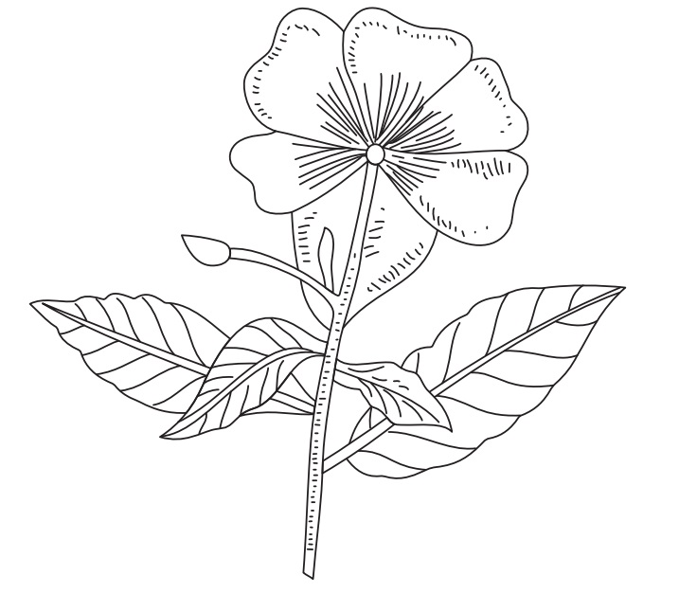
Catharanthus roseus

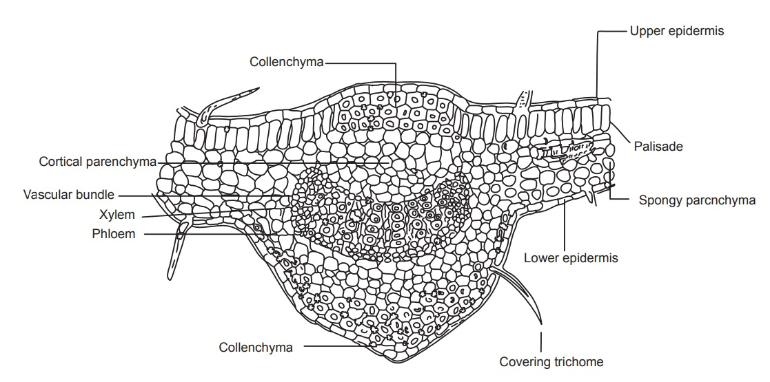

Transverse section of Vinca leaf

Chemical Constituents

Alkaloids are present in entire shrub but leaves and roots contain more alkaloids. About 90 alkaloids have been isolated from Vinca from which some like Ajmalicine, Serpentine and Tetrahydroalstonine are known and are present in other species of Apocynaceae. The important alkaloids in Catharanthus are the dimer indole indoline alkaloids Vinblastine and Vincristine and they possess defi-nite anticancer activity. Vindoline and Catharanthine are indole monomeric alkaloids. It also contains monoterpenes, sesquiterpene, indole and indoline glycoside.

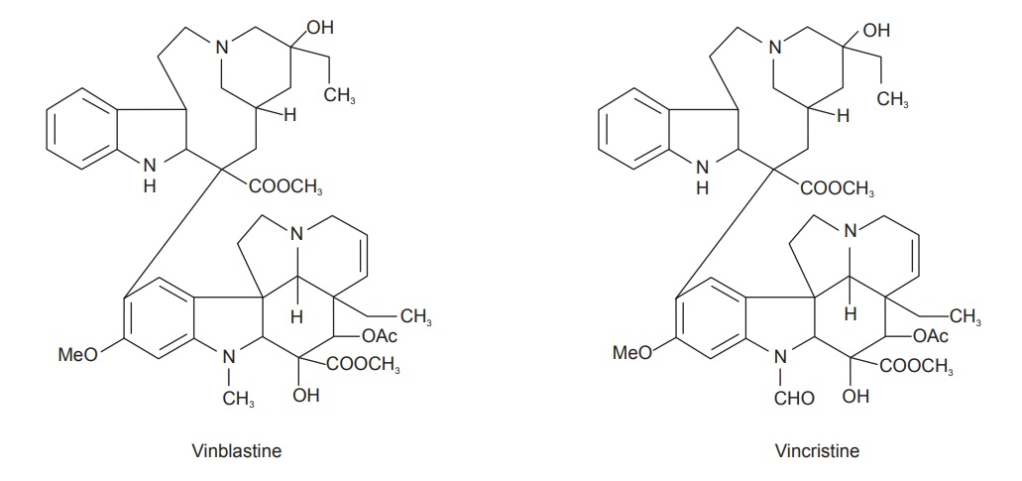

Uses

Vinblastin is an antitumour alkaloid used in the treatment of Hodgkin’s disease. Vincristine is a cytotoxic compound and used to treat leukaemia in children. Vinca is used in herbal practice for its astringent and tonic properties in menorrhagia and in haemorrhages generally. In cases of scurvy and for relaxed sore throat and inflamed tonsils, it may also be used as a gargle. For bleeding piles, it may be applied externally, as well as taken internally. It is also used in the treatment of diabetes.

The flowers of the Periwinkle are gently purgative, but lose their effect on drying. If gathered in the spring and made into a syrup, they impart all their virtues, and this, it is stated, is excellent as a gentle laxative for children and also for overcoming chronic constipation in grown persons.

Mechanism of Action
Vinca alkaloids including vincristine, vinblastine, vindesine, and vinflunine are chemotherapeutic compounds commonly used to treat various cancers. Vinca alkaloids are one of the first microtubule-targeting agents to be produced and certified for the treatment of hematological and lymphatic neoplasms. Microtubule targeting agents like vincristine and vinblastine work by disrupting microtubule dynamics, causing mitotic arrest and cell death.
These alkaloids are microtubule damaging agents. Mitotic spindle is required for equal partitioning of DNA into 2 daughter cells during cell division in eukaryotes. It consists of chromatin and microtubule which is composed of tubulin.
Vinca alkaloids are cell cycle specific. They bind to microtubular protein- βtubulin and inhibit their polymerization with α-tubulin to form microtubules. As intact mitotic spindle is not formed, duplicated chromosome cannot align with division plate. Hence, they block cell cycle in metaphase of mitosis and exert cytotoxic effect.
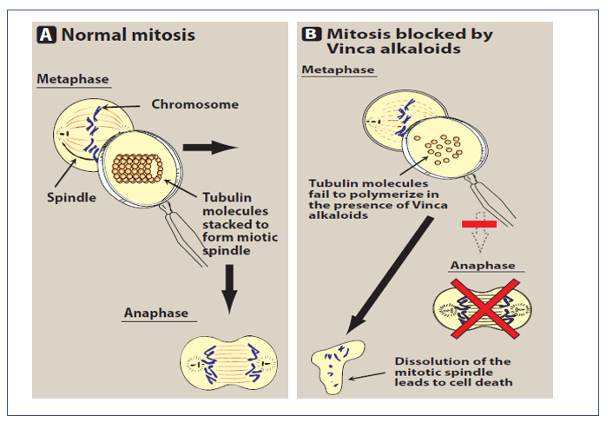

Marketed Products

It is one of the ingredients of the preparation known as Cytocristin (Cipla).

Contraindications

- They should not be used by pregnant women, women who are planning for pregnancy or breast-feeding mothers as they cause birth defect.

- Patients who are taking these drugs should not receive any vaccination.

Conclusion
Vinca is one of the in most cases found to have the lifesaving properties in most of the cancers, vinca have the anticancer and the anti-tumor houses. The semi synthetic derivatives of vinca are well documented for the anticancer activity and the crude extract also possesses the anticancer activity. Also, it belongs to the category of cytotoxic agents which have been approved with FDA such as vinblastine, vincristine and vinorelbine. Further other agents such as vinflunine that are used ion cancer as second-line transitional carcinoma of the urothelium are in pipeline. Overall review and literature thus conclude that vinca is potential ethnopharmacologically as anticancer agent.

