**Extraction and Isolation of Atropine**

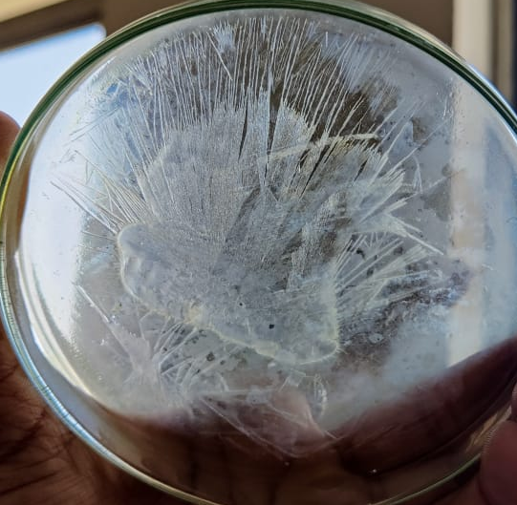

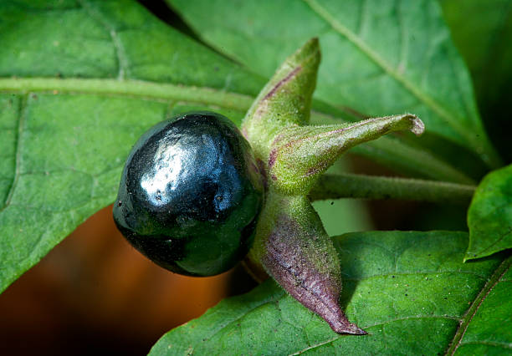

**1.Sources of Atropine**:-

Atropa belladonna, Daturainoxia, D.metel, D.stramonium.

**2.Biological source**:-

Belladonna herb consists of dried leaves or the leaves and other aerial parts of *Atropa belladonna* or *Atropa acuminate*. It contains not less than 0.3% of the alkaloids of belladonna her, calculated as l-hyoscyamine.

**3.Geographical source**:-

It is indigenous to and cultivated in England and other European countries. In India, it is found in the Western Himalayas from Simla to Kashmir and adjoining areas of Himachal Pradesh. It’s chief habitat is Jammu and in forests of Sindh,andChinab valley.

**4. Cultivation and Collection**:-

Propagation – Seeds are sown by by broadcasting

Method in well prepared beds with the application of fungicide.

Soil :- Belladonna grows well in deep fertile soils of medium texture.

Climatic Conditions:- Cultivation of belladonna at an altitude of 1400 m above is found to be satisfactory. Sowing is done in May and July.

Growing period – Belladonna begin growing in early spring or during late autumn.

**Collection** - The leaves, as well as, the flowering tops are cut and sundried or dried in shade. While grading and packaging for market, wooly stems and foreign organic matter are rejected

**Phytochemistry**:-

Atropine-

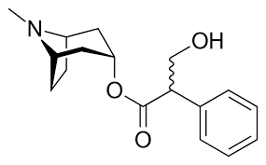

Scopolamine-

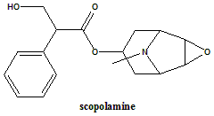

Hyoscyamine-

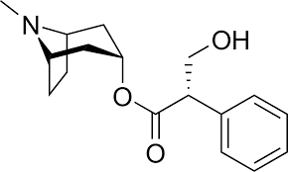

**Extraction and Isolation**:-

1. Take accurately quantity of belladonna leaves and powder them to obtain coarse size powder.

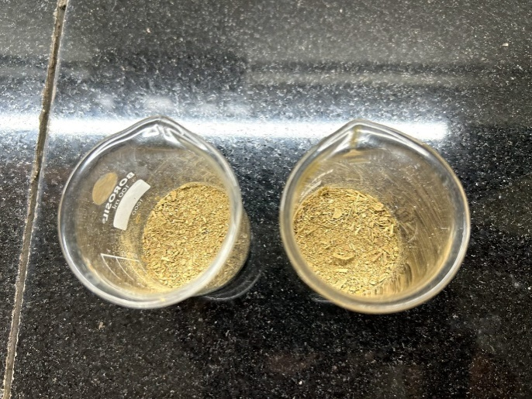

1. Extract powder mix with 95% ethanol, Filter the distilled of solvent, evaporate upto a syrupy mass produced. (Basic reason behind use of 95% ethanol is alkaloid are soluble in polar solvent when they are present in salt form and soluble in non polar solvent when they are free bases) so we use 95% alcohol.

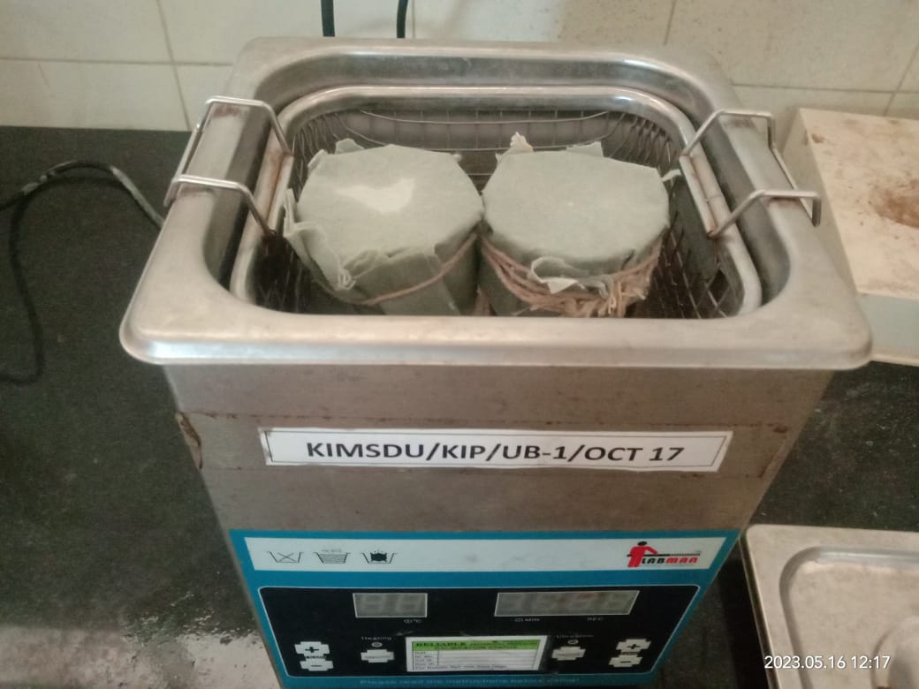

1. Add sufficient quantity of 1% HCl to syrupy mass it will help to remove resinous matter. ( Reason behind addition of 1% HCl is to remove the resinous material in the form of PPT so filter the material and discard the Precipitate, it contains resinous matter)

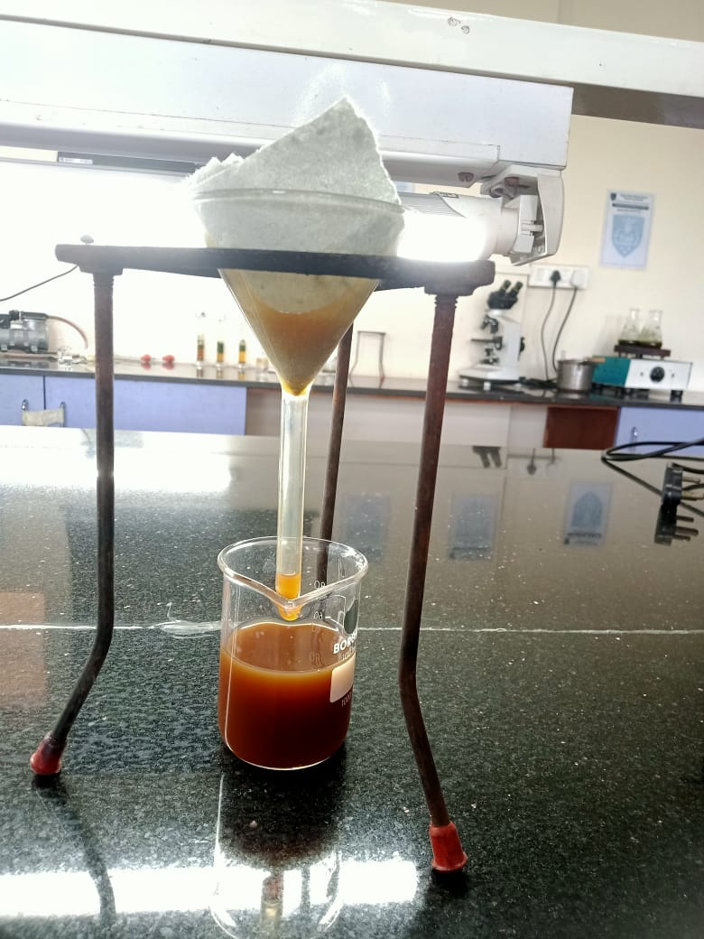

1. After that add petroleum ether, shake well and make it alkaline with ammonia solution

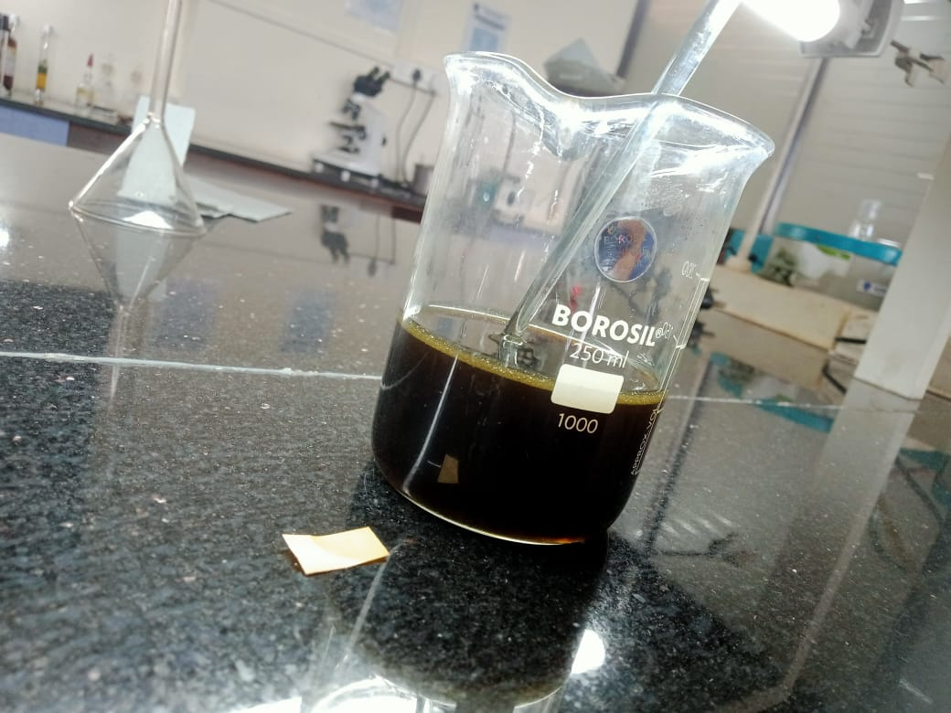

1. The extract mix with a chloroform , separate the chloroform.

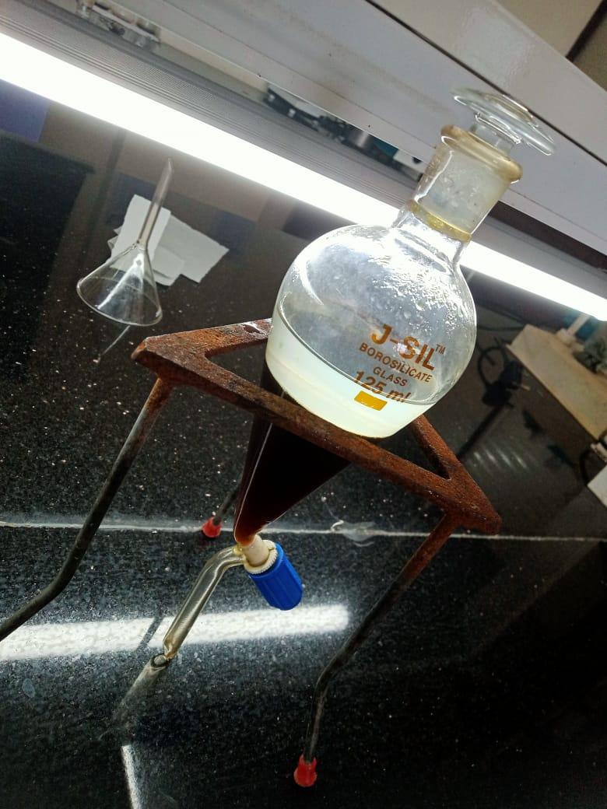

1. Evaporate chloroform layer to its ¼ volume, add oxalic acid, which will help to separate crystals of atropine and hyoscyamine oxalate.

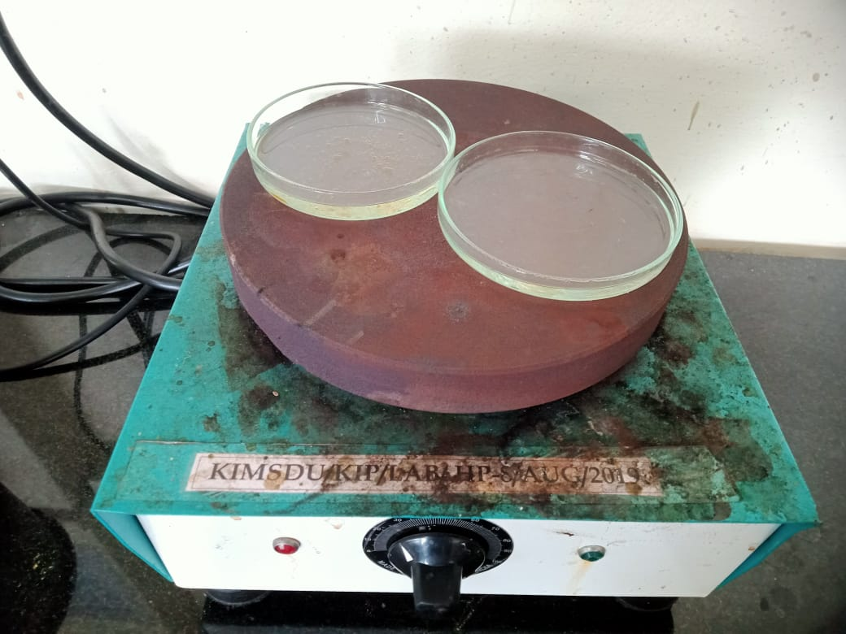

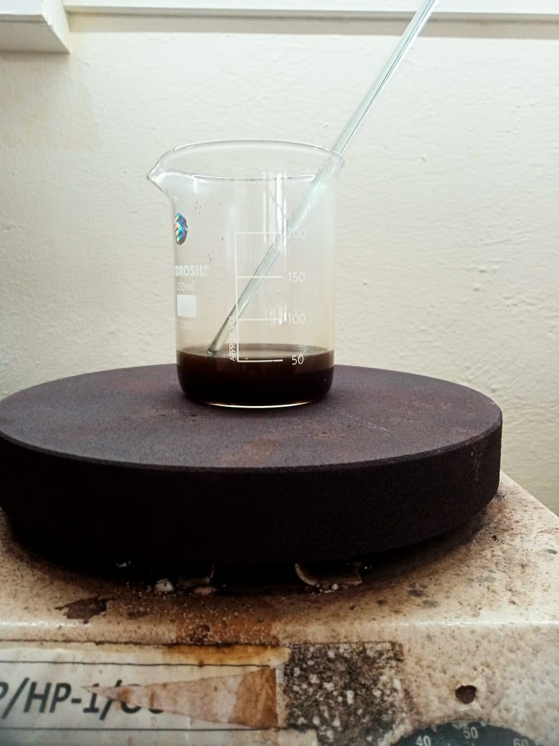

1. To separate hyoscyamine and atropine dissolve crystals in acetone/ether filter it, filtrate will have hyoscyamine oxalate crystals and residue will be of atropine oxalate.

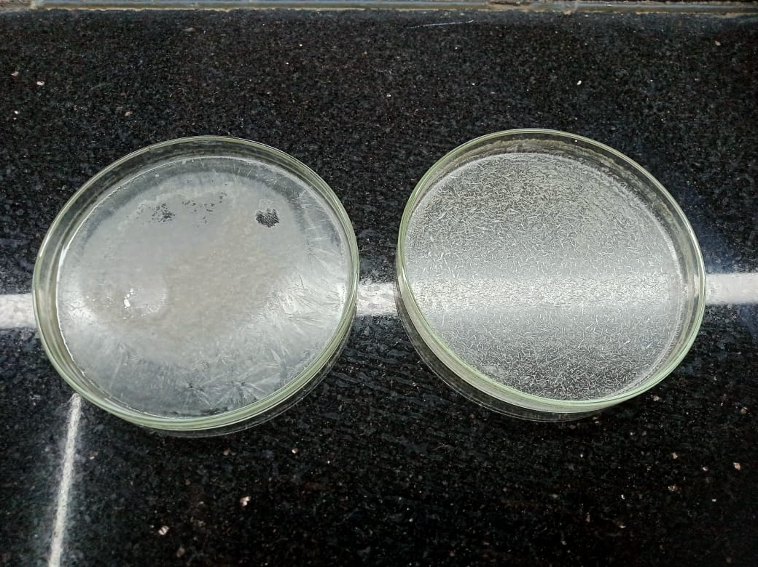

**Uses** :-

1.Atropine is used as a pain reliever and as a muscle relaxant .

2. Atropine is used as a Anti – inflammatory and use in a treatment of a cough .

3. Atropine act by interfearing with the transmission nerve impulse by Acetylcholine .

4. Atropine is suitable for a gastrointestinal problems i.e. abnormal intestinal motility,bile

Stone, and irritable bowel disease.

5. Atropine is used as a antidote in a opium and chloroform poisoning.

6. Ophthalmologist use atropine to dilate patient pupil for eye examination.

**Marketed preparations of Atropine:-**

