Extraction and Isolation
The extraction of alkaloids is based on their basic character and solubility pattern. The general scheme for extraction is shown in Fig. 6. Extraction is usually served by one of the following general methods; 1. The plants are defatted with petroleum ether, especially in case of seeds and leaves to remove the fat soluble constituents and then with polar solvents. The extract is concentrated under reduced pressure and treated with alkali so that the free bases convert in their salts and separated with organic solvents. This process is known as Stas-Otto process. This method is frequently used in the extraction of ergotamine (Kokate et al., 2005) from ergot.
2. The powdered material is moistened with water and mixed with lime, which combines with acids, tannins and other phenolic substances and sets free the alkaloid salts. Extraction is then carried out with organic solvents such as ether or petroleum sprit. The concentrated organic liquid is then shaken with aqueous acid and allowed to separate. Alkaloid salts are now in aqueous liquid, while many impurities remain behind in the organic liquid.
3. The powdered material is extracted with polar solvents such as water or aqueous alcohol containing dilute acid. Pigments and other unwanted materials are removed by shaking with chloroform or other organic solvents. The free alkaloids are then precipitated by the addition of excess sodium bicarbonate or ammonia and then separated by filtration or by extraction with organic solvents.
4. The extract is treated with ammonia so as to convert the alkaloid salts into their free bases. Such liberated alkaloids in free base form are conveniently extracted with organic solvents like ether, benzene, chloroform etc. This method is not useful for the isolation of alkaloids of quaternary nitrogen.
5. The alkaloids present in the extract are converted into their reineckates by treating with H[Cr(NH3)2(SCN)4] (Reinecke’s solution). The product is then dissolves in acetone and then passed this solution through an ion exchange column which afforded the alkaloids in a high state of purity.
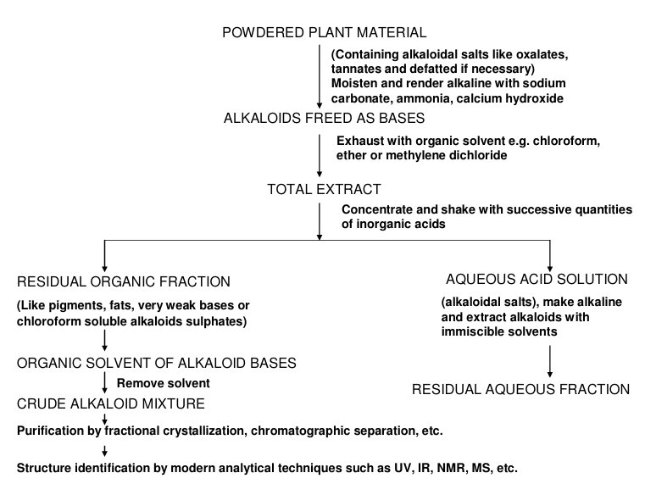
Further purification of crude extract of alkaloids is done by following ways, which may, however vary for individual alkaloid.
1. Direct crystallization from solvent: It is a simple method of isolation in which the alkaloids crystallise directly by fractionation process and may not be useful in case of complex mixtures.
2. Steam distillation: This method is specially employed for volatile liquid alkaloids like coniine, sparteine and nicotine. However this method is not suitable for alkaloids of high molecular weights. In this method, the aqueous extract is made alkaline with caustic soda or sodium carbonate and then alkaloids are distilled off in steam.
3. Gradient pH technique: There is variation in the extent of basicity of various alkaloids of same plant. On the basis of this property, the crude alkaloid mixture is dissolved in 2% tartaric acid solution and extracted with benzene so that the first fraction contains neutral and/or very weakly basic alkaloids. The pH value of the aqueous solution is increased gradually by 0.5 increments to pH 9 and extraction is carried out at each pH with organic solvents. By this way, the alkaloids of different basicity are extracted and strongly basic alkaloids extracted at the end.
4. Chromatographic techniques: Chromatography is an ideal method for separation of a vast number of alkaloids. The separation of alkaloids carried out by using stationary and mobile phase of different organic solvents. The different techniques of chromatography used for separation of individual alkaloid from complex mixture are as following; a. Paper chromatography (PC): This technique is simplest and most widely used among other chromatographic techniques because of its applicability to isolation, identification and some times quantitative determination of all type of natural products. It is a partition as well as an absorption type technique, in which the mobile phase is either individual or mixture of organic solvents and the stationary phase is hydrophilic surface of paper. The choice of the solvent used to run a chromatogram depends upon the nature of alkaloid. Usually non polar solvents like benzene/ acetone/ water are commonly used for separation of non polar alkaloids and polar solvents like butanol/ acetic acid/ water used for separation of polar alkaloids. Both one and two dimensional ascending and descending, some times horizontal chromatographic techniques applied using Whatman filter paper sheet of various types i.e. No.1, 2, 3 etc. The paper sheet is washed with 5% 2N HCl to remove the impurities before starts the separation. The paper is visualised under UV light.of long wavelength or spread with iodoplatinate reagent in the form of coloured spots. The Rf values and colour appearance of spots on paper sheet are useful in preliminary identification of alkaloids by this technique. b. Thin layer chromatography (TLC): TLC is an important tool extensively used for identification, separation and determination of the purity of isolated alkaloid. Although TLC method is used in qualitative analysis but it having a great importance in quantitative analysis also (Oswald and Fluck, 1964; 1964). The TLC separation of alkaloids can be performed on silica gel, alumina, cellulose powder or kieselguhr. Silica gel is the most active stationary phase and good separation is achieved even when several milligrams substance applied. This method is also used for preparative separation of alkaloids (Tschesche et al., 1963). In TLC, the substances are identified preliminary on the basis of their mobility in suitable solvent system and moreover on the basis of their reaction with selective or specific detection reagents or on the basis of their absorption or fluorescence in UV light Developed TLC plate is sprayed by several visualizing reagents for detection of alkaloids. Many alkaloids can be seen on the chromatogram even in daylight and a large number yield typical fluorescence colours in UV light (365 nm). The reagents most commonly used for detecting alkaloids are Dragendorff reagent, acidified iodine- iodine solution, iodoplatinate, antimony (III)chloride, cerium sulphate in sulphuric acid and cerium sulphate in phosphoric acid. Papaverrubine type alkaloids give a red spot with hydrogen chloride vapour, Rauwolfia alkaloids give colour with mixture of ferric chloride and perchloric acid and also with iodine vapour, phenylalkylamines are visualised with ninhydrin. Beside these reagents, cinnamaldehyde hydrochloric acid for indole alkaloids, sulphuric acid for purine bases and betaines and the van Urk reagent for ergot alkaloids are often used.
Preparative TLC: In this method, comparatively thicker layer of adsorbent are employed for preparative work and the separated bands of compounds are scraped from the plate and subjected to solvent extraction. This technique generates sufficient quantity of material for complete spectral analysis. Preparative TLC was performed for cryptopleurine and piperidylacetophenone (Al Shamma et al., 1982) on 1 mm thick commercial plates precoated with Al2O3 GF-254 developing with ammoniated CHCl3 and determined the Rf values. c. Column chromatography (CC): This method is very popular and used extensively for quantitative separation and purification of different natural products from crude plant extract or mixture. Column of different size and dimensions are used for separation. Choice of stationary phase (adsorbents) and mobile phase (organic/ inorganic solvents) is based on the nature of components present in the crude extract. A large number of adsorbents are available which can be used in the column chromatography, some being better for one type of components and some for others. For the separation of alkaloid, silica gel (Yinggang et al., 2003; Roumy et al., 2006) and neutral alumina (Hart et al., 1968) are extensively used. Beside these, some more adsorbents are kieselguhr, silicates (magnesium/calcium silicate), tricalcium phosphate, calcium sulphate, glass power, salts of heteropoly- tungstic, molybdic and tetraboric acids, ferric and chromic oxides, zinc carbonate/ ferrocyanide, charcoal, zirconium phosphate, hydrous zirconium oxide, lanthanum oxide, bentonites, cellulose powder (including acetylated, ion exchanger), starch, sucrose, mannitol, dextran gels (sephadex), polyamides etc. Eluotropic solvents used in column chromatography, in order of increasing polarity are petroleum ether, n-hexane, cyclohexane, carbon tetrachloride, trichloro ethylene, benzene, dichloromethane, chloroform, diethyl ether, diethyl formamide, ethyl acetate, pyridine, n-propanol, ethanol, methanol, formamide and water. Polarity and composition of solvents is depending upon the nature of compound to be eluted i.e. non-polar compounds elutes with non polar solvents whereas polar compounds elutes with polar solvents. Polarity is changed by observing the mobility of the compounds to be elutes.
d. Gas liquid chromatography (GLC): Gas chromatography separates volatile substances by percolating a gas stream over a stationary phase. It can be applied to almost any type of compound 25 which has reasonably volatility and stable under the chromatographic conditions. GLC is the most selective and versatile form of gas chromatography, since there exists a wide range of liquid phases usable upto 4500C. This method is applicable for the examination of alkaloids of opium, tobacco, coniine and belladonna. Modification of the sample structure may be accomplished by derivatisation and the most widely applied general derivatisation is silylation. The compound containing labile functional groups viz. alcohols, amines, carboxylic acids and thiols are converted into corresponding silylamines, esters and thioesters. The common derivatising agents used in GLC are trimethylchlorosilane, hexamethyldisilazone and N, O-bis-trimethylacetamide. e. High performance thin layer chromatography (HPTLC): This method is very useful in both qualitative and quantitative analysis. It is a major advancement of TLC, which requires shorter time, saving reagents and better resolution. The basic difference between conventional TLC and HPTLC is only in particle and pore size of the sorbents. The linear development method is most familiar technique in HPTLC. The analytical profiles for tropine alkaloids and several other natural products i.e. flavonoids and steroids have been developed using this technique. HPTLC is conveniently applied for compilation of profiles pertaining to varied range of bioactive constituents such as berberine, quinine, opium alkaloids, colchicines, chelidonine, sanguinarine, serpentine, raubasine, asarone, elemicine, eugenol, thymole coumarine, pulegon, flavones, diosgenin, silymarin, catechin, anthraquinone derivatives, gibberellins, antibiotics and number of other compounds of natural origin. Using external standards, the detection limits of bulaquine, chloroquine, and primaquine by HPTLC (Saxena et al., 2003) on silica plates were 0.25, 0.59 and 0.53 µg respectively while the lower limits of quantification were 0.52, 1.21 and 1.07 µg respectively with detection wavelength at 254 nm. The separation was achieved on precoated Silica gel 60 F254 (20×20 cm, 0.2 mm) plates using n-hexane/ diethyl ether/ methanol/ diethylamine (37.5:37.5:25:0.5, v/v) as solvent system. HPTLC is a sophisticated and automated form of TLC. f. High performance liquid chromatography (HPLC): In HPLC method, the separation of one component from another is based upon their absorption of UV light and the functional group interaction with the analytical column substrate. The amount of caffeine in a sample of coffee may be determined to a high degree of accuracy using HPLC techniques. It has become the most versatile, safest, dependable, fastest and sensitive chromatographic technique for the quantitative and qualitative analysis of natural as well as synthetic compounds. The alkaloids like morphine, papaverine, codeine, emetine, antibiotics, ergot alkaloids etc. can be analysed by HPLC. Since the 26 time of its invention in 1966 by Horvath and Lipsky, several natural products including several antibiotics (Cooper et al., 1973; Buhs et al., 1974; Wold et al., 1977) has been determined qualitatively as well as quantitatively successfully. Chloroquine, primaquine and bulaquine has resolved (Saxena et al., 2003) with the help of HPLC without no interference with retention times of 4.22, 5.72 and 17.26 min respectively by using RP C8 lichrospher 25 x 0.4 cm, 5µ column and the solvent was acetonitrile: sodium acetate buffer (pH 5.6) in ratio of 55:45 with detection wavelength 265 nm. The profile of berberine bridge enzyme catalyzed transformation of (S)-reticulin to (-) scoulerine (Winkler et al., 2006) was carried out at four different time to determine the reaction progress. The series of common solvents used in this technique with relative decreasing order of polarity is acetic acid, ethylene glycol, glycerol, formamide, acetic anhydride, furfural, acetonitrile, methanol, ethanol, dimethyl formamide, propanol, iso-propanol, methyl ethyl ketone, butanol, cyclohexanol, pyridine, diethyl sulfoxide, methyl acetate, ethyl acetate, dioxane, tetrahydrofuran and chloroform.

