Streptococcus
Streptococci are Gram positive cocci arranged in chains or pairs (Fig. 23.1). They are part of the normal flora of humans and animals. Some ofthem are human pathogens. The most important ofthem is Streptococcus pyogenes causing pyogenic infections, with a characteristic tendency to spread, as opposed to staphylococcal lesions which are typically localised. It is also responsible for the nonsuppurative lesions, acute rheumatic fever and glomerulonephritis which occur as sequelae to infection. Cocci in chains were first seen in erysipelas and wound infections by Billroth (1874), who called them streptococci (streptos, meaning twisted or Fig. 23.1 Streptococci coiled). Ogston (1881) isolated them from acute abscesses, distinguished them from staphylococci and established their pathogenicity by animal inoculation. Rosenbach (1884) isolated the cocci from human suppurative lesions and gave them the name Streptococcus pyogenes.
CLASSIFICATION
- Several systems of classification have been employed but in medical bacteriology the following method is useful (Fig. 23.2).
- Streptococci are first divided into obligate anaerobes and facultative anacrobes.
- The former are designated peptostreptococci and are considered in a later chapter.
- The aerobic and facultative anaerobic streptococci are classified on the basis of their hemolytic properties.
- Brown (1919) categorised them into three varieties based on their growth in 5% horse blood agar pour plate cultures.
- Alpha (x) hemolytic streptococci produce a greenish discolouration with partial hemolysis around the colonies.
- The zone of lysis is small (1 or 2 mm wide) with indefinite margins, and unlysed erythrocytes can be made out microscopically within this zone.
- These are known as 'viridans streptococci' or Streptococcus viridans (from 'viridis' meaning green).
- The alpha streptococci are normal commensals in the throat, but may cause opportunist infections rarely.
- Pnemococcus (Str. pneumoniae) is also an alpha hemolytic streptococcus. Beta (ẞ) hemolytic streptococci produce a sharply defined, clear, colourless zone of hemolysis, 2-4 mm wide, within which red cells are completely lysed.
- The term 'hemolytic streptococci' strictly applies only to beta lytic strains. Most pathogenic streptococci belong to this group.
- Gamma (y) or nonhemolytic streptococci produce no change in the medium and so are sometimes referred to as 'indifferent streptococci'.
- They include the fecal streptococci (enterococci, Str. faecalis) and related species. They are called the 'enterococcus group'.
- Hemolytic streptococci were classified by Lancefield (1933) serologically into groups based on the nature of a carbohydrate (C) antigen on the cell wall.
- These are known as Lancefield groups, twenty of which have been identified so far and named A-V (without I and J).
- The great majority of hemolytic streptococci that produce human infections belong to group A.
- Hemolytic streptococci of group A are known as Str. pyogenes. These may be further subdivided into types based on the protein (M, T and R) antigens present on the cell surface (Griffith typing). About eighty types of Str. pyogenes have been recognised so far (types 1, 2, 3 and so on). Table below shows the medically important streptococci and their characteristics.

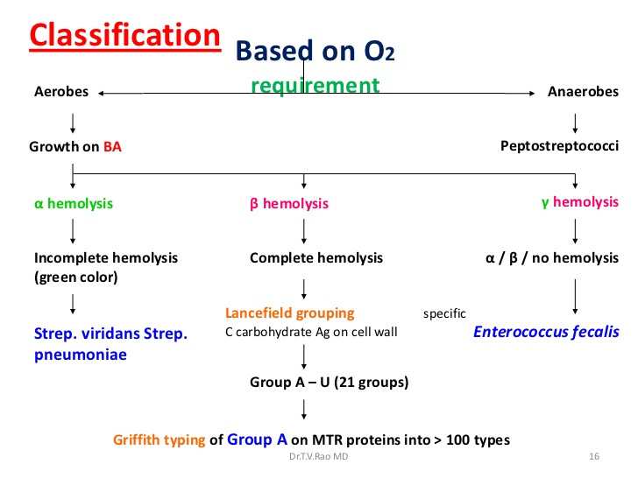

STREPTOCOCCUS PYOGENES
Morphology:
The individual cocci are spherical or oval 0.5-1.0 µm in diameter.
Size variations result from cultural conditions, for example, when grown anaerobically, they are somewhat smaller.
They are arranged in chains, the length of which varies within wide limits and is influenced by the nature of the culture medium, chains being longer in liquid than in solid media.
Chain formation is due to the cocci dividing in one plane only and the daughter cells failing to separate completely.
There is often an appearance of pairing within the chains. Significance was once attached to the length of the chains, and streptococci had been classified accordingly (Str. longus and brevis) but this has no relevance to virulence or other properties. In fact, some nonpathogenic streptococci form the longest chains, for example, Str. salivarius.Streptococci are nonmotile and nonsporing. S
ome strains of Str. pyogenes and some group C strains have capsules composed of hyaluronic acid, while polysaccharide capsules are encountered in members of group B and D. These capsules are best seen in very young cultures.

Cultural characteristics:
It is an aerobe and a facultative anaerobe, growing best at a temperature of 37°C (range 22-42 °C). It is exacting in nutritive requirements, growth occurring only in media containing fermentable carbohydrates or enriched with blood or serum. On blood agar,after incubation for 24 hours, the colonies are small (0.5-1.0 mm) circular, semitransparent, low convex discs with an area of clear hemolysis around them. Growth and hemolysis are promoted by 10 per cent CO,. Virulent strains, on fresh isolation from lesions, produce a 'matt' (finely granular) colony, while avirulent strains form 'glossy' colonies. Strains with well marked capsules produce 'mucoid' colonies, corresponding in virulence to the matt type. Very rarely, nonhemolytic group A streptococci are encountered, which are typical of Str. pyogenes in other respects. In liquid media, such as glucose or serum broth, growth occurs as a granular turbidity with a powdery deposit. No pellicle is formed.

Biochemical reactions:
Streptococci ferment several sugars producing acid but no gas. Streptococci are catalase negative. They are not soluble in 10 per cent bile, unlike pneumocoсcі. Hydrolysis of pyrrolidonyl naphthylamide (PYR test) and failure to ferment ribose are useful in differentiating Str. pyogenes from other streptococci.

Resistance:
Str. pyogenes is a delicate organism, easily destroyed by heat (54 °C for 30 minutes). It dies in a few days in cultures, unless stored at a low temperature (4 °C), preferably in Robertson's cooked meat medium. It can, however, survive in dust for several weeks, if protected from sunlight. It is rapidly inactivated by antiseptics. It is more resistant to crystal violet than many bacteria, including Staph. aureus. Crystal violet (1 mg/L), nalidixic acid (15 mg/L) and colistin sulphate (10 mg/L) added to blood agar provide a good selective medium for the isolation of streptococci, including pneumococci. It is susceptible to sulphonamides and many antibiotics but unlike Staph. aureus does not develop resistance to drugs. Sensitivity to bacitracin is employed as a convenient method for differentiating Str. pyogenes from other hemolytic streptococci.

Antigenic structure: Fig. 23.3 illustrates the disposition ofthe various antigens in Str. pyogenes. The capsule when present inhibits phagocytosis. It is not antigenic in human beings. The cell wall is composed of an outer layer of protein and lipoteichoic acid, a middle layer of group specific carbohydrate and an inner layer of peptidoglycan. The peptidoglycan (mucoprotein) is responsible for cell wall rigidity. It has also some biological properties such as pyrogenic and thrombolytic activity. Serological grouping of streptococci depends on the C carbohydrate. Str. pyogenes belongs to group A. As this antigen is an integral part of the cell wall, it has to be extracted for grouping by a precipitation test with group antisera. For the test, streptococci are grown in Todd-Hewitt broth and extracted with hydrochloric acid (Lancefield's acid extraction method), or formamide (Fuller's method) or by an enzyme produced by Streptomyces albus (Maxted's method) or by autoclaving (Rantz and Randall's method). The extract and the specific antisera are allowed to react in capillary tubes. Precipitation occursrs within five minutes at the interface between the extract and the homologous antiserum. Grouping may also be done by agar gel precipitation. Several protein antigens have been identified in the outer part of the cell wall. Str. pyogenes can be typed, based on the surface proteins M, T and R. The M protein is the most important of these. It acts as a virulence factor by inhibiting phagocytosis. It is antigenic. The antibody to M protein promotes phagocytosis of the coccus and is therefore protective. The M protein is heat and acid stable but susceptible to tryptic digestion. It can be extracted by the Lancefield acid extraction method and typing is done with type specific sera. About 80 M protein types have been recognised. The T protein is an acid labile, trypsin resistant antigen present in many serotypes of Str.pyogenes. It may be specific but many different M types possess the same T antigen. It is usually demonstrated by the slide agglutination test using trypsin-treated whole streptococci. Some types of Str. pyogenes (types 2, 3, 28 and 48) and somestrains of groups B, C and G contain a third antigen, the R protein. The T and R proteins have no relation to virulence. A nontype-specific protein, associated with the M protein, has been identified. This is known as M associated protein (MAP). Hair-like pili (fimbria) project through the capsule of group A streptococci. The pili consist partly of M protein and are covered with lipoteichoic acid which is important in the attachment of streptococci to epithelial cells. Various structural components of Str. pyogenes exhibit antigenic cross reaction with different tissues ofthe human body. Antigenic relationships have been demonstrated between capsular hyaluronic acid and human synovial fluid, cell wall protein and myocardium, group A carbohydrate and cardiac valves, cytoplasmic membrane antigens and vascular intima, and peptidoglycans and skin antigens. It has been postulated that these antigenic cross reactions may account for some of the manifestations of rheumatic fever and other streptococcal diseases, the tissue damage being of an immunological nature.

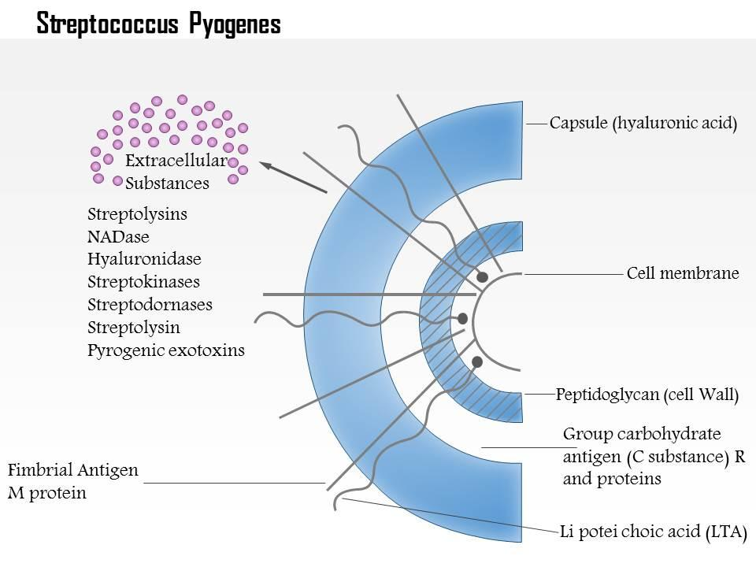
Toxins and other virulence factors:
Str. pyogenes forms several exotoxins and enzymes which contribute to its virulence. Besides these, the M protein also acts as a virulence factor by inhibiting phagocytosis. The C polysaccharide has been shown to have a toxic effect on connective tissue in experimental animals.

Hemolysins
: Streptococci produce two hemolysins, streptolysin 'O' and 'S'. Streptolysin O is so called because it is oxygen labile. It is inactive in the oxidised form but may be reactivated by treatment with mild reducing agents. On blood agar, streptolysin O activity is seen only in pour plates and not in surface cultures. It may be obtained in the active state by growing streptococci in broth containing reducing agents such as sodium hydrosulphite. It is also heat labile. It appears to be important in contributing to virulence. It is lethal on intravenous injection into animals and has a specific cardiotoxic activity. It has leucotoxic activity also. In its biological action, streptolysin O resembles the oxygen labile hemolysins of Cl. perfringens, Cl. tetani and the pneumococcus. Streptolysin O is antigenic and antistreptolysin O appears in sera following streptococcal infection. Estimation ofthis antibody (ASO titre) is a standard serological procedure for the retrospective diagnosis of infection with Str. pyogenes. The lysin is inhibited by cholesterol but not by normal sera. Following certain chemical treatments or bacterial contamination, sera may develop inhibitory activity due to some changes in the lipoproteins. Such sera are unfit for the ASO test. Because of the complexity of the hemolysis inhibition test, ASO test is now done by the serological method of latex agglutination. An ASO titre in excess of 200 units is considered significant and suggests either recent or recurrent infection with streptococci. Streptolysin S and O are produced by groups A, C and G also.
Streptolysin S is an oxygen stable hemolysin and so is responsible for the hemolysis seen around streptococcal colonies on the surface of blood agar plates. It is called streptolysin S since it is soluble in serum. It is a protein but is not antigenic. Convalescent sera do not neutralise streptolysin S activity. It is inhibited nonspecifically by serum lipoproteins.

Pyrogenic exotoxin (Erythrogenic, Dick, scarlatinal toxin):
This toxin was named 'erythrogenic' because its intradermal injection into susceptible individuals produced an erythematous reaction (Dick test, 1924). This test was used to identify children susceptible to scarlet fever, a type of acute pharyngitis with extensive erythematous rash, caused by the Str. pyogenes strains producing this toxin. Blanching of the rash on local injection of convalescent serum was used as a diagnostic,test for scarlet fever (Schultz Charlton reaction, 1918).The Dick test and Schultz Charlton reaction are now only of historical value as scarlet fever is no longer a common or serious disease. The primary effect of the toxin is induction of fever and so it was renamed Streptococcal pyrogenic exotoxin (SPE). Three types of SPE have been identified SPE A,B and C. Types A and C are coded for by bacteriophage genes, while type B gene is chromosomal. SPEs are 'superantigens' (like staphylococcal enterotoxins and TSS toxin), T cell mitogens which induce massive release of inflammatory cytokines causing fever, shock and tissue damage.

Streptokinase (fibrinolysin): This toxin promotes the lysis ofhuman fibrin clots by activating a plasma procursor (plasminogen). It is an antigenic protein and neutralising antibodies appear in convalescent sera. Anti-streptokinase antibody provides retrospective evidence of streptococcal infection. Fibrinolysin appears to play a biological role in streptococcal infections by breaking down the fibrin barrier around the lesions and facilitating the spread of infection. Streptokinase is given intravenously for the treatment of early myocardial infarction and other thromboemboloic disorders.

Deoxyribonucleases (Streptodornase, DNAase): These cause depolymerisation of DNA. Pyogenic exudates contain large amounts of DNA, derived from the nuclei of necrotic cells. Streptodornase helps to liquefy the thick pus and may be responsible for the thin serous character of streptococcal exudates. This property has been applied therapeutically in liquefying localised collections of thick exudates, as in empyema. A preparation containing streptokinase and streptodornase is available for this purpose. Four antigenically distinct DNAases, A,B, C and D, have been recognised, of which type B is the most antigenic in human beings. Demonstration of antiDNAase B antibody is useful in the retrospective diagnosis of Str. pyogenes infection, particularly in skin infections, where ASO titres may be low. Streptodornase B and D also possess ribonuclease activity. Nicotinamide adenine dinucleotidase (NADase, formerly diphosphopyridine nucleotidase, DPNase): This acts on the coenzyme NAD and liberates nicotinamide from the molecule. It is antigenic and is specifically neutralised by the antibody in convalescent sera. The biological significance of NADase is not known, though it is believed to be leucotoxic. Hyaluronidase: This enzyme breaks down the hyaluronic acid of the tissues. This might favour the spread of infection along the intercellular spaces. Streptococci possess a hyaluronic acid capsule and also elaborate a hyaluronidase-a seemingly selfdestructive process. It is, however, found that strains that form hyaluronidase in large quantities (M types 4 and 22) are noncapsulated. The enzyme is antigenic and specific antibodies appear in convalescent sera. Serum opacity factor: Some M types of Str. pyogenes produce a lipoproteinase which produces opacity when applied to agar gel containing horse or swine serum. This is known as serum opacity factor (SOР). Many strains also produce proteinase,phosphatase, esterases, amylase, N acetyl glucosaminidase, neuraminidase and other toxins or enzymes. It is not known whether, and to what extent, these contribute to pathogenesis.

PATHOGENICITY: Str. pyogenes produces pyogenic infections with a tendency to spread locally, along lymphatics and through the bloodstream. Respiratory infections: The primary site of invasion of the human body by Str. pyogenes is the throat. Sore throat is the most common of streptococcal diseases. It may be localised as tonsillitis or may involve the pharynx more diffusely (pharyngitis). Virulent group A streptococci adhere to the pharyngeal epithelium by means of lipoteichoic acid covering the surface pili. The glycoprotein fibronectin on the epithelial cells probably serves as the lipoteichoic acid ligand. Tonsillitis is more common in older children and adults than in younger children, who commonly develop diffuse pharyngitis. Localisation is believed to be favoured by hypersensitivity due to prior contact. From the throat, streptococci may spread to the surrounding tissues, leading to suppurative complications, such as otitis media, mastoiditis, quinsy, Ludwig's angina and suppurative adenitis. It may rarely lead to meningitis. Streptococcal pneumonia seldom follows throat infection but may occur as a complication of influenza or other respiratory viral diseases. Skin and soft tissue infections: Str. pyogenes causes a variety of suppurative infections of the skin, including infection ofwounds or burns, with a predilection to produce lymphangitis and cellulitis. Infection of minor abrasions may at times lead to fatal septicemia. The two typical streptococcal infections of the skin are erysipelas and impetigo. The former is a diffuse infection involving the superficial lymphatics. The affected skin, which is red, swollen and indurated, is sharply demarcated from the surrounding healthy area. While erysipelas is rare and seen only in older patients, impetigo is found mainly in young children. Impetigo is caused by Str. pyogenes belonging to a limited number of serotypes, usually the higher numbered M types, instead ofthe lower numbered M types which cause throat infections. Impetigo and streptococcal infection of scabies lesions arere the main causes leading to acute glomerulonephritis in children in the tropics. In pyoderma, antibody response to streptolysin O is not high and ASO estimation does not have as much clinical significance as in pharyngeal infections. Antibody to DNAase B and hyaluronidase are more useful in retrospective diagnosis of pyoderma antecendent to acute glomerulonephritis. Streptococcal subcutaneous infections range from cellulitis to necrotising fasciitis. The latter condition is more commonly caused by a mixed aerobic and anaerobic bacterial infection but some strains of Str. pyogenes (more particularly M types 1 and 3 strains forming pyrogenic exotoxin A) may alone be responsible. This is ordinarily a sporadic condition and has been known since 1883 but small outbreaks in the UK and the USA have recently caused much alarm because of their severity and high fatality. These strains have earned notoriety under the name 'flesh eating bacteria'. In such cases, extensive necrosis of subcutancous and muscular tissues and adjacent fascia is associated with a severe systemic illness-a toxic shock-like syndrome with disseminated intravascular coagulation and multiple system failure. Str. pyogenes can be isolated from the affected site and rising titres of antistreptolysin and anti-DNAase B demonstrated. Though the isolates are penicillin sensitive in vitro, treatment with penicillin may not be effective. Vancomycin is the drug of choice in life threatening infections. Soft tissue infections with some M types of Str. pyogenes (1, 3, 12, 28) may sometimes cause a toxic shock syndrome resembling staphylococcal TSS. Streptococcal TSS and necrotising fasciitis occur only in persons nonimmune to the infecting M types.
Genital infections: Both aerobic and anaerobic streptococci are normal inhabitants of the female genitalia. Str. pyogeneswas an important cause of puerperal sepsis, with the infection usually being exogenous. The emphatic demonstration by Semmelweis in 1847 that hospital outbreaks of puerperal fever could be prevented by the simple measure of handwashing by those attending the labour wards remains a landmark in clinical microbiology. Puerperal fever is now much more commonly due to endogenous infection with anaerobic streptococci. Streptococcal puerperal sepsis used to take a heavy toll of life before antibiotics became available

Other suppurative infections: Str. pyogenes may cause abscesses in internal organs such as the brain, lungs, liver and kidneys, and also septicemia and pyemia.

Nonsuppurative complications: Str. pyogenes infections lead to two important nonsuppurative sequelae acute rheumatic fever and acute glomerulonephritis. These complications ensue 1-3 weeks after the acute infection so that the organism may not be detectable when sequelae set in. They differ in their natural history in a number of respects.
The pathogenesis of these complications is not clearly understood.The essential lesion in rheumatic fever is carditis, including connective tissue degeneration of the heart valves and inflammatory myocardial lesions characterised by Aschoff nodules. Typically,rheumatic fever follows persistent or repeated streptococcal throat infections with a strong antibody response. The lesions are believed to be the result of hypersensitivity to some streptococcal component. It has also been suggested that there may be an element of autoimmunity involved, and antigenic cross-reactions have been demonstrated between streptococci and heart tissues. Lesions resembling rheumatic fever have been produced experimentally in rabbits by repeated
infection with Str. pyogenes and in mice by injection of sonic lysates of the cocci. While rheumatic fever may follow infection with any serotype of Str. pyogenes, nephritis is caused by only a few 'nephritogenic' types. In the tropics, skin infections are perhaps more important in this respect than throat infections. The nephritis is usually a self-limited episode that resolves without any permanent damage. The pathogenesis may be due to antigenic cross-reactions between the glomerular membrane antigen and cell membranes of nephritogenic streptococci, or more often it may be an immune complex disease. This condition has been produced in monkeys and rabbits by repeated infection with type 12 Str. pyogenes or injection of bacterial products, and in mice with soluble streptococcal products. Epidemiology: The major source of Str. pyogenes is the human upper respiratory tract - throat, nasopharynx or nose - of patients and carriers. Carrier rates of up to 20 per cent have been observed. Symptomless infection is common and helps to maintain the organism in the community. Transmission of infection is either by direct contact or through contaminated fingers, dust or fomites. In the tropics, streptococcal infection of the skin is common and may be spread by nonbiting insects, particularly the eye gnat Hippelates. Streptococcal infections of the respiratory tract are more frequent in children 5-8 years of age than in children below two years or in adults. They are more common in winter in the temperate countries. No seasonal distribution has been identified in the tropics. Crowding is an important factor in the transmission of infection. Outbreaks of infection may occur in closed communities such as boarding schools or army camps. Immunity is type specific and appears to be associated with antibody to the M protein. Reinfections occur because of the multiplicity of serotypes.

Laboratory diagnosis: In acute infections,diagnosis is established by culture, while in the nonsuppurative complications, diagnosis is mainly based on the demonstration of antibodies. Presumptive information may be obtained by an examination of Gram stained films from pus and CSF. The presence of Gram positive cocci in chains is indicative of streptococcal infection. However, smears are of no value in infections ofthe throat or genitalia, where streptococci may form part of the resident flora. For cultures, swabs should be collected under vision from the affected site and either plated immediately or sent to the laboratory in Pike's medium (blood agar containing 1 in 1,000,000 crystal violet and 1 in 16,000 sodium azide). The specimen is plated on blood agar and incubated at 37 °C anaerobically or under 5-10% CO₂, as hemolysis develops better under these conditions. Sheep blood agar is recommended for primary isolation because it is inhibitory for Haemophilus haemolyticus, colonies of which may be confused with those of hemolytic streptococci. Hemolytic streptococci are grouped by the Lancefield technique. The fluorescent antibody technique has been employed for the rapid identification of group A streptococci. A convenient method for the identification of Str. pyogenes is based on Maxted's observation that they are more sensitive to bacitracin than other streptococci. A filter paper disc dipped Acute glomerulonephritis Throat or skin Not necessary Pyodermal types 49, 53-55, 59-61 and pharyngitis strains 1 and 12 Moderate Lowered Not known Absent Not indicated Spontaneous resolution Good in a solution ofbacitracin (1 unit/ml) is applied on the surface of an inoculated blood agar. After incubation, a wide zone of inhibition is seen with Str. pyogenes but not with other streptococci. Typing of Str. pyogenes is required only for epidemiological purposes. If required, this may be done by precipitation or agglutination. Rapid diagnostic test kits for the detection of streptococcal group A antigen from throat swabs are available commercially. The tests can be completed in 1-4 hours and are nearly as specific as cultures, though less sensitive. In rheumatic fever and glomerulonephritis, a retrospective diagnosis of streptococcal infection may be established by demonstrating high levels of antibody to streptococcal toxins. The usual test done is antistreptolysin O titration. ASO titres higher than 200 are indicative of prior streptococcal infection. High levels are usually found in acute rheumatic fever but in glomerulonephritis, titres are often low. Antideoxyribonuclease B (antiDNAase B) estimation is also commonly employed. Titreshigher than 300 are taken as significant. AntiDNAase B and antihyaluronidase tests are very useful for the retrospective diagnosis of streptococcal pyoderma, for which ASO is of much less value. The streptozyme test, a passive slide hemagglutination test using erythrocytes sensitised with a crude preparation of extracellular antigens Copyrighted material Streptococcus▸ 211 of streptococci, is a convenient, sensitive and specific screening test. It becomes positive after nearly all types of streptococcal infections, whether of the throat or the skin. Prophylaxis: The indication for prophylaxis in streptococcal infection is only in the prevention of rheumatic fever. This is achieved by a long-term administration of penicillin in children who have developed carly signs of rheumatic fever. This prevents streptococcal reinfection and further damage to the heart. Antibiotic prophylaxis is not useful for glomerulonephritis as this complication follows a single streptococcal infection, and reinfections do not occur. Treatment: All beta hemolytic group A streptococci are sensitive to penicillin G, and most are sensitive to erythromycin. In patients allergic to penicillin, erythromycin or cephalexin may be used. Strains resistant to erythromycin have been reported. Tetracylines and sulphonamides are not recommended. Antimicrobial drugs have no effect on established glomerulonephritis and rheumatic fever.

