PODOPHYLLUM HEXANDRUM

Podophyllum hexandrum, also known as Indian Podophyllum or Himalayan Mayapple, is a high-altitude medicinal plant of the Himalayas renowned for its high concentration of podophyllotoxin, an important precursor for anticancer drugs.
Synonyms
- Botanical: Podophyllum emodi Wall., Sinopodophyllum hexandrum (Royle) T.S. Ying.
- Common/Local: Indian Podophyllum, Himalayan Mayapple, Bankakri (Hindi/Urdu), Papra (Unani), Aindri, Wun-wangan (Kashmiri).
Biological Source
It consists of the dried rhizomes and roots of Podophyllum hexandrum Royle. It belongs to the family Berberidaceae.
Geographical Source
It is native to the Himalayan regions, found at altitudes ranging from 2000 to 4500 meters. Its distribution spans across India (Kashmir, Himachal Pradesh, Sikkim), Nepal, Bhutan, Pakistan, Afghanistan, and China.
Cultivation and Collection
- Habitat: Prefers temperate, sub-alpine regions with cold climates, high snowfall, and dry summers.
- Propagation: Can be propagated by seeds or by division of rhizomes.
- Collection: Rhizomes from plants older than two years are typically collected in autumn (September to March).
- Drying: Rhizomes are dug out, washed, and dried in the sun or on wire nets above fires.
Macroscopy
- Appearance: Knotty, tortuous, and somewhat flattened cylindrical rhizomes with short internodes.
- Size: Rhizomes are 3–8 cm long and 1–2 cm thick.
- Colour: Earthy brown to yellowish brown externally; white to yellowish internally.
- Fracture: Short, horny, and starchy.
- Odour & Taste: Slight characteristic odour; bitter, acrid, and starchy taste.
Microscopy
- Epiblema: Single-layered, yellowish-brown cells, slightly projecting outwards with suberized walls.
- Exodermis: Single-layered with thin-walled smaller cells.
- Cortex: 18–22 layers of parenchymatous cells loaded with starch grains; typically lacks calcium oxalate crystals.
- Endodermis: Prominent single layer with Casparian strips.
- Vascular Bundles: Radial and alternate (4–9 groups) with exarch protoxylems.

Chemical Constituents

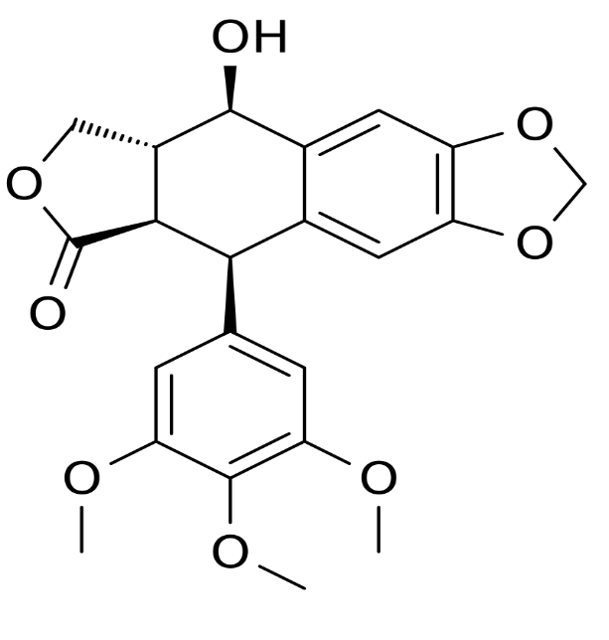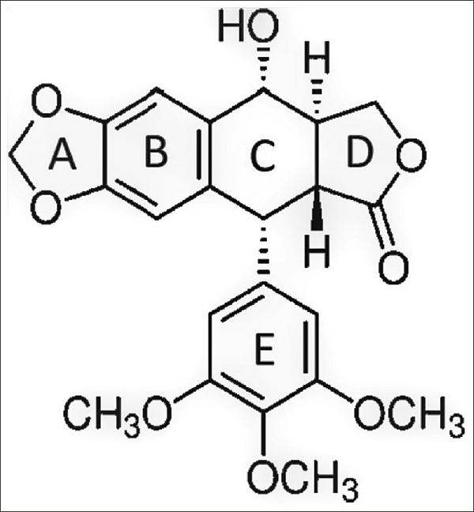
PODOPHYLLOTOXIN PODOPHYLLIN

- Resin (Podophyllin): Indian Podophyllum contains 7–16% resin, significantly higher than the American species (P. peltatum) which contains 2–8%.
- Lignans: The primary active principle is podophyllotoxin (up to 4–8% in Indian species). Others include 4'-demethylpodophyllotoxin, podophyllotoxone, and picropodophyllin.
- Flavonoids: Quercetin, kaempferol, astragalin.
- Other: Starch, essential oil (responsible for odour), and mineral salts.
Chemical Tests
- Alcoholic Extract + Copper Acetate: Macerate 0.5 g drug with 10 ml alcohol and filter; add strong copper acetate solution to produce a brown precipitate.
- KOH Test: Powdered drug in KOH solution forms a yellow solution that turns dark; acidifying with HCl causes precipitation of resin.
- Jelly Test: Shake 0.4 g powder with 2 ml ethanol and 0.5 ml KOH; standing results in a stiff jelly.
Uses
- Anticancer: Source of podophyllotoxin used to synthesize Etoposide and Teniposide for treating lung and testicular cancers and leukemias.
- Dermatological: Topical treatment for venereal warts (condyloma acuminata) and other skin warts.
- Gastrointestinal: Acts as a purgative, cholagogue (stimulates bile), and hepatic stimulant.
- Radioprotective: Shown to provide significant protection against radiation-induced damage.
- Others: Traditional use for fever, syphilis, and skin diseases like psoriasis.

Adulterants and Substitutes
- Adulterants: Rhizomes of A. latifolia and other Podophyllum species are common adulterants.
- Substitutes: Podophyllum peltatum (American Podophyllum) is used as a substitute but contains significantly lower podophyllotoxin and includes α- and β-peltatins, which are absent in P. hexandrum. Other potential substitutes include species from the genera Dysosma and Juniperus.
Extraction Process of Podophyllotoxin
The extraction of podophyllotoxin from Podophyllum hexandrum is complex because the compound exists within plant vacuoles as an inactive glucoside that must be activated by cytoplasmic enzymes.
- Conventional Methods:
  - Reflux Extraction: The most efficient traditional method, typically using methanol for approximately 4 hours, yielding up to 5.79% podophyllotoxin.
  - Hot Ethanol Percolation: Dried rhizome particles are percolated with warm ethanol, followed by a purification step.
  - Soxhlet Extraction: Dried and powdered plant material is extracted with methanol for about 5 to 8 hours at 60°C.
- Green & Innovative Technologies:
  - Subcritical Water Extraction (SWE): A green method using water at high pressure (4 MPa) and temperature (180°C). When combined with macroporous resin enrichment, it can achieve a recovery yield of 74.6%.
  - Ultrasound-Assisted Extraction (USAE): Uses sound waves to create cavitation bubbles that break down cell walls. Optimized conditions (e.g., 69.3% ethanol at 58.8°C for ~50 mins) provide high stability, allowing the extract to be stored for up to 6 days.

