NUTRITIONAL AND MEDICINAL VALUES OF MUSHROOMS

Summary of topic:
Edible mushrooms are globally valued for their nutraceutical and medicinal benefits, recognized as a future superfood due to their low-calorie, high-protein, and nutrient-rich profiles. Their fruiting bodies contain numerous beneficial metabolites. Submerged cultivation provides a reliable method for producing mycelium biomass and bioactive compounds. These metabolites offer various health benefits, including antioxidant, antimicrobial, anticancer, antidiabetic, anti-inflammatory, antiviral, and anti-COVID-19 effects. As protein demand rises, consumers are increasingly turning to mushrooms as a meat alternative.

Learning Outcomes:
By the end of the course/module, students will be able to:
- Identify Medicinal Mushrooms: Recognize and differentiate between commonly used medicinal mushrooms and their respective medicinal properties.
- Understand Active Compounds: Demonstrate knowledge of the key bioactive compounds in medicinal mushrooms, such as polysaccharides (e.g., beta-glucans), triterpenes, and phenols.
- Explain Mechanisms of Action: Understand and describe how medicinal mushrooms exert their therapeutic effects at the cellular and molecular levels, including immune modulation, antioxidant activity, and anti-inflammatory effects.
Learning Objectives:
• Introduction to Medicinal Mushrooms:
- Define medicinal mushrooms and their traditional uses in various cultures (e.g., Chinese, Japanese, and indigenous medicine).
- Identify the key species of medicinal mushrooms used in modern alternative medicine.
• Chemical Constituents of Medicinal Mushrooms:
- Explain the chemical compounds responsible for the medicinal properties of mushrooms, including polysaccharides, terpenoids, lectins, and other bioactive molecules.
• Health Benefits:
- Examine the immune-boosting properties of medicinal mushrooms, focusing on the role of beta-glucans in immune modulation.
- Discuss the antioxidant and anti-inflammatory properties and their relevance to chronic diseases like heart disease, cancer, and neurodegenerative conditions.
- Explore the potential cognitive-enhancing effects of mushrooms, especially in aging populations.

Introduction:
Nutritional values of Mushrooms:
Mushroom is considered to be a complete, healthy food and suitable for all age groups, child to aged people. The nutritional value of mushroom is affected by numerous factors such as species, stage of development and environmental conditions. Mushrooms are rich in protein, dietary fibres, vitamins and minerals. They comprise about eighty to ninety per cent of water, and eight to ten per cent of fiber. In addition to these, mushroom is an excellent source of vitamins especially C and B (Folic acid, Thiamine, Riboflavin and Niacin). Minerals viz., potassium, sodium and phosphorous are higher in fruiting bodies of the mushroom. It also contains other essential minerals (Cu, Zn, Mg) in traces but deficient in iron and calcium. The digestible carbohydrate profile of mushroom includes starches, pentoses, hexoses, disaccharides, amino sugars, sugar alcohols and sugar acids. The total carbohydrate content in mushroom varied from 26-82% on dry weight basis in different mushrooms. The crude fibre composition of the mushroom consists of partially digestible polysaccharides and chitin.
Edible mushrooms commonly have low lipid level with higher proportion of polyunsaturated fatty acids. All these resulted in low calorific yield from mushroom foods. Mushrooms do not have cholesterol. Instead, they have ergosterol that acts as a precursor for Vitamin-D synthesis in human body. The protein content of edible mushrooms is usually high, but varies greatly. The crude protein content of mushrooms varied from 12 – 35% depending upon the species. The free amino acids composition differs widely but in general they are rich in theronine and valine but deficient in sulphur containing amino acids (ethionine and cysteine). Nutritive values of different mushroom are given in Table 1.

Table 1: Nutritive values of different mushrooms (dry weight basis g/100g)

Mushroom | Carbohydrate | Fibre | Protein | Fat | Ash | Energy k cal
Agaricus bisporous | 46.17 | 20.90 | 33.48 | 3.10 | 5.70 | 499
Pleurotus sajor-caju | 63.40 | 48.60 | 19.23 | 2.70 | 6.32 | 412
Lentinula edodes | 47.60 | 28.80 | 32.93 | 3.73 | 5.20 | 387
Pleurotus ostreatus | 57.60 | 8.70 | 30.40 | 2.20 | 9.80 | 265
Vovarella volvaceae | 54.80 | 5.50 | 37.50 | 2.60 | 1.10 | 305
Calocybe indica | 64.26 | 3.40 | 17.69 | 4.10 | 7.43 | 391
Flammulina velutipes | 73.10 | 3.70 | 17.60 | 1.90 | 7.40 | 378
Auricularia auricula | 82.80 | 19.80 | 4.20 | 8.30 | 4.70 | 351

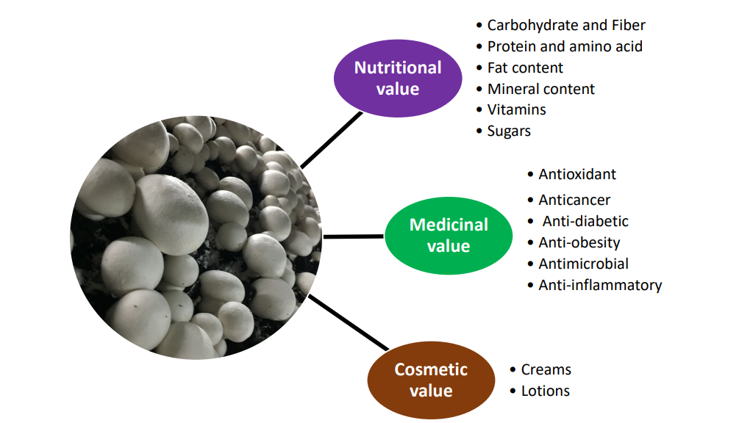

Figure 1. A summary of nutritional, medicinal, and cosmetic value of Agaricus bisporus.
Source: https://www.mdpi.com/2076-3417/11/13/5943
Medicinal values:
Since thousands of years, edible fungi have been revered for their immense health benefits and extensively used in folk medicine. Specific biochemical compounds in mushrooms are responsible for improving human health in many ways. These bioactive compounds include polysaccharides, tri- terpenoids, low molecular weight proteins, glycoproteins and immunomodulating compounds. Hence mushrooms have been shown to promote immune function; boost health; lower the risk of cancer; inhibit tumor growth; help balancing blood sugar; ward off viruses, bacteria, and fungi; reduce inflammation; and support the body's detoxification mechanisms. Increasing recognition of mushrooms in complementing conventional medicines is also well known for fighting many diseases. Medicinal values of the some important mushroom are given in Table 2.

Table 2: Medicinal values of some important mushrooms

Mushroom | Compounds | Medicinal properties
Ganoderma lucidum | Ganoderic acid  Beta-glucan | Augments immune system Liver protection  Antibiotic properties  Inhibits cholesterol synthesis
Lentinula edodes | Eritadenine Lentinan | Lower cholestrol Anti-cancer agent
Agaricus bisporous | Lectins | Enhance insulin secretion
Pleurotus sajor-caju | Lovastatin | Lower cholesterol
Ganoderma frondosa | Polysaccharide Lectins | Increases insulin secretion Decrease blood glucose
Auricularia auricula | Acidic polysaccharides | Decrease blood glucose
Flammulina velutipes | Ergothioneine Proflamin | Antioxidant  Anti cancer activity
Trametes versicolor | Polysaccharide-K (Kresin) | Decrease immune system depression
Cordyceps sinensis | Cordycepin | Cure lung infections Hypoglycemic activity Cellular health properties  Anti-depressant activity

- Good for heart
The edible mushrooms have little fat with higher proportion of unsaturated fatty acids and absence of cholesterol and consequently it is the relevant choice for heart patients and treating cardiovascular diseases. Minimal sodium with rich potassium in mushroom enhances salt balance and maintaining blood circulation in human. Hence, mushrooms are suitable for people suffering from high blood pressure. Regular consumption of mushrooms like Lentinula, Pleurotus spp were stern to decrease cholesterol levels.

Low calorie food
The diabetic patients choose mushroom as an ideal food due to its low calorific value, no starch, and little fat and sugars. The lean proteins present in mushrooms help to burn cholesterol in the body. Thus it is most preferable food for people striving to shed their extra weight.

Prevents cancer
Compounds restricting tumor activity are found in some mushrooms but only a limited number have undergone clinical trials. All forms of edible mushrooms, and white button mushrooms in particular, can prevent prostate and breast cancer. Fresh mushrooms are capable of arresting the action of 5- alpha-reductase and aromatase, chemicals responsible for growth of cancerous tumors. The drug known as Polysaccharide-K (Kresin), is isolated from Trametes versicolor (Coriolus versicolor), which is used as a leading cancer drug. Some mushroom-derived polysaccharides have ability to reduce the side effects of radiotherapy and chemotherapy too. Such effects have been clinically validated in mushrooms like Lentinula edodes, Tramtes versicolor, Agaricus bisporous and others.

Anti-aging property
The polysaccharides from mushrooms are potent scavengers of super oxide free radicals. These antioxidants prevent the action of free radicals in the body, consequently reducing the aging process. Ergothioneine is a specific antioxidant found in Flammulina velutipes and Agaricus bisporus which is necessary for healthy eyes, kidney, bone marrow, liver and skin.

Regulates digestive system
The fermentable fiber as well as oligosaccharide from mushrooms acts as a prebiotics in intestine and therefore they anchor useful bacteria in the colon. This dietary fibre assists the digestion process and healthy functioning of bowel system.

Strengthens immunity
Mushrooms are capable of strengthening the immune system. A diverse collection of polysaccharides (beta-glucans) and minerals, isolated from mushroom is responsible for up-regulating the immune system. These compounds potentiate the host’s innate (non-specific) and acquired (specific) immune responses and activate all kinds of immune cell.
References:
- Arman Hamza, Ankit Mylarapu, K. Vijay Krishna, Devarai Santhosh Kumar, An insight into the nutritional and medicinal value of edible mushrooms: A natural treasury for human health, Journal of Biotechnology,Volume 381, 2024, Pages 86-99, ISSN 0168-1656, https://doi.org/10.1016/j.jbiotec.2023.12.014.
- Usman, M., Murtaza, G., & Ditta, A. (2021). Nutritional, Medicinal, and Cosmetic Value of Bioactive Compounds in Button Mushroom (Agaricus bisporus): A Review. Applied Sciences, 11(13), 5943. https://doi.org/10.3390/app11135943
- https://duliajancollegeonline.co.in/attendence/classnotes/files/1694765326.pdf

