1. Inoculation Techniques
Inoculation techniques transfer pure microbial cultures aseptically to sterile media, preventing contamination while achieving desired growth patterns for enumeration, isolation, or maintenance.
- Broth Culture Inoculation
Broth culture inoculation transfers pure microbial cells into liquid nutrient media to establish uniform suspensions for growth studies, inoculum preparation, and biochemical testing.

Direct Transfer
Principle: Aseptically transferring a small inoculum (10⁶-10⁸ CFU) from a pure colony or slant directly into sterile broth initiates exponential growth within 4-24 hours.
Aseptic Procedure:
Near Bunsen burner flame:
1. Flame-sterilize nichrome wire loop until red-hot
2. Cool loop 5-10 seconds in air (test on uninoculated agar)
3. Flame mouth of parent culture tube 10 seconds (convection currents)
4. Remove cotton plug/cap with pinky finger
5. Touch loop lightly to single well-isolated colony (not edge growth)
6. Flame tube mouth again, replace plug immediately
7. Flame mouth of sterile broth tube (5-10 mL nutrient broth/LB)
8. Remove plug, insert cooled loop to BOTTOM of broth
9. Swirl gently or drag along glass (AVOID AEROSOL - no vigorous shaking)
10. Flame tube mouth, replace plug TIGHTLY
11. Incubate 35-37°C, 150-250 rpm shaking (aeration critical)
Expected Timeline:
- 4-8h: Slight haze (10⁷ CFU/mL, early log)
- 16-24h: Moderate turbidity (10⁹ CFU/mL, late log/early stationary)
- >48h: Maximum stationary phase
Verification: OD₆₀₀ 0.5-1.0 ≈ 4-8×10⁸ CFU/mL (E. coli); Gram stain purity check.
Common Media: Nutrient broth, Luria-Bertani (LB), Tryptic soy broth (TSB), Yeast Mannitol Broth (YMB for Rhizobium).
Applications: Overnight inoculum prep, API biochemical strips, antibiotic MIC testing, growth curve initiation.
Serial Dilution Inoculation
Principle: Log-phase parent culture undergoes 10-fold sequential dilutions to create standardized inoculum densities (10³-10⁶ CFU/mL) for reproducible growth kinetics studies.
Procedure:
Materials: 9 mL saline blanks (0.85% NaCl), micropipettes, vortex mixer
1. Prepare dilution series (label 10⁻¹ through 10⁻⁶):
Tube 1: 1 mL parent culture (10⁹ CFU/mL) + 9 mL saline = 10⁻¹
Tube 2: 1 mL from 10⁻¹ + 9 mL = 10⁻²
Continue through 10⁻⁶ (total dilution factor = 10⁶)
2. Vortex each tube 10 seconds immediately after transfer
3. Inoculum preparation:
- Growth curve: 1% (v/v) inoculum from 10⁻⁴ → 100 mL broth
- CFU verification: Plate 0.1 mL aliquots (10⁻⁵, 10⁻⁶, 10⁻⁷)
4. Flask inoculation (250 mL Erlenmeyer):
- 100 mL broth + 1 mL standardized inoculum
- Initial OD₆₀₀ ≈ 0.02-0.05 (lag phase entry)
5. Sampling schedule:
Time 0, 1, 2, 4, 6, 8, 10, 12, 16, 20, 24h
Measure: OD₆₀₀, CFU/mL, pH, glucose
Dilution Factor Calculation:
Final dilution = Dilution₁ × Dilution₂ × ... × Dilutionₙ
Example: 1 mL → 9 mL (1:10) × 5 transfers = 10⁻⁵ total dilution
CFU/mL original = CFU/plate × 10 × dilution factor
Verification Plates (Parallel):
10⁻⁵ plate: 45 colonies → 45 × 10 × 10⁵ = 4.5 × 10⁷ CFU/mL original
10⁻⁶ plate: 4 colonies → 4 × 10 × 10⁶ = 4.0 × 10⁷ CFU/mL (average)
Advantages: Reproducible starting densities, growth phase control, statistical plating validation.
Troubleshooting Broth Inoculation
Problem | Cause | Solution
No growth | Dead inoculum, wrong temp | Fresh slant, verify 35°C
Contamination | Poor aseptic technique | Flame 15s, closer to flame
Pellicle (surface film) | Aerobe, poor aeration | Increase rpm to 250
Flocculent (clumps) | Spore-former | Serial dilute, sonicate
Lysed culture | Autolysis, pH drop | Add 0.1% glucose, buffer
Success Criteria: Uniform turbidity, Gram stain purity (>95% target morphology), CFU/mL 10⁸-10⁹ within 24h, characteristic growth pattern preserved.
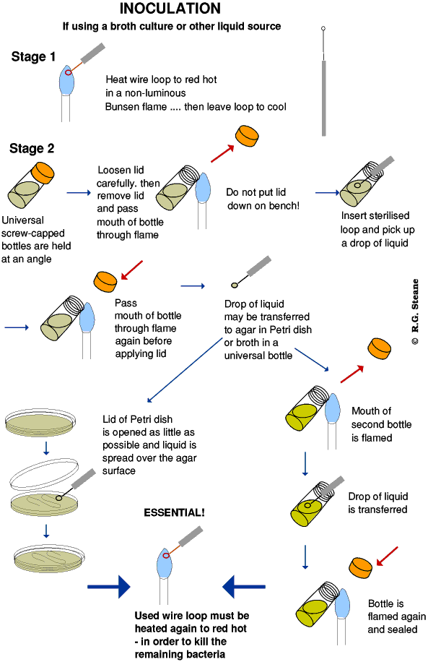
- Solid Media Inoculation
Solid media inoculation transfers pure microbial cultures onto agar surfaces or into agar depths to obtain isolated colonies, perform motility tests, and study cultural characteristics.
Stab Inoculation
Principle: Sterile needle delivers inoculum deep into semi-solid agar (0.3-0.5% agar concentration), creating defined growth patterns that reveal motility and anaerobic capabilities.
Procedure:
Materials: Straight nichrome needle, motility test medium (MTM) or SIM medium tubes
1. Flame-sterilize needle until entire wire glows red-orange
2. Cool 10 seconds (test by streaking uninoculated agar)
3. Flame mouth of pure culture tube 10 seconds
4. Remove cap, pick single colony with cooled needle tip
5. Flame tube mouth, replace cap
6. Flame mouth of MTM tube, remove cap
7. Stab needle PERPENDICULARLY through center to 2/3 tube depth
8. Slowly withdraw along SAME track (avoid lateral spread)
9. Flame tube mouth, cap TIGHTLY
10. Incubate UPRIGHT 35°C/24-48 hours
Interpretation Results:
Motile organisms (Proteus, E. coli):
- Diffuse growth radiates from stab line
- Umbrella-shaped haze at surface
- Entire tube turbid
Non-motile organisms (Shigella, Klebsiella):
- Growth confined sharply to stab line
- Tube remains clear
- No surface pellicle
Additional Indicators:
- Black FeS precipitate: H₂S production (Salmonella, Citrobacter)
- Red ring after Kovac's: Indole positive (E. coli)
Applications: Motility confirmation, anaerobe cultivation, H₂S testing.
Streak Inoculation
Principle: Progressive mechanical dilution across agar surface using flamed loop creates isolated colonies from single cells by 10⁴-10⁶ fold reduction.
Standard Quadrant Streak Procedure:
1. Flame loop red-hot, cool 10 seconds
2. First quadrant: Heavy inoculum (10⁸ CFU) - 12-15 back-forth streaks across 1/4 plate
3. Flame loop, cool
4. Second quadrant: 2-3 sweeps from 1st quadrant edge → 8-12 streaks into 2nd quadrant
5. Flame loop, cool
6. Third quadrant: 2 sweeps from 2nd → 6-8 streaks in 3rd quadrant
7. Flame loop, cool
8. Fourth quadrant: 2 sweeps from 3rd → 4-6 streaks in final 1/4
9. Invert plate, incubate 35°C/24-48h
Expected Colony Distribution:
Quadrant | Density | Appearance
1st | 10⁸ CFU | Confluent lawn
2nd | 10⁵ CFU | Semi-confluent
3rd | 10³ CFU | Discrete microcolonies
4th | 10¹ CFU | 30-100 isolated colonies
Spread/Pour Plate Inoculation
Spread Plate Technique (Quantitative)
Principle: 0.1 mL standardized dilution uniformly distributed across agar surface yields countable colonies (30-300/plate).
Procedure:
1. Serial dilute sample to 10⁻⁵ through 10⁻⁷
2. Pipette 0.1 mL onto center of DRIED nutrient agar plate
3. Flame-sterilize L-shaped glass spreader (ethanol soak → flame)
4. Spread uniformly:
a) Touch spreader edge to agar, light pressure
b) Rotate plate 60° → back-forth motion
c) Rotate 60° → repeat
d) Final edge circular sweep
5. Rest spreader on plate edge 10 seconds (drain fluid)
6. Invert, incubate 35°C/24-48h
7. CFU/mL = colonies × dilution factor × 10
Pour Plate Technique (Anaerobe Detection)
Principle: Sample mixed with molten agar (45°C) solidifies with colonies distributed at surface, subsurface, and deep levels.
Procedure:
1. Pipette 1.0 mL dilution (10⁻⁴ to 10⁻⁶) into sterile Petri dish
2. Add 15-20 mL molten Plate Count Agar EXACTLY 45°C
3. Immediate swirling (5 seconds maximum):
- Figure-8 motion (center only)
- Rotate plate 60° × 3 directions
4. Solidify undisturbed 15 minutes
5. Incubate INVERTED 35°C/48h
Colony Types:
- Surface (50-70%): Large, typical morphology (aerobes)
- Subsurface (1-3 mm): Pinhead, lens-shaped (facultative anaerobes)
- Deep (>3 mm): Tiny, subsurface-only (obligate anaerobes)
Aseptic Technique Checklist (Mandatory)
- Bunsen flame ON (blue cone, 5-10 cm)
- Work within 10 cm inner flame zone
- Loop cools 10s (test on agar)
- Tube mouths flamed 10s before/after
- Caps held in hand (NEVER table)
- Plates held at 45° angle
- Single-motion transfers
- Work surface 70% ethanol wiped
Applications by Purpose
Purpose | Technique | Target Result
Pure isolation | Streak plate | 30-100 colonies/plate
Viable counts | Spread plate | 30-300 colonies
Motility test | Stab inoculation | Diffuse vs. stab growth
Anaerobe detection | Pour plate | Deep colonies
Stock culture | Slant streak | Characteristic growth

2. Study of Colony Characteristics: Morphological Characteristics
Colony morphological characteristics refer to the visible physical features of bacterial/fungal colonies grown on solid agar media, providing preliminary identification clues through standardized descriptive terminology.
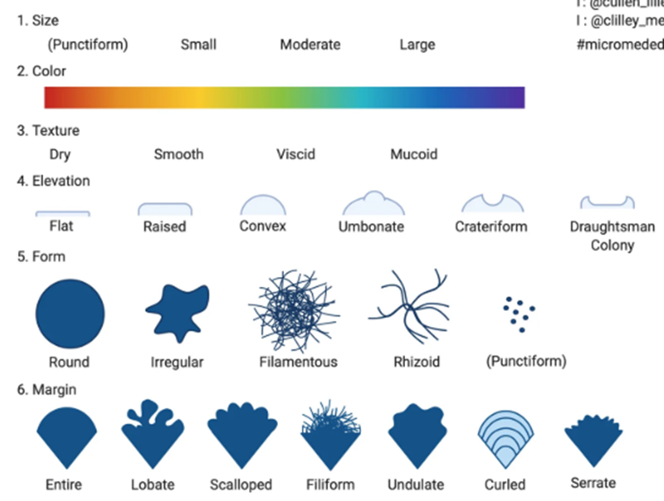
Key Morphological Parameters
Size
Measurement: Diameter in millimeters (mm) using ruler or colony counter graticule.
Classification:
Size Category | Diameter | Examples
Punctiform/Pinpoint | <0.5 mm | Pasteurella, slow-growing mycobacteria
Small | 0.5-1.0 mm | Shigella, Salmonella
Medium | 1.0-2.0 mm | E. coli, Enterococcus
Large | >2.0 mm | Bacillus, Proteus
Significance: Growth rate indicator; rapid growers (>1 mm/24h) vs. slow (<0.5 mm/48h).
Shape (Form)
Description: Overall outline when viewed from above.
Shape | Description | Examples
Circular | Perfect circle, symmetrical | Staphylococcus aureus (golden), Streptococcus
Irregular | Asymmetrical, variable outline | Mycobacterium tuberculosis (rough, dry)
Filamentous | Thread-like extensions | Bacillus anthracis, Nocardia
Rhizoid | Root-like branches | Bacillus subtilis, soil actinomycetes
Spindle | Elongated, football-shaped | Proteus mirabilis (swarming)
Margin (Edge)
Description: Perimeter characteristics examined at low angle illumination.
Margin Type | Characteristics | Examples
Entire | Smooth, continuous edge | Staphylococcus aureus
Undulate | Wavy border | Pseudomonas aeruginosa
Lobate | Primary lobes (wide) | Enterobacter aerogenes
Filamentous | Thread-like projections | Bacillus anthracis (medusa head)
Curled | Curved tendrils | Proteus spp.
Scalloped | Scooped appearance | Vibrio parahaemolyticus
Elevation
Description: Height profile viewed by tilting plate at 45° angle against light.
Elevation | Profile | Examples
Flat | No elevation, thin film | Vibrio cholerae
Raised | Dome-like, moderate height | Salmonella
Convex | Egg-shaped, hemispherical | E. coli
Pulvinate | Cushion/pillow-shaped | Klebsiella pneumoniae (very convex)
Umbonate | Central knob/umbrella | Serratia marcescens
Umbilicate | Central depression | Fusobacterium
Standard bacterial colony morphology diagram showing size, shape, margin, elevation variations.​
Surface Characteristics (Texture)
Examined by touch with sterile loop:
Texture | Description | Examples
Smooth | Even, glistening | Streptococcus pyogenes
Rough/Granular | Pebbly surface | Mycobacterium tuberculosis
Wrinkled/Rhizoid | Folded, cracked | Serratia (wrinkled)
Mucoid | Slimy, sticky | Klebsiella, encapsulated Streptococcus pneumoniae
Dry/Butyrous | Buttery, smears | Staphylococcus epidermidis
Dry/Powdery | Breaks apart | Corynebacterium
Additional Morphological Features
Opacity
- Transparent: See through (light passes)
- Translucent: Hazy (diffused light)
- Opaque: Solid, no light transmission
Color/Pigmentation
Pigment | Color | Examples
Pyocyanin | Green-blue | Pseudomonas aeruginosa
Pyoverdine | Yellow-green | Fluorescent Pseudomonas
Prodigiosin | Red | Serratia marcescens
Melanin | Brown-black | Proteus, Alcaligenes
Carotenoid | Orange-yellow | Micrococcus luteus
Consistency (Disruption Test)
Touch sterile loop to colony edge:
- Brittle/Friable: Crumbles (dry)
- Butyrous: Spreads smoothly (butter-like)
- Mucoid: Stringy, sticky
- Membranous: Tough, elastic film
Practical Examination Protocol
1. Incubation: 35°C/24-48h nutrient agar/blood agar
2. Examination conditions:
- Room light + oblique illumination (penlight)
- Tilt plate 30-45° for elevation/margin
- Colony counter ×2 magnification
3. Recording format:
Organism: Bacillus subtilis, Size: Large (3-5 mm), Shape: Irregular rhizoid, Margin: Filamentous, Elevation: Flat, Surface: Rough, dry, Opacity: Opaque, Color: Creamy white, Texture: Butyrous
Identification Significance
Example Profiles:
Staphylococcus aureus: Large (2-4 mm), circular, entire margin, low convex, golden yellow, smooth/glistening, opaque
Escherichia coli: Medium (1-2 mm), circular, entire, convex, gray/white, smooth, opaque
Bacillus subtilis: Large (4-6 mm), irregular rhizoid, filamentous margin, flat, white/creamy, rough, dry powdery

3. Motility Tests
Motility tests determine bacterial movement capability through flagella-powered locomotion, distinguishing motile (directional swimming) from non-motile organisms and Brownian motion (random jiggling).
Hanging Drop Method
Principle: Living bacteria suspended in hanging liquid droplet observed under phase-contrast microscopy; true motility shows directional movement relative to field, unlike random Brownian motion.
Procedure:
Materials: Depression slide (concavity), coverslip, petroleum jelly/Vaseline, fresh broth culture (4-6h)
1. Cleaning: Wipe depression slide and coverslip with 70% ethanol
2. Prepare coverslip:
- apply THIN Vaseline ring to coverslip perimeter (toothpick)
- OR dab four corner dots (seals hanging drop)
3. Inoculum preparation:
- Touch sterile loop to young broth culture surface (not sediment)
- Place small droplet (0.5-1 μL) center of Vaseline ring
4. Assembly:
- Invert depression slide over coverslip (concavity DOWN)
- Press gently until droplet touches center of concavity
- Seal excess Vaseline with additional dabs
5. Microscopy:
- Place slide on mechanical stage
- Locate droplet edge at 10× (low power)
- Switch to 40× (high-dry objective)
- Close iris diaphragm (increase contrast)
- Focus edge of droplet (highest cell density)
Phase-Contrast Setup (Preferred):
- Oil immersion 100× optional for flagella visualization
- Wet mount equivalent, no staining distortion
Observation Time: Examine within 5-10 minutes (prevents settling).
Expected Results:
Motile bacteria (E. coli, Proteus):
- Rapid directional swimming
- Forward/backward spirals
- Cells move out of focus quickly
Non-motile bacteria (Shigella, Klebsiella):
- No displacement relative to field
- Jiggling in place (Brownian motion <2 μm/sec)
Brownian motion:
- Random vibration (thermal energy)
- <2 μm/sec, no net displacement
Precautions:
- Use young cultures (flagella intact)
- Avoid overcrowding (focus single plane)
- Petroleum jelly seal prevents evaporation
- Discard slides in disinfectant (pathogen safety)
Limitations: Subjective, live cells only, poor for microaerophiles.
Sloppy Agar (Semi-solid Agar) Method
Principle: Motile bacteria migrate through 0.3-0.4% agar medium creating diffuse turbidity; non-motile confined to inoculation line. Visual macroscopic detection.
Standard Medium: SIM agar (Sulfide-Indole-Motility) or Motility Test Medium (MTM):
Composition (per liter):
Beef extract 3.0 g
Peptone 10.0 g
NaCl 5.0 g
Agar 0.3-0.4% (3-4 g)
Thiosulfate 0.3 g (H₂S detection)
Ferrous ammonium sulfate 0.2 g
Procedure:
1. Melt MTM agar, cool to 45-50°C, dispense 5 mL tubes
2. Flame-sterilize straight needle
3. Pick young colony (18-24h) from nutrient agar
4. Stab perpendicularly to 1-2 cm depth (center line)
5. Incubate UPRIGHT 35°C/24-48 hours (NO shaking)
Macroscopic Interpretation:
Positive motility (Pseudomonas, Vibrio):
- Diffuse growth radiates from stab
- Tube turbidity top-to-bottom
- Umbrella haze at surface
- Growth exceeds 2 cm from stab line
Negative motility (Salmonella Typhi, Shigella):
- Growth confined to sharp stab line
- Tube remains clear
- No surface pellicle
Additional reactions (SIM medium):
- Black FeS precipitate: H₂S positive (Proteus, Citrobacter)
- Red ring (Kovac's): Indole positive (E. coli)
Enhanced Visualization:
- TTC (2,3,5-triphenyltetrazolium chloride): Motile bacteria reduce to red formazan
- Positive: Pink-red diffuse growth
Interpretation Criteria
Quantitative Motility Index
Migration Distance (cm from stab at 24h):
0-0.5 cm: Non-motile
0.5-1.0 cm: Slightly motile
1.0-2.0 cm: Moderately motile
>2.0 cm: Highly motile (swarming)
Diagnostic Significance
Motile | Non-Motile | Clinical Relevance
E. coli, Proteus mirabilis | Shigella, Klebsiella | Uropathogen differentiation
Vibrio cholerae | V. parahaemolyticus | Cholera diagnosis
Pseudomonas aeruginosa | Enterobacter cloacae | Nosocomial infection ID

Confirmatory Tests:
1. Hanging drop (wet mount) for microscopic confirmation
2. Flagella stain (Leifson method)
3. Molecular: flaA, motA genes PCR

