KRISHNA INSTITUTE OF NURSING SCIENCES, KARAD
LESSON PLAN
SUBJECT: Medical Surgical Nursing
TOPIC : Demonstration on Breast Self- Examination
Group : Anganwadi sevika.
VENUE : Anganwadi hall.
- V. AIDS: Demonstration
DATE :
TIME : 45 minutes
MEDIUM OF TEACHING : Demonstration followed by discussion

GENERAL OBJECTIVES:
At end of the class participants will be will be able to,
- Acquire the knowledge about Breast Self- Examination
- Understand the Anatomy & physiology of breast.
- Risk factors of breast cancer.
- Apply this knowledge in the community health urban/ rural population about Breast Self- Examination

SPECIFIC OBJECTIVES
At end of the class participants will be able to

a) Participants understand the need of breast self-examination.
b) Able to practice regular BSE.
c) Participants should distribute the knowledge of BSE to others.
d) Able to success in early detection of breast cancer & save the life.

TIME | SPECIFIC OBJECTIVES | CONTENTS | T.L. ACTIVITY | A.V. AIDS | EVALUATION
10  Min | Participants able to acquire the knowledge on Breast Self-Examination. | INTRODUCTION:  What is a breast self-examination (BSE)?  BSE is a procedure a woman can do to physically and visually examine her breasts and underarm areas for changes. It has not been shown that BSEs alone can accurately determine the presence of breast cancer. (Performed by a health care provider every three years for women in their 20s and 30s, and every year for women ages 40 and older) and mammography.  When should BSEs be done?  By doing BSEs regularly, you get to know how your breasts normally feel and look so that you are able to detect any changes more easily.  Women can begin practicing BSE at about age 20 and continue the practice throughout their lives—even during pregnancy and after menopause.  Breast self-examination can be performed every month. Become familiar with how your breasts usually look and feel so that you may notice any change from what is normal for you:  - If you still menstruate, the best time to do BSE is when your breasts are least likely to be tender or swollen, such as a few days after your period ends.  - If you no longer menstruate, pick a certain day—such as the first day of each month—to remind yourself to do BSE.  - If you are taking hormones, talk with your health care provider about when to do BSE.  Changes to look for  Check with your health care provider if you find any change in your breast(s) that causes you concern. Changes in your breasts may include:  • Development of a lump  • A discharge other than breast milk  • Swelling of the breast  • Skin irritation or dimpling  • Nipple abnormalities (such as pain, redness, scaliness, or turning inward) | Lecture & discussion | PPT on LCD | Participants can understood the importance of BSE

TIME | SPECIFIC OBJECTIVES | CONTENTS | T.L. ACTIVITY | A.V. AIDS | EVALUATION
10 MIN | Participants should able to know anatomy of breast. | Each breast has 15 to 20 sections, or lobes, that surround the nipple in a radial manner, like spokes on a wheel. Inside these lobes are smaller sections, called lobules. At the end of each lobule are tiny "bulbs" that produce milk. These structures are linked together by small tubes called ducts, which carry milk to the nipples. Fat fills the spaces between the lobes and ducts.  The nipple is in the center of a dark area of skin called the areola. The areola contains small glands that lubricate the nipple during breastfeeding. There are no muscles in the breasts, but muscles lie under each breast to cover the ribs.  Each breast also contains blood vessels and vessels that transport lymph. Lymph is a fluid that travels through a network of channels called the lymphatic system and carries cells that help the body fight infections. The lymph vessels lead to the lymph nodes which are small, bean-shaped glands that are part of the infection-fighting lymphatic system. Lymph nodes are located in the armpits, above the collarbone, and in the chest. If a cancer has reached these nodes, it may mean that cancer cells have spread to other parts of the body. Lymph nodes are also found in many other parts of the body including inside the chest, abdominal cavity, and the groin.  Breast development and function depend on hormones produced by the ovaries, namely estrogen and progesterone. Estrogen elongates the ducts and causes them to create side branches. Progesterone increases the number and size of the lobules in order to prepare the breast for nourishing a baby. After ovulation, progesterone makes the breast cells grow, and blood vessels enlarge and fill with blood. At this time, the breasts often become engorged with fluid and may be tender and swollen. | Lecture & discussion | 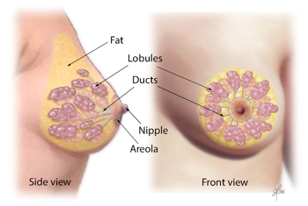 | Participants should understand anatomy of breast

TIME | SPECIFIC OBJECTIVES | CONTENTS | T.L. ACTIVITY | A.V. AIDS | EVALUATION
10 MIN | Participants should know the risk factors of breast cancer | Risk Factors You Cannot Change  Getting older. After age 50.  Genetic mutations. Inherited changes (mutations) to certain genes, such as BRCA1 and BRCA2.  Reproductive history. Early menstrual periods before age 12 and starting menopause after age 55 expose women to hormones longer.  Having dense breasts. Dense breasts have more connective tissue than fatty tissue.  Personal history of breast cancer or certain non-cancerous breast diseases. Women who have had breast cancer.  Family history of breast cancer. A woman’s risk for breast cancer is higher if she has a mother, sister, or daughter (first-degree relative)  Previous treatment using radiation therapy. Women who had radiation therapy to the chest or breasts (like for treatment of Hodgkin’s lymphoma) before age 30 have a higher risk of getting breast cancer later in life.  Women who took the drug diethylstilbestrol (DES), which was given to some pregnant women to prevent miscarriage.  Risk Factors You Can Change  Not being physically active. Who are not physically active.  Being overweight or obese after menopause. Older women who are overweight or obese.  Taking hormones. Some forms of hormone replacement therapy (estrogen and progesterone)  Reproductive history. Having the first pregnancy after age 30, not breastfeeding, and never having a full-term pregnancy Drinking alcohol. A woman’s risk for breast cancer increases with the more alcohol she drinks. | Lecture & discussion | PPT on LCD | Participants can give answer by asking questions.

TIME | SPECIFIC OBJECTIVES | CONTENTS | T.L. ACTIVITY | A.V. AIDS | EVALUATION
15 MIN | understand the steps of breast self examinations | - Stand in front of a mirror that is large enough for you to see your breasts clearly. Check each breast for anything unusual. Check the skin for puckering, dimpling, or scaliness. Look for a discharge from the nipples.  - Watching closely in the mirror, clasp your handsbehind your head and press your hands forward.  - Next, press your hands firmly on your hips and bend slightly toward the mirror as you pull your shoulders and elbows forward.  Do steps 2 and 3 to check for any change in the shape or contour of your breasts. As you do these steps, you should feel your chest muscles tighten.  - Gently squeeze each nipple and look for a discharge.  - The breasts are best examined while lying down because it spreads the breast tissue evenly over the chest. Lie flat on your back, with one arm over your head and a pillow or folded towel under the shoulder. This position flattens the breast and makes it easier to check. | Demonstration | On Model | Participants can understand steps of BSE

TIME | SPECIFIC OBJECTIVES | CONTENTS | T.L. ACTIVITY | A.V. AIDS | EVALUATION
- Use the pads of the fingers of your other hand to check the breast and the surrounding area firmly, carefully, and thoroughly. Some women like to use lotion or powder to help their fingers glide easily over the skin. Feel for any unusual lump or mass under the skin. Feel the tissue by pressing your fingers in small, overlapping areas about the size of a dime. To be sure you cover the whole breast, take your time and follow a definite pattern: lines, circles, or wedges.
- Some research suggests that many women do BSE more thoroughly when they use a pattern of up-and-down lines or strips. Other women feel more comfortable with other patterns. The important thing is to cover the whole breast and pay special attention to the area between the breast and the underarm, including the underarm itself. Check the area above the breast, up to the collarbone, and all the way over to your shoulder.
Consider using one of these patterns:
- Lines. Start in the underarm area and move your fingers downward little by little until they are below the breast. Then move your fingers slightly toward the middle and slowly move back up. Go up and down until you cover the whole area.
- Circles. Beginning at the outer edge of your breast, move your fingers slowly around the whole breast in a circle. Move around the breast in smaller and smaller circles, gradually working toward the nipple. Don't forget to check the underarm and upper chest areas, too.
- Wedges. Starting at the outer edge of the breast, move your fingers toward the nipple and back to the edge. Check your whole breast, covering one small, wedge-shaped section at a time. Be sure to check the underarm area and the upper chest.

TIME | SPECIFIC OBJECTIVES | CONTENTS | T.L. ACTIVITY | A.V. AIDS | EVALUATION
The American Cancer Society recommends using three different levels of pressure to examine your breasts:
- Light pressure—to examine the tissue closest to the skin
- Medium pressure—to feel a little deeper
- Firm pressure—to feel deeper tissue closer to the chest wall
- Some women repeat step 5 in the shower. Your fingers will glide easily over soapy skin, so you can focus on feeling for changes underneath.
- What if you find a lump?
- One of the most frightening moments for a woman is seeing or feeling something different or unusual while performing breast self-examination. One of the most important reasons to do regular breast self-examination is so that you know what is normal for your breasts. If you find a lump, it is important not to panic.
- If you discover lumpiness in one breast or feel something "different" in the tissue, or if you feel a definite lump, there may be valid reason for concern, and it is important to contact a health care provider. Sometimes, the lumpiness may be due to menstrual changes, but if you have nipple discharge or skin changes such as dimpling or puckering, your health care provider may want to see you right away.
- It is natural to be frightened when discovering a lump, butdo not let the prospect of cancer keep you from taking action. Remember that most breast lumps are benign (not cancer).

TIME | SPECIFIC OBJECTIVES | CONTENTS | T.L. ACTIVITY | A.V. AIDS | EVALUATION
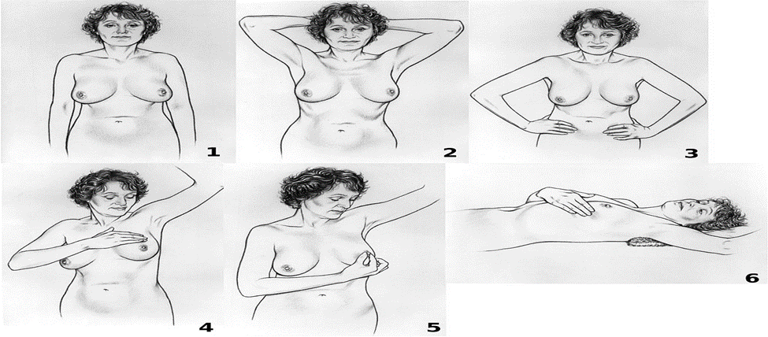
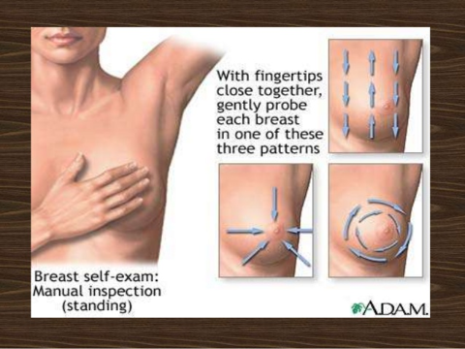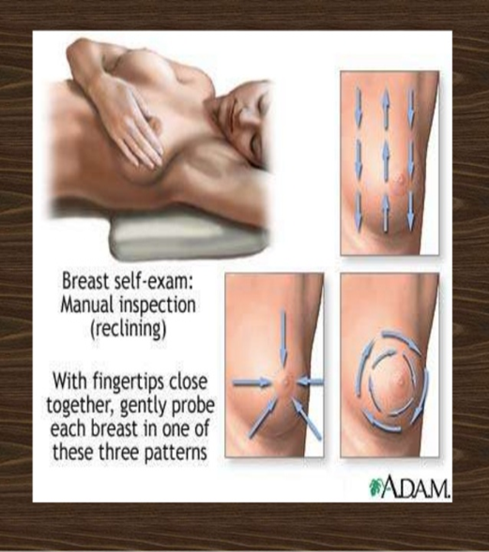

TIME | SPECIFIC OBJECTIVES | CONTENTS | T.L. ACTIVITY | A.V. AIDS | EVALUATION
Conclusion:
As mentioned earlier, the aim of a BSE is to familiarize a women with her breasts which will help in early detection of any abnormality. Ideally, after age of twenty, BSE must be done by a lady once atleast every month. And atleast once a year, a clinical breast examination by a medical professional should be done. These are only guidelines, and may not always be feasible for a normal person.
The best time to do a BSE is during a bath, which will give a woman a reasonable time to be alone with herself and concentrate on this. Even though a formal BSE may not be done every time, being aware of the characteristics of the breast will allow woman to pick up any abnormality early.
References:
- Eggertsen SC, Bergman JJ. Breast self-examination: historical perspective and current progress. J Fam Pract. 1983 Apr;16(4):713–716. [PubMed] [Google Scholar]
- Holtzman D, Celentano DD. The practice and efficacy of breast self-examination: a critical review. Am J Public Health. 1983 Nov;73(11):1324–1326. [PMC free article] [PubMed] [Google Scholar]
- Miller AB, Chamberlain J, Tsechkovski M. Self-examination in the early detection of breast cancer. A review of the evidence, with recommendations for further research. J Chronic Dis. 1985;38(6):527–540. [PubMed] [Google Scholar]
- O'Malley MS, Fletcher SW. US Preventive Services Task Force. Screening for breast cancer with breast self-examination. A critical review. JAMA. 1987 Apr 24;257(16):2196–2203. [PubMed] [Google Scholar]
- Baquet C, Ringen K. Cancer control in blacks: epidemiology and NCI program plans. Prog Clin Biol Res. 1986;216:215–227. [PubMed] [Google Scholar]

