**Introduction of palliative care**

**Introduction:**

Palliative care is derived from Latin word” Palliare”means to cloak. Palliative care is given by a medical, nursing and other health care team members for the people those suffers life limit illness. It focuses mainly on the reduction in the pain and other physical symptoms to improve quality of life. In India 5.4% million in a year patients’ needs palliative care. (Journal of the Association of Physicians of India.)

1st Hospital in India for palliative care

Shanthibhavan Palliative Hospital started under the leadership of Dr.L.J.DeSouza he was Onco surgeon .With motto –By the people –for the people. Also known as No bills Hospital.



Dame Cicely Mary Saunders well known nurse .she played important role to start palliative care.

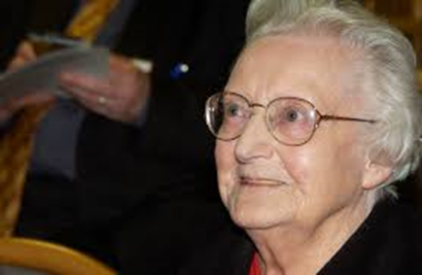

She explains very well about holistic pain concept like physical social psychological and spiritual.

She also known as mother of palliative care. She recognized the different ways are available to make the patient confortable those near death and there life will be free from distress.

Dr. Rajagopal - Father of Palliative Care in India.

M. R. Rajagopal is an Indian palliative care physician referred to as the 'father of palliative care in India' in honor of his significant contribution to the palliative care scene in India. (Wikipedia).



What is palliative care?

Palliative care is specialized cares given to patient those are dealing with life-threatening disease.

Palliative care is an approach that improves the quality of life of patients (adults and children) and their families who are facing problems associated with life-threatening illness.(World health Organization )

Objectives of palliative care:

1. Palliative care will helpful for nurses, patient and care givers to increase the knowledge about palliative care.

2. It helps to improve quality of life of palliative care cancer patient.

3. Improves decision making power for the relatives as well as patient during their treatment.

4. Improves communication between patient and other health care workers.

5. Palliative care knowledge helps the patient & care takers to accept dying as a normal process.

**Benefits related with palliative care:**

* To improve quality of life.
* To reduce pain
* It helps for longer survival
* It helps in decision making process
* Improves care givers satisfaction
* Improves functional capacity of patient.
* It helps Independency while care.
* It helps to relieve stress.

**Good qualities of a nurse:**

* She can able to deliver good communication.
* Good problem solver
* Good skill competency in clinical area.
* Able to collaborate with other health care team members.
* She should have cultural sensitivity
* She should have good teaching skills.

Facts related with palliative care as per (World Health Organization):

1. Each year it was estimated that 40 million people need palliative care and 78% of people live in low and middle Scio-economic condition countries. Worldwide 14% of people need palliative care.

2. Rules and restrictive policies related with drug like Morphine and other palliative medicine.

3. Inadequate training programme for health care professionals, limited resources, which affects on palliative care.

4. Early hospitalization will reduced hospital stay of the patient.

Components of palliative care:-

* Reduction in the pain and other physical symptoms.
* Holistic approach of care includes physical, social, psychological and spiritual domain.
* Integrated team approach while caring to patient.
* Proper communication to understand the disease condition and future care
* Proper assessment and timely nursing care
* Empowering the patient and care givers.
* Bereavement care.

Palliative care can be given in the following settings:

* In the hospital 
* Nursing Homes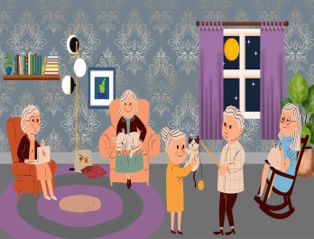
* At home:



* Outpatient department

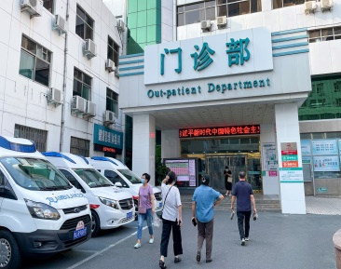

* Physician’s clinic:

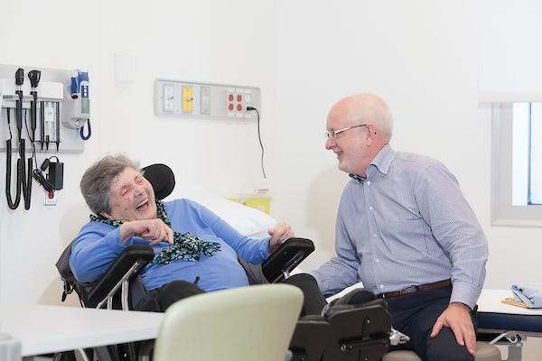

Who can give palliative care?

Oncologist: -He will decide treatment plan and Medicine. He will take help other paramedical workers for better effect . 

Nurse:- She plays a major role in palliative care she gives necessary holistic care, monitoring the need and try to relives the symptoms .



Dietitian: -Dietitian will try to address the nutritional needs and provide dietary plans according to caloric requirement of the patient.



Social Workers: -A social worker provides psychological support to family and arranges family meetings, looking for transport facilities find out other resources for providing care and also arrangement of hospice care in home.



Pain therapists: - Specialize in pain management .He will do planning for control on pain.



Therapists (Occupational, speech, physical, etc.)-

A physical therapist will arrange some exercises programme to maintain patient’s mobility during time of treatment and after treatment also.

Occupational therapists typically focus on daily tasks and functioning abilities to help independence. 

Speech therapist will help to improve in speech.

Counsellor:-.He helps the patient as well as relatives to adapt some coping strategies to deal with stressful and emotional situation

Volunteers: They will come from community sectors and trying to provide linkage between health-care institutions and patients. They also plays different role like create awareness in community about palliative care, increasing funds with help of other agencies.

Community health workers: - This people will work specially in remote area where they may not have access for palliative care.



Hospice Care Centre:-In this Centre care given to patient where cure is not possible only symptomatic care is given to patient to relive his cancer symptoms.

Barriers in palliative care:-

* Knowledge about palliative care:- Relatives as well as patient do not know much about palliative care.
* Lack of resources related with palliative care.
* Lack of integration into the medical care for palliative care
* Governmental policies and procedure related with narcotics
* Lack of awareness in social media.
* Cultural and religious beliefs related with care.
* Misconception related with palliative care.
* Low socioeconomic condition.

Common Nursing Assessment in palliative care:-

* General Assessment: - It includes patient personal history, general appearances and vital signs, present history.
* Focused assessment:-It is related with body’s specific system with will depend upon patient’s present problem or complains.
* Present History of patient.
* Past Medical history of the patient.
* Present complains of the patient.
* Social History
* Medication History.
* Caregiver’s information.
* Diagnostic Evaluation.
* Nursing Diagnosis
* Plan of care
* Nursing Implementation.
* Evaluation
* Advanced Care Planning.

Nurse’s role in palliative care:-

Nurse’s plays important role in the palliative care setting. She always tries in reduceding the symptoms of the illness and this improves quality of life of person as well as care givers.

Symptom Management:-Her main primary goals to improve health condition of the patient and she proactively managing the treatment related side-effects to improve quality of the patient. She acts as a leader and trying to provide evidence based care into her clinical practices.

Communication:-Communication skill was much essential in palliative care .She was very much trained in communication skill while taking decision making, with patient and caregivers, planning goals of care .She should be knowledgeable and able to facilitate non –threating conversation regarding palliative care treatment .



Advocacy:- Nurses are well advocate in palliative care setting.

Being available all the times:-Nurses are all the time available in the palliative care setting while rendering the basic care to patient. She is trying to fulfill all the fundamental needs of the patient.

Being coordination of care:-She is trying to coordinate with other health care members and building a good interpersonal relationship with other services. She is trying to reducing the symptoms, maintaining dignity, and providing good comfort care.

Act as care givers:-She act as a primary care providers and reducing the distressing symptoms to improve quality of life. 

Act as a teacher: - Every time she gives health information related with health conditions of the patient. Even she teaches how to handle health conditions of the patient.

Counselor:-She supports during the care .help in decision making during palliative care. Psychological support during emotional outburst.

Act as an educator:-She educates the patient in different settings.

Researcher: - She tries to evidences based practice in clinical setting to improve quality of life of person.

Administrator:-She promotes good working condition in the environment for the palliative care patient.

Conclusion:

In conclusion today we discuss about what is mean by palliative care, components of palliative care, facts, and settings of palliative care, who can give palliative care, barriers in palliative care and nursing assessment in palliative care.

References:

1. .<https://www.who.int/news-room/fact-sheets/detail/palliative-care>.
2. https://www.cancer.gov/about-cancer/advanced-cancer/care-choices/palliative-care-fact-sheet.
3. Hawley P. Barriers to Access to Palliative Care. Palliat Care. 2017 Feb 20;10:1178224216688887. doi: 10.1177/1178224216688887. PMID: 28469439; PMCID: PMC5398324.
4. Cherny, Nathan I., and others, 'Barriers to the delivery of palliative care', in Nathan I. Cherny, and others (eds), Oxford Textbook of Palliative Medicine, 6 edn (Oxford, 2021; online edn, Oxford Academic, 1 Aug. 2021), https://doi.org/10.1093/med/9780198821328.003.0008, accessed 25 June 2024.
5. Hagan TL, Xu J, Lopez RP, Bressler T. Nursing's role in leading palliative care: A call to action. Nurse Educ Today. 2018 Feb;61:216-219. doi: 10.1016/j.nedt.2017.11.037. Epub 2017 Dec 8. PMID: 29245101; PMCID: PMC5859921.
6. <https://nursingguild.com/blog/what-is-a-palliative-care-nurse-and-what-do-they-do/>.