Glycolysis: All Steps with Diagram, Enzymes, Products, Energy Yield and Significance

Glycolysis is derived from the Greek words (glykys = sweet and lysis = splitting). It is a universal catabolic pathway in the living cells.
Glycolysis can be defined as the sequence of reactions for the breakdown of Glucose (6-
carbon molecule) to two molecules of pyruvic acid (3-carbon molecule) under aerobic
conditions; or lactate under anaerobic conditions along with the production of small amount of
energy.
This pathway was described by Embden, Meyerhof and Parnas. Hence, it is also called
as Embden-Meyerhof pathway (EM pathway). Glycolysis is the central pathway for glucose catabolism in which glucose (6-carbon compound) is converted into pyruvate (3-carbon compound) through a sequence of 10 steps.
Glycolysis takes place in both aerobic and anaerobic organisms and is the first step toward the metabolism of glucose.
The glycolytic sequence of reactions differs from one species to the other in the mechanism of its regulation and the subsequent metabolic fate of the pyruvate formed at the end of the process.
In aerobic organisms, glycolysis is the prelude to the citric acid cycle and the electron transport chain, which together release most of the energy contained in glucose. It is also referred to as Embden-Meyerhof-Parnas or EMP pathway in honor of the pioneer workers in the field.
Site of Glycolysis Glycolysis occurs in the cell’s cytosol (cytoplasm).
.
Types of Glycolysis:
There are two types of glycolysis.
Aerobic Glycolysis: It occurs when oxygen is plentiful. Final product is production of Eight ATP molecules.
Anaerobic Glycolysis: It occurs when oxygen is scarce. Final product is production of two ATP molecules.

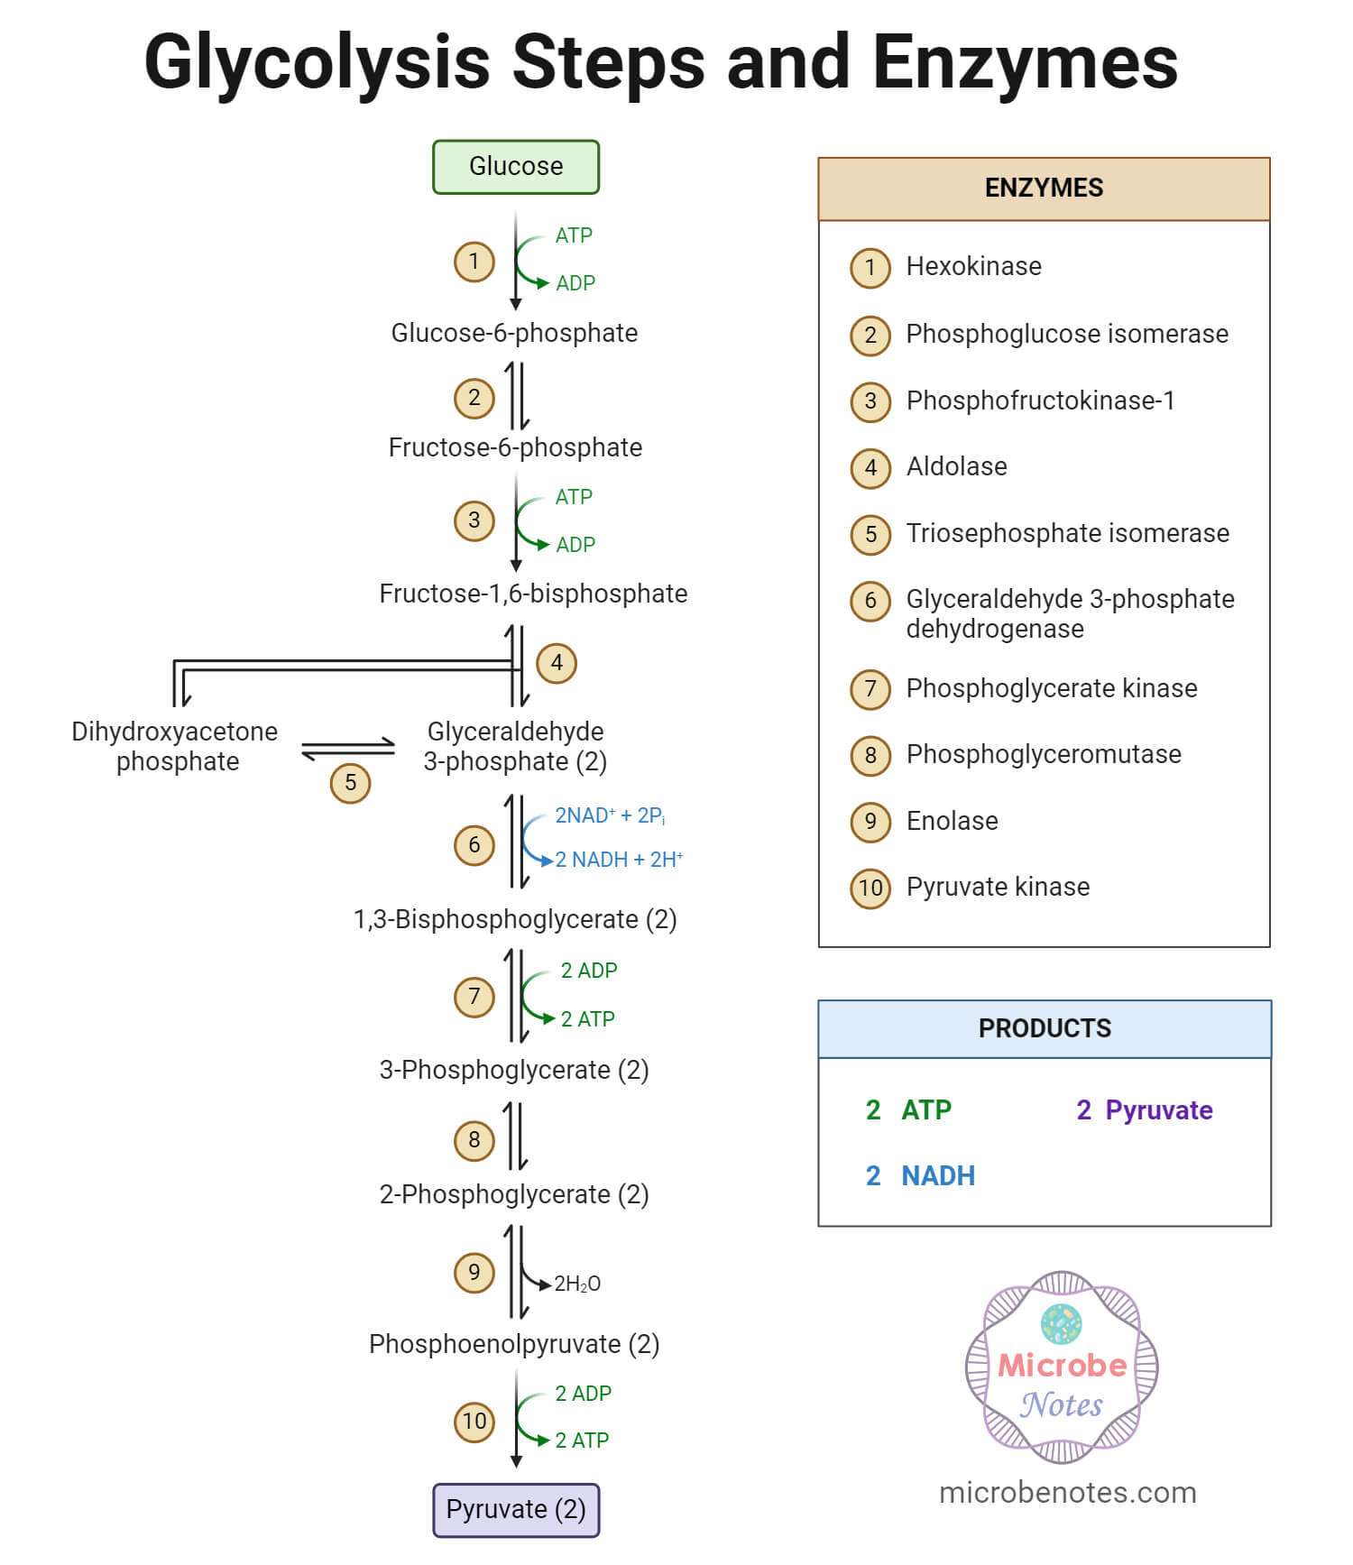

Steps of Glycolysis:
Glycolysis is an extra mitochondrial pathway and is carried by a group of eleven enzymes.
Glucose is converted to pyruvate in 10 steps by glycolysis. The glycolytic patway can be divided into two phases:
Preparatory Phase :
This phase is also called glucose activation phase molecules of ATP are invested and the hexose chain is cleaved into two triose phosphates. During this, phosphorylation of glucose and it’s conversion to glyceraldehyde
place. The steps 1, 2, 3, 4 and 5 together are called as the preparatory phase.
Payoff Phase :
This phase is also called energy extraction phase glyceraldehyde-3-phophate to pyruvate and the coupled formation of ATP take place. Because Glucose is split to yield two molecules of D the payoff phase occurs twice per molecule of glucose. The steps after 5 c phase.

Step 1- Phosphorylation of glucose
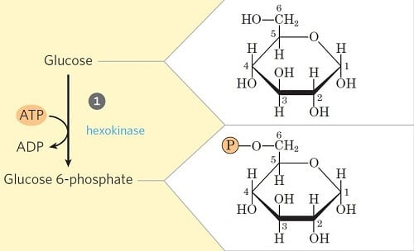
In the first step of glycolysis, the glucose is initiated or primed for the subsequent steps by phosphorylation at the C₆ carbon.
The process involves the transfer of phosphate from the ATP to glucose forming Glucose-6-phosphate in the presence of the enzyme hexokinase and glucokinase (in animals and microbes).
This step is also accompanied by considerable loss of energy as heat.

Step 2- Isomerization of Glucose-6-phosphate

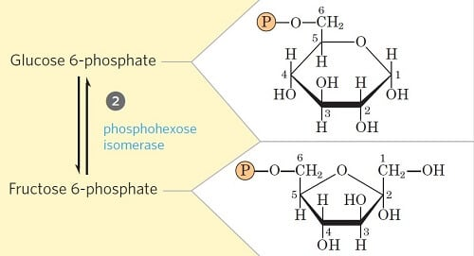
Glucose 6-phosphate is reversibly isomerized to fructose 6-phosphate by the enzyme phosphohexoisomerase/phosphoglucoisomerase.
This reaction involves a shift of the carbonyl oxygen from C1 to C2, thus converting an aldose into a ketose.

Step 3- Phosphorylation of fructose-6-phosphate
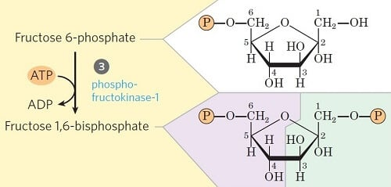
This step is the second priming step of glycolysis, where fructose-6-phosphate is converted into fructose-1,6-bisphosphate in the presence of the enzyme phosphofructokinase.
Like in Step 1, the phosphate is transferred from ATP while some amount of energy is lost in the form of heat as well.

Step 4- Cleavage of fructose 1, 6-diphosphate 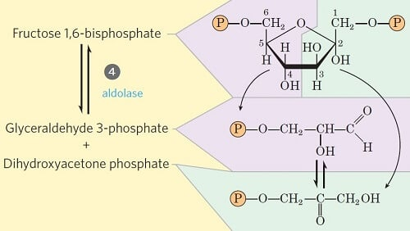
- This step involves the unique cleavage of the C-C bond in the fructose 1, 6-bisphosphate.
- The enzyme fructose diphosphate aldolase catalyzes the cleavage of fructose 1,6-bisphosphate between C₃ and C₄ resulting in two different triose phosphates: glyceraldehyde 3-phosphate (an aldose) and dihydroxyacetone phosphate (a ketose).
- The remaining steps in glycolysis involve three-carbon units, rather than six carbon units.

Step 5- Isomerization of dihydroxyacetone phosphate

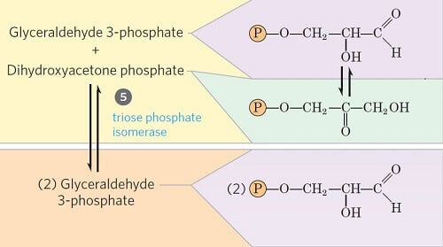
Glyceraldehyde 3-phosphate can be readily degraded in the subsequent steps of glycolysis, but dihydroxyacetone phosphate cannot be. Thus, it is isomerized into glyceraldehyde 3-phosphate instead.
In this step, dihydroxyacetone phosphate is isomerized into glyceraldehyde 3-phosphate in the presence of the enzyme triose phosphate isomerase.
This reaction completes the first phase of glycolysis.

Step 6- Oxidative Phosphorylation of Glyceraldehyde 3-phosphate 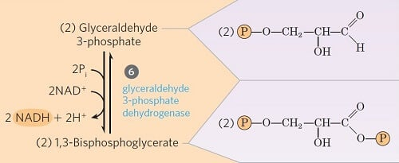
Step 6 is one of the three energy-conserving or forming steps of glycolysis.
The glyceraldehyde 3-phosphate is converted into 1,3-bisphosphoglycerate by the enzyme glyceraldehyde 3-phosphate dehydrogenase (phosphoglyceraldehyde dehydrogenase).
In this process, NAD⁺ is reduced to coenzyme NADH by the H– from glyceraldehydes 3-phosphate.
Since two moles of glyceraldehyde 3-phosphate are formed from one mole of glucose, two NADH are generated in this step.

Step 7- Transfer of phosphate from 1, 3-diphosphoglycerate to ADP
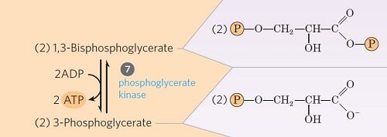
This step is the ATP-generating step of glycolysis.
It involves the transfer of phosphate group from the 1, 3-bisphosphoglycerate to ADP by the enzyme phosphoglycerate kinase, thus producing ATP and 3-phosphoglycerate.
Since two moles of 1, 3-bisphosphoglycerate are formed from one mole of glucose, two ATPs are generated in this step.

Step 8- Isomerization of 3-phosphoglycerate

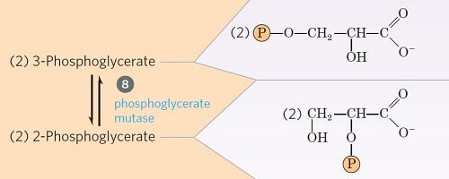
The 3-phosphoglycerate is converted into 2-phosphoglycerate due to the shift of phosphoryl group from C3 to C2, by the enzyme phosphoglycerate mutase.
This is a reversible isomerization reaction.

Step 9- Dehydration 2-phosphoglycerate
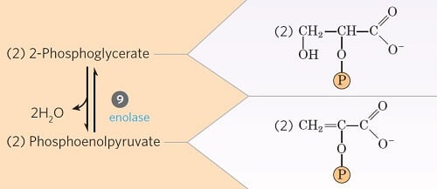
In this step, the 2-phosphoglycerate is dehydrated by the action of enolase (phosphopyruvate hydratase) to phosphoenolpyruvate.
This is also an irreversible reaction where two moles of water are lost.

Step 10- Transfer of phosphate from phosphoenolpyruvate
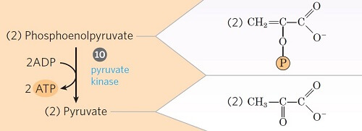
This is the second energy-generating step of glycolysis.
Phosphoenolpyruvate is converted into an enol form of pyruvate by the enzyme pyruvate kinase.
The enol pyruvate, however, rearranges rapidly and non-enzymatically to yield the keto form of pyruvate (i.e. ketopyruvate). The keto form predominates at pH 7.0.
The enzyme catalyzes the transfer of a phosphoryl group from phosphoenolpyruvate to ADP, thus forming ATP
Energetics of glycolysis:
Glycolysis converts one molecule of glucose into two molecules of pyruvate, generating a net gain of 2 ATP and 2 NADH molecules. The process involves an energy investment phase (consuming 2 ATP) and a payoff phase (producing 4 ATP), occurring in the cytosol under both aerobic and anaerobic conditions. Energetics of Glycolysis Net Yield : 4 ATP - 2 ATP = 2 ATP molecules In addition to it, Oxidation and Phosphorylation of Glyceraldehyde 3-phosphate -> 1,3 - bisphosphiglycerate is involved. In this step, 2 NAD molecules are consumed to form 2 NADH molecules. Therefore, 2 NADH molecules = 6 ATP molecules Hence

Significance of Glycolysis Pathway
- All tissues employ the glycolytic pathway for the breakdown of glucose to provide energy in the form of ATP.
- An important pathway for the production of energy, especially under anaerobic conditions.
- It is crucial for the generation of energy in cells without mitochondria.
- It forms products that are intermediates for other metabolic pathways.
- Glycolysis interfaces with glycogen metabolism, the pentose phosphate pathway, the formation of amino sugars, triglyceride synthesis (by means of glycerol 3-phosphate), the production of lactate (a dead-end reaction), and transamination with alanine.

References
- Jain JL, Jain S, and Jain N (2005). Fundamentals of Biochemistry. S. Chand and Company.
- Nelson DL and Cox MM. Lehninger Principles of Biochemistry. Fourth Edition.
- Berg JM et al. (2012) Biochemistry. Seventh Edition. W. H Freeman and Company.
- Madigan MT et al. (2012). Brock Biology of Microorganisms. Thirteenth Edition. Pearson Education, Inc.
- https://www.khanacademy.org/science/biology/cellular-respiration-and-fermentation/glycolysis/a/glycolysis

