**Methods for Cultivation of Virus**

Since the viruses are obligate intracellular parasites, they cannot be grown on any inanimate culture medium. Viruses can be cultivated within suitable hosts, such as a living cell. Generally, three methods are employed for virus cultivation.

**Learning Objective of Topic:**

To understand the principles, techniques, and applications involved in the cultivation of viruses using embryonated eggs. This method is vital in virology for the growth and study of viruses, as well as for vaccine production.

**1. Inoculation of virus into animals.**

**2. Inoculation of virus into embryonated eggs.**

**3. Tissue culture**

**1. Inoculation of Virus in Animals**

Laboratory animals are widely used for routine cultivation of viruses; they play an essential role in studies of viral pathogenesis. Live animals such as monkeys, mice, rabbits, guinea pigs, and ferrets are widely used for cultivating viruses. Monkeys were used for the isolation of Poliovirus. However, due to their risk to handlers, monkeys find only limited applications in Virology. Mice are the most widely employed animals in virology. The different routes of inoculation in mice are intracerebral, subcutaneous, intraperitoneal, or intranasal. After the animal is inoculated with the virus suspension, the animal is observed for signs of disease, visible lesions, or is killed so that infected tissues can be examined for virus.

**Advantages:**

**1.** Animal inoculation may be used as a diagnostic procedure for identifying and isolating a virus

from a clinical specimen.

**2.** Mice provide a reliable model for studying viral replication.

**3.** Gives unique insight into viral pathogenesis and host-virus relation.

**4.** Used for the study of immune responses, epidemiology, and oncogenesis.

**Disadvantages:**

**1.** Expensive and difficult in the maintenance of animals.

**2.** Difficulty in choosing animals for a particular virus.

**3.** Some human viruses cannot be grown in animals or can be grown but do not cause disease.

**4.** Mice do not provide models for vaccine development.

**5.** It will lead to the generation of escape mutants.

**6.** Issues related to animal welfare systems.

**Inoculation of the Virus into Embryonated eggs**

Before the advent of cell culture, animal viruses could be propagated only on whole animals or embryonated chicken eggs. Good Pasture in 1931 first used the embryonated hen’s egg for the cultivation of the virus. The process of cultivation of viruses in embryonated eggs depends on the type of egg which is used. The egg used for cultivation must be sterile and the shell should be intact and healthy. A hole is drilled in the shell of the embryonated egg, and a viral suspension or suspected virus-containing tissue is injected into the fluid of the egg. Viral growth and multiplication in the egg embryo is indicated by the death of the embryo, by embryo cell damage, or by the formation of typical pocks or lesions on the egg membranes. An embryonated egg offers various sites for the cultivation of viruses (Fig 3). The different sites of viral inoculation in embryonated eggs are:

* Chorioallantoic membrane (CAM).
* Amniotic Cavity.
* Allantoic Cavity.
* Yolk sac.
* Embryo.
* Air sac.

**Chorioallantoic Membrane (CAM):**

Is mainly employed in the growth of poxvirus. Virus growth and replication in the CAM are indicated by visible lesions (pocks); grey-white areas in transparent CAM. Herpes simplex virus is also grown.

Each pock is derived from a single virion. The morphology of the pocks may vary depending on the nature of the virus. Under optimal conditions, each infectious virus particle can form one pock.

Hence this method is suitable for plaque studies. Herpes simplex virus can also be inoculated via CAM.

**Allantoic Cavity:**

Is the most popular and simple method for viral inoculation. Allantoic inoculation is employed for the growth and replication of the influenza virus for vaccine production. This will provide a rich yield of influenza and some paramyxoviruses. Other allantoic vaccines include Yellow fever and rabies vaccines. Duck eggs provide a better yield of rabies virus and were used for the preparation of the inactivated non-neural rabies vaccines. But they need a longer incubation period than embryonated hen’s egg. Most of the avian viruses can be isolated using this method.

**Amniotic Cavity:**

The amniotic sac is employed inoculated for primary isolation of the influenza virus and the mumps virus. Growth and replication of the virus in egg embryos can be detected by haemagglutination assay.

**Yolk Sac:**

It is also a simplest method for the growth and multiplication of viruses. Mostly mammalian viruses are isolated using this method. Immune interference mechanisms can be detected in most avian viruses. This method is also used for the cultivation of some bacteria like Chlamydiae and Rickettsiae.

**Advantages:**

Widely used method for the isolation of virus and growth.

Ideal substrate for viral growth and replication.

Isolation and cultivation of many avian and mammalian viruses.

**1.** Cost-effective and maintenance is much easier.

**2.** Less labour is needed.

**3.** The embryonated eggs are readily available.

**4.** Sterile and wide range of tissues and fluids

**5.** They are free from contaminating bacteria and many latent viruses.

**6.** Specific and nonspecific factors of defense are not involved in embryonated eggs.

**7.** Widely used method to grow virus for some vaccine production.

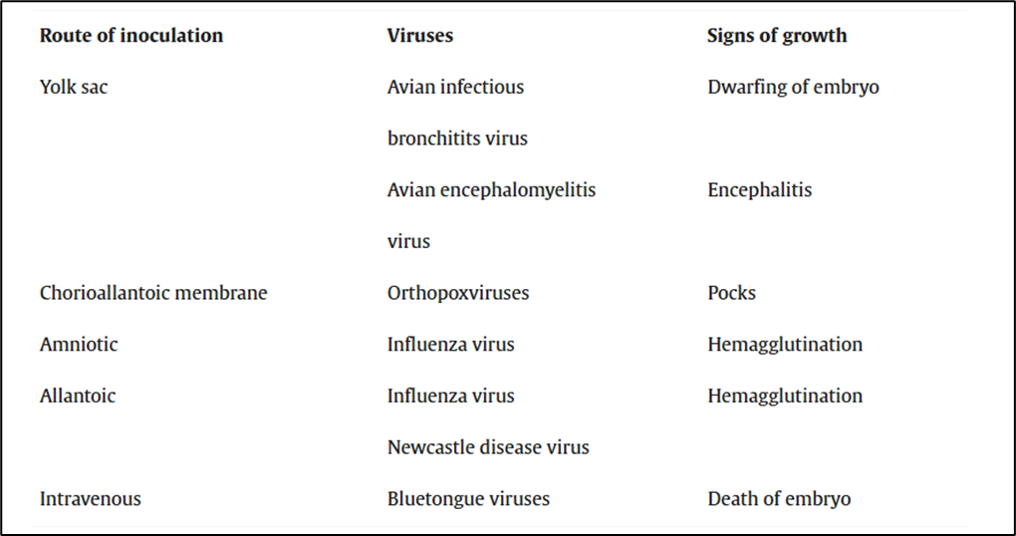

**Learning Outcome:**

* 1. **The efficiency of viral propagation:** A ratio of viruses propagated to resources used (cost, time, and effort).
  2. **Eggs' suitability for different virus strains:** Assessing which types of viruses (e.g., avian, mammalian) grow best in specific types of eggs.
  3. **Clinical signs in embryos:** Observations of any signs such as swelling, discoloration, or hemorrhage in infected embryos.
  4. **Time to peak virus production:** The time taken for the virus to reach its highest replication level in the eggs.
  5. **Cytopathic effects (CPE) observed:** Monitoring of physical changes such as death or deformation of the embryos, which can indicate virus growth.

**Short Notes:**

**1. Introduction to Cultivation of Virus in Embryonated Egg:** Embryonated eggs, especially chicken eggs, have been widely used for cultivating viruses. This method involves inoculating the virus into various parts of the egg, such as the yolk sac, allantoic sac, or amniotic sac. The embryo's cellular structures support viral replication, and this technique is still commonly used for vaccine production, such as in the case of influenza.

**2. Methods of Inoculation:** The virus can be inoculated into different parts of the embryonated egg, each serving a different purpose:

* **Yolk Sac Inoculation:** This is mainly used for viruses that need to infect the embryo's developing cells.
* **Amniotic Sac Inoculation:** This method is used for viruses that replicate in the amniotic fluid and tissues.
* **Allantoic Sac Inoculation:** Frequently used for viruses that grow well in the allantoic fluid and have the ability to affect the embryo indirectly.

**3. Advantages of Cultivating Viruses in Embryonated Eggs:**

* **Cost-effective:** Embryonated eggs are relatively inexpensive and accessible.
* **High Yield:** The embryonated egg provides a conducive environment for virus propagation, allowing for a high virus yield.
* **Safety and Purity:** Since the virus is contained within the egg, contamination risks are minimized, and virus strains can be carefully controlled and isolated.

**4. Limitations of Embryonated Egg Cultivation:**

* **Limited to Certain Viruses:** Not all viruses can grow in embryonated eggs, especially those that require mammalian cells for replication.
* **Ethical Concerns:** The use of live embryos raises ethical concerns, especially related to animal welfare.
* **Time-Consuming:** The process can be slow, requiring several days for the virus to propagate within the embryo.

**One-line Questions with Answers on Cultivation of Virus in Embryonated Egg**

**1. Which part of the egg is used to cultivate the influenza virus?**  
**Answer:** The allantoic sac is typically used to cultivate the influenza virus.

**2. Why is the embryonated egg considered cost-effective for virus cultivation?**  
**Answer:** Embryonated eggs are inexpensive and widely available, making them a cost-effective option.

**3. What is the primary disadvantage of using embryonated eggs for virus cultivation?**  
**Answer:** The primary disadvantage is that not all viruses can replicate in embryonated eggs.

**4. Which part of the egg is suitable for viruses that need to replicate in amniotic fluid?**  
**Answer:** The amniotic sac is suitable for viruses that replicate in amniotic fluid.

**5. How long does the virus cultivation process typically take in embryonated eggs?**  
**Answer:** The process can take several days, depending on the virus and incubation conditions.