Uterine fibroids are common growths of the uterus. They often appear during the years you're usually able to get pregnant and give birth. Uterine fibroids are not cancer, and they almost never turn into cancer. They aren't linked with a higher risk of other types of cancer in the uterus either. They're also called leiomyomas (lie-o-my-O-muhs) or myomas.

Fibroids vary in number and size. You can have a single fibroid or more than one. Some of these growths are too small to see with the eyes. Others can grow to the size of a grapefruit or larger. A fibroid that gets very big can distort the inside and the outside of the uterus. In extreme cases, some fibroids grow large enough to fill the pelvis or stomach area. They can make a person look pregnant.

Many people have uterine fibroids sometime during their lives. But you might not know you have them, because they often cause no symptoms. Your health care professional may just happen to find fibroids during a pelvic exam or pregnancy ultrasound.

## **Symptoms**

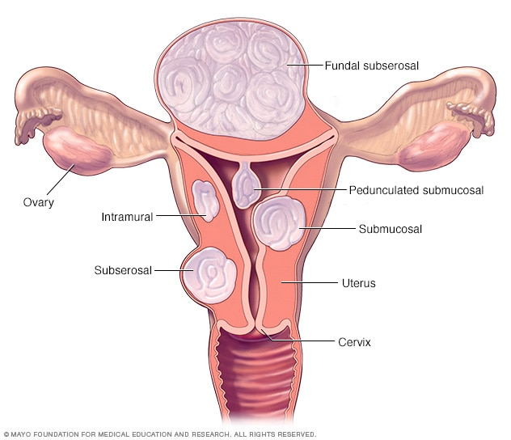

**Fibroid locations**

Enlarge image

Many people who have uterine fibroids don't have any symptoms. In those who do, symptoms can be influenced by the location, size and number of fibroids.

The most common symptoms of uterine fibroids include:

* Heavy menstrual bleeding or painful periods.
* Longer or more frequent periods.
* Pelvic pressure or pain.
* Frequent urination or trouble urinating.
* Growing stomach area.
* Constipation.
* Pain in the stomach area or lower back, or pain during sex.

Rarely, a fibroid can cause sudden, serious pain when it outgrows its blood supply and starts to die.

Often, fibroids are grouped by their location. Intramural fibroids grow within the muscular wall of the uterus. Submucosal fibroids bulge into the uterine cavity. Subserosal fibroids form on the outside of the uterus.

### **When to see a doctor**

See your doctor if you have:

* Pelvic pain that doesn't go away.
* Heavy or painful periods that limit what you can do.
* Spotting or bleeding between periods.
* Trouble emptying your bladder.
* Ongoing tiredness and weakness, which can be symptoms of anemia, meaning a low level of red blood cells.

Get medical care right away if you have severe bleeding from the vagina or sharp pelvic pain that comes on fast.