**Basics of Microscopes**

**Summary**

A **microscope** is an essential scientific instrument used to magnify small objects for detailed observation, aiding research in biology, medicine, materials science, and more.

#### **Types of Microscopes:**

1. **Optical Microscopes**
   1. **Compound Microscope**: High magnification (40x–1000x), used for cells and tissues.
   2. **Stereo Microscope**: Provides 3D views with low magnification (10x–40x), used for dissection.
2. **Electron Microscopes**
   1. **Transmission Electron Microscope (TEM)**: High resolution (up to 2,000,000x), used for internal cell structures.
   2. **Scanning Electron Microscope (SEM)**: Produces 3D surface images with magnification up to 300,000x.
3. **Specialized Microscopes**
   1. **Fluorescence Microscope**: Uses fluorescent dyes for specific cell structures.
   2. **Confocal Microscope**: Provides high-resolution 3D imaging.

#### **Parts of a Microscope:**

Key components include the **ocular lens, objective lenses, stage, diaphragm, light source, condenser, coarse and fine adjustment knobs, and mechanical stage.** Each part plays a role in magnification, focusing, and light regulation.

#### **Uses of Microscopes:**

1. **Biological Research** – Cell biology, microbiology, and genetics.
2. **Medical Diagnostics** – Histopathology, hematology, and pathogen detection.
3. **Industrial Applications** – Materials science, metallurgy, and electronics.
4. **Environmental Science** – Soil and water analysis, plant biology.
5. **Forensic Science** – Evidence and trace material analysis.

#### **Use and Care of Microscopes:**

* **Proper Use**: Start with low magnification, adjust light, fine-tune focus, and document observations.
* **Care & Maintenance**: Clean lenses with lens paper, store in a dry place, handle carefully, and perform regular maintenance.

**Learning Objectives:**

Upon completion of this topic, learners will be able to:

1. Define a microscope and explain its role in biological and material sciences.
2. Identify different types of microscopes and their specific applications.
3. Describe the structure and function of various microscope components such as the ocular lens, objective lenses, stage, and condenser.
4. Explain the working principles of compound, stereo, electron, fluorescence, and confocal microscopes.
5. Use a microscope to observe specimens effectively under different magnifications.
6. Follow standard procedures for microscope maintenance, cleaning, and safe handling.

**Learning Outcomes:**

By the end of this topic, learners will be able to:

1. Describe the fundamental principles of microscopy and its significance in scientific research.
2. Differentiate between various types of microscopes, including optical, electron, and specialized microscopes.
3. Identify and explain the function of key microscope components.
4. Apply proper microscopy techniques for viewing and analyzing specimens.
5. Demonstrate proper care, maintenance, and handling of microscopes.

**Basics of Microscope**

A microscope is an essential scientific instrument designed to magnify small objects, allowing for detailed observation that is otherwise impossible to achieve with the naked eye. By utilizing lenses and, in some cases, digital technology, microscopes enable scientists and researchers to explore the intricacies of cells, microorganisms, and minute structures. This magnification capability is crucial in various fields such as biology, medicine, and materials science, aiding in the discovery of new organisms, understanding diseases, and developing advanced materials. The importance of microscopes in modern science cannot be overstated, as they have revolutionized our ability to observe and analyze the microscopic world, leading to numerous breakthroughs and advancements.

**Microscopes: Definition, Types, and Importance**

**1. Definition**

A microscope is a scientific instrument that magnifies small objects, making them visible to the human eye. It uses lenses and, in modern versions, digital imaging to enlarge the appearance of minute specimens, allowing for detailed observation and analysis.

**2. Types of Microscopes**

Microscopes are indispensable tools in scientific research, allowing us to observe objects at the cellular and molecular levels. There are various types of microscopes:

**1. Optical Microscopes**

**Compound Microscope**

Components: Eyepiece lens, objective lenses, stage, light source.

Magnification: Typically ranges from 40x to 1000x.

Uses: Viewing cells, tissues, and microorganisms.

Advantages: Simple to use, high magnification.

Limitations: Limited resolution compared to electron microscopes.

**Stereo Microscope (Dissecting Microscope)**

Components: Two separate optical paths for each eye, low magnification.

Magnification: Typically ranges from 10x to 40x.

Uses: Dissection, observing surface details of specimens.

Advantages: Provides a 3D view, suitable for larger specimens.

Limitations: Lower magnification and resolution.

**2. Electron Microscopes**

**Transmission Electron Microscope (TEM)**

Components: Electron gun, condenser lens, specimen holder, objective lens.

Magnification: Up to 2,000,000x.

Uses: Viewing internal structures of cells, viruses, and nanoparticles.

Advantages: High resolution, detailed internal views.

Limitations: Requires thin specimens, complex preparation.

**Scanning Electron Microscope (SEM)**

Components: Electron gun, scanning coils, detectors.

Magnification: Up to 300,000x.

Uses: Viewing surface topography and composition.

Advantages: Detailed 3D images of surfaces, high resolution.

Limitations: Only surface views, sample preparation needed.

**3. Specialized Microscopes**

**Fluorescence Microscope**

Components: Light source, filters, fluorochromestained samples.

Uses: Visualizing specific structures within cells using fluorescent dyes.

Advantages: Specificity, ability to highlight individual components.

Limitations: Requires staining, potential photobleaching.

**Confocal Microscope**

Components: Laser light, scanning mirrors, pinhole aperture.

Uses: Creating 3D images of thick specimens.

Advantages: High resolution, 3D imaging, reduces outoffocus light.

Limitations: Expensive, complex setup.

**Parts of a Microscope:**

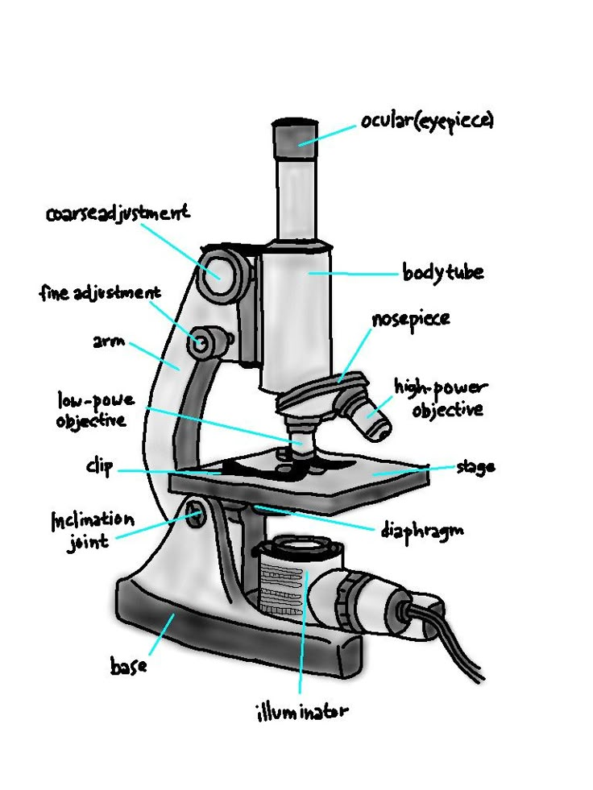

1. **Ocular Lens (Eyepiece)**

Location: At the top of the microscope.

Function: Magnifies the image of the specimen, usually 10x or 15x.

Notes: Look through this lens to view the specimen.

**2. Body Tube**

Location: Connects the eyepiece to the objective lenses.

Function: Maintains the correct distance between the eyepiece and the objective lens.

**3. Revolving Nosepiece (Turret)**

Location: Below the body tube.

Function: Holds and allows rotation of the objective lenses to change magnification.

Notes: Can rotate to select different objective lenses.

**4. Objective Lenses**

Location: Attached to the nosepiece.

Function: Provide varying levels of magnification (e.g., 4x, 10x, 40x, 100x).

Notes: Most microscopes have 34 objective lenses.

**5. Stage**

Location: Below the objective lenses.

Function: Platform where the slide/specimen is placed.

Notes: May have stage clips or a mechanical stage for holding slides in place.

**6. Stage Clips**

Location: On the stage.

Function: Hold the slide in place.

Notes: Essential for keeping the slide steady during observation.

**7. Mechanical Stage**

Location: Attached to the stage.

Function: Allows precise movement of the slide.

Notes: Has knobs to control the movement in X and Y directions.

**8. Coarse Adjustment Knob**

Location: On the arm of the microscope.

Function: Moves the stage up and down to focus on the specimen.

Notes: Used for general focusing with low power objectives.

**9. Fine Adjustment Knob**

Location: Near the coarse adjustment knob.

Function: Provides precise focusing.

Notes: Used for finetuning focus, especially with high power objectives.

**10. Diaphragm (Iris or Disc)**

Location: Below the stage.

Function: Regulates the amount of light reaching the specimen.

Notes: Can be adjusted to control contrast and clarity.

**11. Light Source (Illuminator)**

Location: Beneath the stage.

Function: Provides the light needed to view the specimen.

Notes: Can be a mirror (reflecting external light) or an electric bulb.

**12. Condenser**

Location: Below the stage, above the light source.

Function: Focuses light onto the specimen.

Notes: Includes a lens system for concentrating light.

**13. Arm**

Location: Vertical support that connects the base to the body.

Function: Used for carrying the microscope.

Notes: Provides structural support.

**14. Base**

Location: Bottom of the microscope.

Function: Supports the microscope.

Notes: Ensures stability.

**Uses of Microscopes**

**1. Biological Research**

**Cell Biology**

Observation of Cell Structure: Microscopes are used to study the morphology and organelles within cells, such as the nucleus, mitochondria, and endoplasmic reticulum.

Cell Division: Researchers use microscopes to observe and understand processes like mitosis and meiosis.

**Microbiology**

Identification of Microorganisms: Microscopes help in identifying bacteria, viruses, fungi, and protozoa.

Study of Microbial Behavior: Microscopes are used to observe microbial growth, reproduction, and interactions.

**Genetics**

Chromosome Analysis: Microscopes enable the study of chromosomes, aiding in understanding genetic disorders and inheritance patterns.

DNA Visualization: Techniques like fluorescence microscopy are used to visualize DNA and RNA sequences.

**2. Medical Diagnostics**

**Histopathology**

Tissue Examination: Pathologists use microscopes to examine tissue samples for diagnosing diseases like cancer.

Biopsy Analysis: Microscopes help in analyzing biopsy samples to detect abnormal cells.

**Hematology**

Blood Smear Analysis: Microscopes are used to examine blood smears for diagnosing conditions like anemia, leukemia, and infections.

Bone Marrow Examination: Microscopes help in evaluating bone marrow samples to diagnose hematological disorders.

**Microbial Identification**

Pathogen Detection: Clinical laboratories use microscopes to detect and identify pathogens in samples like blood, urine, and sputum.

**3. Industrial Applications**

**Material Science**

Surface Analysis: Scanning electron microscopes (SEM) are used to analyze the surface structure and composition of materials.

Nanotechnology: Microscopes are essential for studying nanoparticles and nanomaterials, aiding in the development of new materials.

**Metallurgy**

Microstructure Examination: Microscopes help metallurgists study the microstructure of metals and alloys to understand their properties and performance.

Failure Analysis: Microscopes are used to investigate the causes of material failure in industrial components.

**Electronics**

Semiconductor Inspection: Microscopes are used to inspect and analyze semiconductor wafers, ensuring the quality of electronic components.

Printed Circuit Board (PCB) Inspection: Microscopes help in examining the quality and integrity of PCBs in electronic devices.

**4. Environmental Science**

**Soil and Water Analysis**

Microorganism Identification: Microscopes are used to identify microorganisms in soil and water samples, aiding in environmental monitoring and assessment.

Particle Analysis: Microscopes help in analyzing particulate matter in environmental samples.

**Plant Biology**

Study of Plant Cells: Microscopes are used to study plant cell structure, chloroplasts, and cellular processes like photosynthesis.

Pollen Analysis: Microscopes help in examining pollen grains for research in botany and agriculture.

**5. Forensic Science**

**Crime Scene Investigation**

Evidence Analysis: Forensic scientists use microscopes to examine evidence such as hair, fibers, and residues.

Document Examination: Microscopes help in analyzing handwriting, ink, and paper in questioned document investigations.

**Trace Evidence Analysis**

Particle Identification: Microscopes are used to identify and analyze trace evidence like gunshot residue, glass fragments, and soil samples.

**Use and Care of Microscopes:**

**1. Proper Use of Microscopes**

**Preparation**

Cleanliness: Ensure the workspace is clean and free of dust. Clean the microscope lenses with lens paper or a soft, lintfree cloth.

Setup: Place the microscope on a stable, flat surface. Ensure that all parts are functioning correctly.

**Viewing a Specimen**

1. Start with the Lowest Magnification:

Begin with the lowest power objective lens (e.g., 4x or 10x). This makes it easier to locate the specimen and center it in the field of view.

**2. Place the Slide:**

Place the slide on the stage and secure it using stage clips or the mechanical stage.

**3. Adjust the Light Source:**

Turn on the light source and adjust the diaphragm to control the amount of light passing through the specimen.

**4. Use the Coarse Adjustment Knob:**

Slowly raise the stage using the coarse adjustment knob until the specimen comes into focus.

**5. FineTune Focus:**

Once the specimen is roughly in focus, use the fine adjustment knob to sharpen the image.

**6. Increase Magnification:**

Once the specimen is in focus at a low magnification, rotate the nosepiece to switch to a higher power objective lens. Refine the focus using the fine adjustment knob.

**7. Adjust Light and Diaphragm:**

As you increase magnification, you may need to adjust the light intensity and diaphragm to get a clear image.

**8. Centering the Specimen:**

Use the mechanical stage controls to move the slide and center the specimen in the field of view.

**Recording Observations**

Documentation: Take detailed notes of your observations, including magnification levels and any notable features of the specimen.

Photography: If your microscope is equipped with a camera, capture images for further analysis and recordkeeping.

**2. Care and Maintenance of Microscopes**

**Cleaning**

**1. Lens Cleaning:**

Clean lenses with lens paper or a soft, lint-free cloth. Avoid using tissues or cloth that may scratch the lenses.

Use lens cleaning solution for stubborn spots.

**2. Body Cleaning:**

Wipe the body of the microscope with a damp, soft cloth to remove dust and dirt.

Ensure no liquid enters the internal parts of the microscope.

**Storage**

**1. Covering:**

When not in use, cover the microscope with a dust cover to prevent dust accumulation.

Store the microscope in a dry, cool place away from direct sunlight and humidity.

**2. Storage Environment:**

Store the microscope in a sturdy cabinet or case to protect it from physical damage.

**Handling**

**1. Carrying the Microscope:**

Always carry the microscope with both hands, holding the arm with one hand and supporting the base with the other.

**2. Avoiding Jarring Movements:**

Handle the microscope gently to avoid jarring or shaking that could damage delicate components.

**Regular Maintenance**

**1. Inspection:**

Periodically inspect the microscope for any signs of wear or damage. Ensure that all mechanical parts move smoothly.

**2. Servicing:**

If necessary, have the microscope serviced by a professional to ensure it remains in optimal working condition.

**References**

1. Campbell, N. A., & Reece, J. B. (2008). *Biology* (8th ed.). Benjamin Cummings. ISBN: 9780321558237
2. Nelson, D. L., & Cox, M. M. (2013). *Lehninger Principles of Biochemistry* (6th ed.). W.H. Freeman. ISBN: 9781429234146
3. Murphy, D. B., & Davidson, M. W. (2012). *Fundamentals of Light Microscopy and Electronic Imaging* (2nd ed.). Wiley-Blackwell. ISBN: 9780471692140
4. Goldstein, J. I., Newbury, D. E., Joy, D. C., Lyman, C. E., Echlin, P., Lifshin, E., Sawyer, L., & Michael, J. R. (2003). *Scanning Electron Microscopy and X-Ray Microanalysis* (3rd ed.). Springer. ISBN: 9781441994812
5. Staley, J. T., & Salyers, A. A. (2007). *Microbial Life* (2nd ed.). Sinauer Associates. ISBN: 9780878937609
6. Alberts, B., Johnson, A., Lewis, J., Raff, M., Roberts, K., & Walter, P. (2007). *Molecular Biology of the Cell* (5th ed.). Garland Science. ISBN: 9780815344322
7. Kumar, V., Abbas, A. K., & Aster, J. C. (2014). *Robbins & Cotran Pathologic Basis of Disease* (9th ed.). Saunders. ISBN: 9781455726134
8. Callister, W. D., Jr. (2014). *Materials Science and Engineering: An Introduction* (9th ed.). Wiley. ISBN: 9781118324578
9. Maier, R. M., Pepper, I. L., & Gerba, C. P. (2009). *Environmental Microbiology* (2nd ed.). Academic Press. ISBN: 9780123946263
10. Nazarova, Y. V. (2014). *Practical Light Microscopy in Biology*. Wiley-Blackwell. ISBN: 9780124186514

**Question Bank on Basics of Microscopes**

**Multiple Choice Questions (MCQs)**

1. What is the typical magnification range of a compound microscope?

a) 10x - 40x

b) 100x - 2000x

c) 40x - 1000x

d) 200x - 400x

Correct Answer: c) 40x - 1000x

2. Which part of the microscope is used to hold and rotate the objective lenses?

a) Stage

b) Arm

c) Revolving Nosepiece

d) Coarse Adjustment Knob

Correct Answer: c) Revolving Nosepiece

3. Which lens is closest to the specimen in a compound microscope?

a) Ocular Lens

b) Objective Lens

c) Condenser

d) Eyepiece

Correct Answer: b) Objective Lens

4. What is the function of the diaphragm in a microscope?

a) Magnification

b) Illumination

c) Focusing

d) Controlling light intensity

Correct Answer: d) Controlling light intensity

5. Which type of microscope provides a 3D view of the specimen?

a) Compound Microscope

b) TEM

c) SEM

d) Fluorescence Microscope

Correct Answer: c) SEM

6. What is the primary function of the coarse adjustment knob?

a) Fine tuning focus

b) Moving the stage quickly for general focus

c) Controlling light intensity

d) Changing magnification

Correct Answer: b) Moving the stage quickly for general focus

7. Which microscope technique is used to visualize fluorescently labelled samples?

a) Brightfield Microscopy

b) Phase Contrast Microscopy

c) Fluorescence Microscopy

d) Darkfield Microscopy

Correct Answer: c) Fluorescence Microscopy

8. What is the maximum magnification typically achieved by a scanning electron microscope (SEM)?

a) 1,000x

b) 100,000x

c) 10,000x

d) 300,000x

Correct Answer: d) 300,000x

9. Which microscope part focuses light onto the specimen?

a) Ocular Lens

b) Objective Lens

c) Condenser

d) Stage

Correct Answer: c) Condenser

10. What is the function of stage clips?

a) Holding the slide in place

b) Changing magnification

c) Adjusting focus

d) Controlling light intensity

Correct Answer: a) Holding the slide in place

**Answer in one sentence:**

1. What part of the microscope is used to view the specimen?

Answer: The ocular lens (eyepiece) is used to view the specimen.

2. What is the function of the revolving nosepiece in a microscope?

Answer: The revolving nosepiece holds and rotates the objective lenses.

3. Which part of the microscope adjusts the focus for sharp images?

Answer: The fine adjustment knob adjusts the focus for sharp images.

4. What is the role of the diaphragm in a microscope?

Answer: The diaphragm controls the amount of light reaching the specimen.

5. Where is the light source located in a microscope?

Answer: The light source is located beneath the stage.

6. How does a stereo microscope differ from a compound microscope?

Answer: A stereo microscope provides a 3D view of the specimen, while a compound microscope does not.

7. Which part of the microscope supports and stabilizes the instrument?

Answer: The base supports and stabilizes the microscope.

8. What magnification levels are typically found in objective lenses?

Answer: Objective lenses typically have magnifications of 4x, 10x, 40x, and 100x.

9. What is the function of the condenser in a microscope?

Answer: The condenser focuses light onto the specimen.

10. What type of microscope uses electron beams to view specimens?

Answer: Electron microscopes, such as TEM and SEM, use electron beams to view specimens.

**Short Answer Questions:**

1. Describe the proper procedure for using a compound microscope to view a specimen.

Answer: Start with the lowest magnification, place the slide on the stage, and secure it with stage clips. Turn on the light source and adjust the diaphragm to control the light intensity. Use the coarse adjustment knob to bring the specimen into focus, and then finetune the focus with the fine adjustment knob. Once the specimen is in focus at low magnification, rotate the nosepiece to switch to a higher power objective lens and readjust the focus using the fine adjustment knob. Ensure the specimen is centered in the field of view using the mechanical stage controls, and document observations or capture images as needed.

2. Explain the importance of cleaning and maintaining a microscope.

Answer: Proper cleaning and maintenance of a microscope are crucial for ensuring accurate observations and prolonging the lifespan of the instrument. Regularly clean lenses with lens paper or a soft, lintfree cloth to prevent scratches and remove dust. Wipe the body of the microscope with a damp cloth to remove dirt. Cover the microscope with a dust cover when not in use, and store it in a cool, dry place away from direct sunlight and humidity. Handle the microscope gently to avoid jarring movements that could damage delicate components, and have it serviced by a professional if necessary to ensure it remains in optimal working condition.