Bacteriophage Plaque Assay: Principle, Procedure, Results
Bacteriophage “bacteria eaters” are infectious agents that replicate as obligate intracellular parasites in bacteria but in extracellular environment they are metabolically inert. A typical phage contains “head” (containing DNA embedded in a protein envelope), “neck”and a protein “tail” (for adsorption to the receptor present in a bacterial cell surface). Bacteriophage (phage for short) are classified into two major groups on the basis of their mode of propagation:
- Virulent (lytic phage): Growth of virulent phage in susceptible bacteria destroys the host cells and produces many copies of themselves. e.g. T2 and T4 phages of E.coli.
- Temperate Phage: Temperate phages are able to enter a non-lytic prophage state.
As the world is struggling with the problems of increase in antimicrobial resistance, various research are underway to evaluate applications of phages to treat bacterial infections (as a replacement of antibiotic therapy).
Using phages to treat bacterial infections was developedback in the 1920s and 1930s in Eastern Europe and the Soviet Union.
Plaque assay is one of the widely used approaches for determining the quantity of infectious virus in a sample. Only viruses that cause visible damage to cells can be assayed in this way. Plaque assay was first developed to calculate the titers of bacteriophage stocks. Currently, its modified procedure is being used for the determination of titer of many different animal viruses too.
Principle of Phage Plaque Assay
When a suspension of an infective phage (e.g. T4 phage) is spread over the lawn of susceptible bacterial cells (e.g. *Escherichia coli),*the phage attaches the bacterial cell, replicate inside it, and kills it during its lytic release. Lysis of the bacteriophage is indicated by the formation of a zone of clearing or plaque within the lawn of bacteria. In the absence of lytic phage, the bacteria form a confluent lawn of growth. Each plaque corresponds to the site where a single bacteriophage acted as an infectious unit and initiated its lytic cycle. The spread of infectious phage from the initially infected bacterial cell to the surrounding cells results in the lysis of the bacteria in the vicinity, eventually forming the plaque that is large enough to be visible to the naked eye. Plaques do not continue to spread indefinitely. The size of the plaque formed depends on the virus, the host, and the conditions of culture. The number of plaques that develop and the appropriate dilution factors can be used to calculate the number of bacteriophages i.e. plaque-forming units (PFU) in a sample.
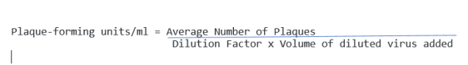

The medium used in phage plaque assays has a relatively low percentage of agar and therefore is calledsoft agar; it permits diffusion of phage to nearby uninfected cells but does not permit new phages to move to remote parts of the plate.
Procedure for Bacteriophage Plaque Assay
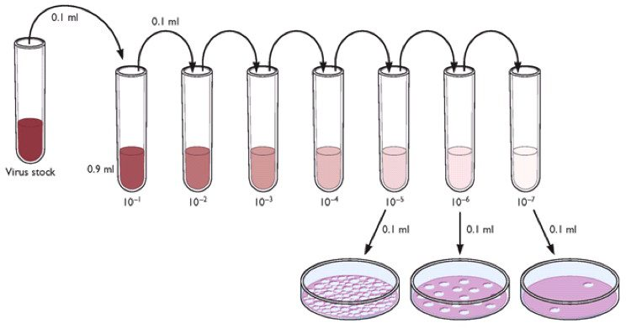
Figure: Bacteriophage Plaque Assay
Preparation of Stock Solution by serial dilution
- Place eight sterile saline tubes (0.9 ml each) in your test-tube rack.
- Label one tube “control” and label the remaining five tubes consecutively from 10-1 through 10-7.
- Label six nutrient agar plates the same as the tubes.
- Using a sterile 1 ml pipette, aseptically transfer 0.1 ml of the bacteriophage suspension provided to the saline tube labeled 10-1.
- Mix the tube well by rolling it between the palms of your hands.
- With another 1 ml pipette, transfer 0.1 ml from the 10-1 tube to 10-2 tube. Mix the tube.
- Using a fresh pipette for each transfer, transfer 0.1 ml of the suspension from the 10-2 tube to the 10-3 tube, and continue this diluting procedure consecutively for the remaining saline tubes. Do not forget to mix each tube well before and after diluting.
Overlaying Plate with Phage-Agar Mixture
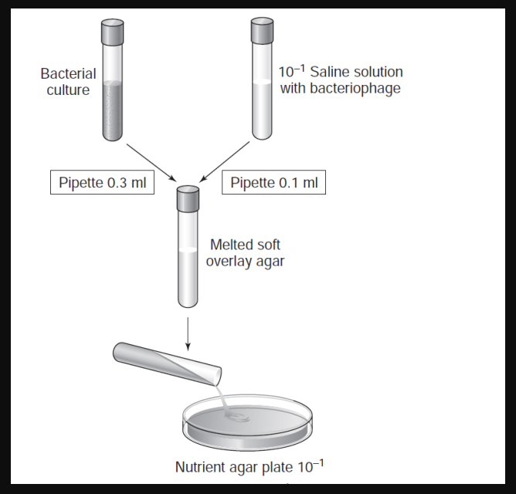

- (Note: you must work quickly here) Obtain six tubes of melted soft overlay agar from the water bath. Pipette 0.3 ml of a broth culture of E.coli into each of the soft agar tubes. Mix each tube well by rolling it between your palms. Label each tube with your initials and return them to the water bath as soon as possible. Do not allow the agar to solidify.
- (Again work quickly) Remove one inoculated tube of soft agar from the water bath. Wipe off all the water from the surface of the tube. Using a 1 ml pipette, aseptically transfer 0.1 ml of the 10-1 saline phage dilution into the soft agar tube. Mix the agar tube by rolling it between your hands.
- Immediately, aseptically pour the soft agar onto the surface of the nutrient agar plate correspondingly labeled as 10-1. Replace the lid and without picking up the plate, rotate it gently in a 6-to 8-inch circle on the surface of the table to evenly distribute the agar.
- Using a fresh 1 ml pipette each time and working quickly, repeat steps 1 and 2 for the remaining saline phage dilution tubes and for the saline control tube.
- For each dilution tube, use its correspondingly labeled nutrient agar plate.
- Allow the soft agar to solidify.
- Invert and incubate plates at 35°C to 37°C for 24 hours.
Results
- After incubation, examine each plate and count the number of plaques on each plate that has clearly differentiated plaques.
- Record your counts. Plates where plaques have covered the entire plate and where plaques are not clearly discernible from each other (more than 300 plaques) should be recorded as TNTC (too numerous to count).
- Calculate the number of lytic phages per milliliter that were in the original bacteriophage suspension using the formula mentioned above.

Dilution of phage | 10 -¹ | 10 ⁻² | 10 ⁻³ | 10 ⁻⁴ | 10 ⁻⁵
Number of plaques
Calculations of plaque units/ml
Results of Bacteriophage Plaque Assay
If 48 plaques are observed in 10-5 dilution factor, as the 0.1 ml virus is added, plaque-forming units/ml will be 4.8 X 10⁷.
In your practical, you can count the plaque-forming units, calculate and tabulate it as follows:
References and Further Reading
- Virology Blog: Detecting viruses: the Plaque assay
- Brock Biology of Microorganisms by Michael T. Madigan
- Principles of Microbiology by Ronald M. Atlas
- Laboratory Exercise in Microbiology by Robert A. Pollack et al.

